Analysis of the
Old Testament
- David Hocking’s Annotated Jasher, Enoch, Isaiah, New Testament
- Isaiah Class Study Notes

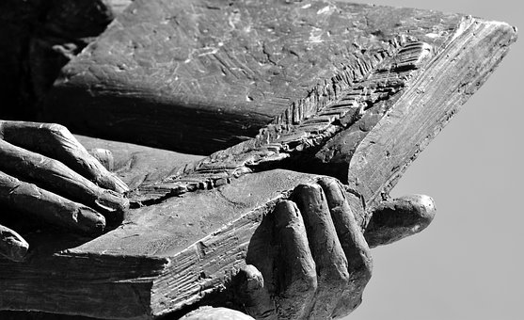
Compiled By Nate Richardson
Available Free at RichardsonStudies.com
Contact editor@richardsonstudies.com

Contents

Cleon Skousen - Ancient Scripture Lecture - Highlights 6
PART 1: UNIVERSITY ISAIAH CLASS VERSE BY VERSE INSIGHTS 7
Additional Isaiah Study Resources 19
PART 2: ISAIAH ANNOTATED BY DAVID HOCKING - HIGHLIGHTS 21
Hocking: Full Annotated Isaiah Contents 22
Hocking: Isaiah 4, Joseph Smith on Safety only to be in Zion’s Stakes, Un-Married Status Frowned upon in Israel 24
Hocking: Gathering Israel: Gordon B. Hinckley on Ensign to the Nations 25
Hocking: Isaiah 10 Chiasm: Remnant Shall Return 26
Hocking: Isaiah 11, Stem (Jesus Christ) & Rod/Root (Joseph Smith) of Jesse 27
Hocking: Ensign Gather Israel, Book of Mormon Western Indians says Joseph Smith 28
Hocking: 5 Woes to them that Go to Egypt, Divine Protection for Zion & Jerusalem, Nibley on Weakness of Egypt vs God etc. 29
Hocking: “That Her Warfare Is Accomplished”: Conflicts with Arab Nations & Israel (HistoryGuy.com) 30
Hocking: Isaiah 49: Song of the Lord’s Latter-Day Servant Joseph Smith: Woodruff Proclaims its Fulfillment 32
Hocking: Israel’s Prominence in the Last Days, Lord Comforts His Returning Children 33
Hocking: Jacob on Isaiah 49: Fulfillment of Promises to Israel 34
Hocking: Isaiah 53: Suffering & Triumph of Messiah, & New Testament Fulfillment of Isaiah Prophecy 35
Hocking: Abinadi on Isaiah 53 37
Hocking: Isaiah 54: Zion Shall be Established & God’s Covenant Protection 38
Hocking: Glory of New Jerusalem, & Joseph Smith is “the smith that bloweth the coals in the fire” 39
Hocking: No Weapon Formed Against Thee Prosper: Modern Israel Miracles 40
Hocking: Gentiles Welcomed to the Covenant 41
Hocking: Blessings for Who Trust the Lord 42
Hocking: Millennial Themes (Bryan Richards) 43
Hocking: Key Events to Interpreting Isaiah (Bruce R. McConkie) 44
Hocking: Reigns of Kings of Judah 47
Hocking: Israel Political Struggles with Neighboring Nations 48
Hocking: Isaiah’s Literary Elements 49
Hocking: Isa. 11:1 Branch Grow Out of His Roots: Genealogy of Christ, Analysis from McConkie, etc. 51
Hocking: House of Israel Timeline 53
Hocking: Isaiah Division: 1-39 Jehovah’s Judgement/Character, 40-66 Jehovah’s Comfort/Redemption 54
Hocking: Mount Moriah & Sinai: Unconditional & Conditional Covenants: The 4 P’s: Promised Land, Posterity, Prosperity, Protection/Security 55
PART 3: JASHER ANNOTATED BY DAVID HOCKING - HIGHLIGHTS 57
Hocking: Jasher Annotations Full Contents & Appendixes 58
Hocking: Book of Jasher Referred to in the Bible 60
Hocking: Book of Jasher Gives Insights to Bible History 61
Hocking: The Flood was in the Spring: Jasher & Other Evidence 63
Hocking: Genealogy of Noah to Abraham to Israel: Added Detail Such as Abraham’s 8 Children 64
Hocking: 2 People, 3 Days, Power of God to Deliver: Jasher & Alma Side-By-Side 65
Hocking: Melchizedek = Shem 66
Hocking: Joseph’s Torn Coat & The Covenant of Liberty 67
Hocking: Joseph Taught 70 Languages by Angel to become Qualified Ruler 68
Hocking: 1 Sam. Refers to Jasher, “Teach…Bow” 69
Hocking: Jasher/Nephi Parallel: Beheading with One’s Own Sword 70
Hocking: Jasher & Book of Mormon: Matching Themes: Naming Kings, Witnesses & Sealing Records by Hand, 1000 Bad Die 0 Good, Ditches Around Cities, Catastrophic Events, Exchange Military Letters 71
Hocking: Hebrew Writing Styles in Jasher & Book of Mormon: Word Phrases, Repetition/Word Groups, Pronouns 74
Hocking: Hebrew Expressions in Jasher & Book of Mormon: Repetition of Particles, Cognitive Accusative 76
Hocking: Hebrew Poetry in Jasher & Book of Mormon: Laments, Crying unto the LORD, Songs 77
Hocking: Worldwide Flood of Noah: Hydroplanet, Hypretherm, Hydrofountains, etc. (Dean Sessions) 80
Hocking: Jasher Miraculous Miracles Are Possible: Comparing with Modern Israel Nation Miracles 82
PART 4: ENOCH ANNOTATED BY DAVID HOCKING - HIGHLIGHTS 87
Hocking: Chronology of Enoch Texts 91
Hocking: Genealogy of Enoch 92
Hocking: Names of 7 Holy Watchers & Their Jobs 93
Hocking: The Beautiful Tree 94
Hocking: 4 Winds, 4 Corners of Earth, Adam in America 95
Hocking: The 3 Books of Parables, Elect One, Astronomical Secrets, 4 Angels, Ancient of Days, Azazel, Watchers, Angels of Punishment, Ancient of Days, Place of Punishment, Secret Oath 96
Hocking: Leviathan & Behemoth 98
Hocking: Garments of Glory/Life from the Lord 99
Hocking: God Weeping, Book of Enoch & Book of Moses 100
Hocking: Enoch’s Translation & Ascension 101
Hocking: The Heavenly Tablets, Earth Copies 102
Hocking: Timeline: 10 “Weeks” as 10 Time Periods: Past & Future 103
Hocking: Intro to 2nd Enoch (Slavonic) 104
Hocking: Description of the 10 Heavens 105
Hocking: Enoch as Metatron & Meaning 106
Hocking: Metatron (Enoch) 70 Names, the 70 Tongues 107
Hocking: Names of the Rulers of the World & Their Jobs 108
Hocking: The 7 Princes of Each Heaven 109
Hocking: Right Hand of MAQOM (The Almighty) Weeping 111
Hocking: The 72 Names of the Holy One, Numerous Amber Crowns, Large Host, 70 Angels Corresponding to the Nations 112
Hocking: The 70 Names of Metatron (Enoch), Moses’ Readings During the 40 Days on the Mount 113
Hocking: Secret Name of God Tetragrammaton YHWH Revealed to Moses, Hillel The Elder who Developed Mishnah Repetition & Talmud, Rabbi Abbahu Oral Torah 114
Hocking: Melchizedek is Shem 115
Hocking: The Enoch Calendar: Key Christ Life Events Occurring on Holy Days 116
Hocking: Courses & Degrees of the Sun Portals 117
Hocking: Nephilim 118
Hocking: Giant Construction, 11’ Skeletons, Sons of God Meaning Covenant Keepers 120
Hocking: Reign of Watchers “Days of Jared” Parallels with Millennial Reign of Christ! 121
PART 6: NEW TESTAMENT ANNOTATED BY DAVID HOCKING – HIGHLIGHTS PENDING RELEASE 122

Cleon Skousen - Ancient Scripture Lecture - Highlights

Notes from a lecture found here: https://youtu.be/a9GZSTSxvvk
25 min Judah Joseph are supposed to work together in the last days. Could suggest temple institute Levites really will build the 3rd Jerusalem temple
Goes through key dates to take note of, easy ways to remember when prophets were
Goes over Anglo-Saxon history identifying them as the house of Ephraim
Joseph Klausner has a book on the Messianic Idea in Israel He talks about Messiah Ben Joseph will come before Messiah Ben David and the Messiah Ben David is the Messiah Jesus Christ Messiah Ben Joseph is Joseph Smith
See around minute 42
The prophet Jeremiah was anointed at year 14 just like Joseph Smith
We found the house of Lehi
Moses was 40 years a prince of Egypt, 40 a shepherd, 40 a prophet

PART 1: UNIVERSITY ISAIAH CLASS VERSE BY VERSE INSIGHTS

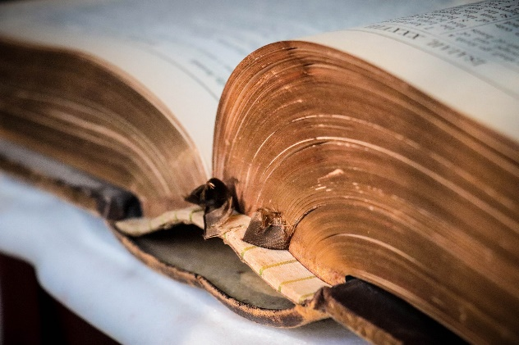
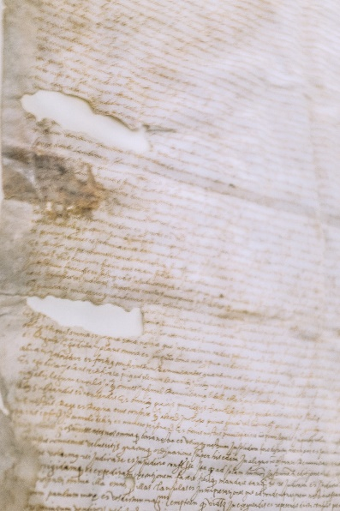
The following are primarily insights from a university class on Isaiah which I took which the professor said I could share but wished to remain anonymous.

Introduction
Going chronologically through the 66 chapters defining hard words and ancient ideas etc.
-Ch2-5 is not past, it applies to me and my day.
No since of time. No chronology. Rollercoaster. Most beautiful promises toward the end. 36-39 is prose.
This book is not as bad translated as others because nobody that was bad could understand it and understand how to mess it up.
*study Isaiah for personal development.
Hebrew mindset is big picture need step back to see.
Why quote Isaiah? They’re Jesus’ words.
He a well poet. Melchizedik=Lord is my king. Isaiah was an aristrocrat. Elijah was something of a hermit. Others were shepherds. Joseph Smith even had shortcomings. This gives us home that God can take imperfect men like us and make things out of it!
Isaiah 770 BC born 740 BC made prophet. 692 BC stops preaching. Jonah is mostly poetry Hebraic and taught in the same time as Isa.
Jesus was more close related to pharacee’s
oral tradition=unwritten law from God. Misnah (200 AD) Gamara (500 AD) these are interpretations of it. A combo of them is the Talmud.
Begged God and Isa’s life extended 15 years.
Talmages JTC McConkie’s for M’s have JST.
Only ¼ JST in LDS scrips. Pres. Packer said the miracle of his lifetime was the LDS version of scriptures.
1/3 of Isa in BFM.
Isa. Assumes we know the doctrine, and teaches other. Need know the bible before Isa to get Isa namely the law in Dueteronomy etc.
Past present and future all one eternal “now” to Jehovah. Omniscient. Moses 1 all things are present with me. Time is an illusion given to us to understand mortality. We understand in linear fasion. God sees in 360 degrees. If can effect later, turute may effect past also. Like The atonement effected past people. Maybe once plates gien to another, God maybe said once plates lent out, hey Nephi, make another set of plates. God knows what kingdom we will end up in, we are here to discover it for ourselves. Alma “time only is measured unto man”. Revelations says eventually time will be o more. If we become slightly more angry, or slightly more plesasant as time goes, by eternity, we will become that perfected. That is said in “Mere Christianity” by CS Lewis.
Job is like a play, each their pard. Many think it’s a true story. Prose 250 words. English poetry 100 words. Heb. Poetry 50 words (Psalm 23). 90 of Isa is sophisticated Heb. Poetry. Heb not use ryme or meter, but repetition/beauty.
LORD=Jehovah. 6,800 times in NT. This is Heb. Translation.
Jewish leaders in Christs time put a fence up around the law so you cant’ get close enough to break them was the idea.
Poetry in Heb. Is ryming ideas not words.

Ch. 1
Ch1 is a preface
find principals of the gospel in ch1.
The great arraignment- meaning, to call someone accused to answer for what they did.
Pophetic perfect: Mosiah 16:6, 2Ne314-8, Isa1:4. Jesus’ baptism and other things were very much as though they had already happened to God.
Heading ch1: great expectations. God is reaching out to them like he always does.
-masters crib: manger comes from French world meaning to feed
-1:4 Gone away backward’ is referring to an animal how they back up, it’s to say Israel goes backward in progress at times or is stubborn at times.
-1:7 your country is desolate” is prophetic perfect tence/ past tense as though it had happened already for it was so sure to happen soon.
-1:8 lodge cucumber= to say that not even a watchtower to respond to enemies has this gardener. Cucumber guard is left alone that is how the people would be.
1:13 vian oblations” is to say offerings, saying things repeatedly without feeling. Getting into the rut of doing ordinances and not seeing their significance. It is speaking to the LDS also, we His convenant people fall into this trap as well… “incense is an abomination” may represente their prayers which were vain, to stop them! They did everything in the wrong spirit. Perhaps they thought “all is well in zion, yea zion prosterpeth” tand they will lose their souls.
1:15 heart not protected in cultural Mormonism. Separate and seed spiritual Mormonism. “hands full of blood” is because it’s become culture not religion. Full is to say they have blown it in every possible way. Their hands having it on them is to say they are covered in sin! i see Isaiah is trying to teach the people the same things Jesus came to teach in his ministry, that they needed to do the right and not just performances.
1:17 do all with eye single to glory of God. “plead for widow”’s welfare is true religion. “seek judgement” is to say, learn to judge well, ada to do well. To “judge the fatherless and the widow” is to say don’t just give time in court to who is rich to pay for lawyers, rather see to it that every one sees justice.
1:18 scarlet is bright red. Crimson is deep red. To say that weather our sins be terrible, or deep, or what have you, they can be gone via the LORD.
-1:23 like Christmas time all we want now is gifts
?-124 they don’t judge widow and fatherless” is to say they bring them not justice in courts of law, not dealing with them because of their poverty.
-1:26 Cry not any more ye desolate, for the Lord shall set up amond his people judges of truth, councelors of righteousness, them called of the Lamb of God to redeem His people.
-1:30 “whose leaf fadeth” is to say, you’ll be like a tree dying, that is, you’ll die!
-1:31 the proud catch flame easily.

Ch. 2
-2:2 mountain” go up symbolically. Spiritually flabby/ out of shape won’t make it up the mountain of the Lord’s standard for His people and not be able to commune with him.
-2:4 no peace unilt the Second Coming of Jesus Christ. Violence: many apostles still carry “For the Strength of Youth” pamphlets in their pockets, to say that violence is not good for any age.
-2:5 “light” see D&C 50:23 what does not uplift spiritually or morally is dark and not of God. Skiing for example could be uplifting!
-2:9 they are humble towards idols bowing to them
-2:11 this is my earth let me tell you how things go around here.
-2:13 to say pride- ceders of Lebanon
-2:14 mountains cease and melt before the Lord, for He alone shall be exhaulted in the Millenial day.
-2:20 they’ll say “hurry throw the idols under the couch!”
-2:22 are you taking wimpy mans advice over God’s?

Ch. 3
-3:3 even the high of status will be wanton. all the wise are carried away captive since they are hard to rule over.
-3:7 “I don’t want to be bishop!” “refuse to be healer”. Who thought had food doesn’t.
-3:9 you can tell a lot about someone by intently looking at them. Some may look into pupils of one and tell how much of the spirit they have with them. The gift of priesthood keys enables them to do that. “can’t you do anything about the light in their eyes?” said one who did not want us to proselyte in Jerusalem. Many look down to the ground there in Jerusalem.
-3:10 this is a commandment. compliment who you have compliment for or it is a sin -Kimball in Miracle of Forgiveness
-3:14 Nephi uses this in his commentary expounding on it.

Ch. 4
-4:1 perhaps is to say that they persist in doing wickedness that they will not change. that they will work hard to sustain their wickedness.
-4:6 there will be physical protection from mighty storm for Zion

Ch. 5
-5:1 there often were vineyard servant songs. these pointed to Jesus Christ. they may be dualistic pointing to Isaiah or others who deliver Israel at times.
-5:2 Masoretic text wild grapes means berushim, worthless stinking things.
-5:4 failed expectations of the Lord’s people
-5:5 Jehovah leaves us on our own when we don’t respond to His care, not cut us down
-5:8 land mongers. trying to enrich themselves. the larger the farm the more money they can make. in the Mosaic law they were supposed to give their land to their inheritors, and if land was sold, in the year of jubilee they were supposed to give it back to the original owner of the land.
-5:10 the Lord won’t let them prosper in sin. *All prosperity comes from the Lord.
-5:11 party mongers. “all [they] want to do is party”.
-5:12 wo to who just want to party. they don’t care about the Lord, don’t read His words, etc.
-5:18 sin mongers. they should be fleeing from evil, but they are drawing it towards them, getting closer and closer to it, then they fall in perhaps not meaning to at first.
-5:21 pride mongers. shouldn’t we, if need be mongers, be righteousness mongers?
-5:23 bribes sell judges to let evil go free
-5:27 the ppl coming to general conference quickly in jets etc as Elder Richards says in “A Marvelous work and a Wonder.” it may also mean that people will come take over us so fast they won’t even have to unlatch their shoes. carry away safe could mean in a car or plane, or the other example it could mean taken away as a slave.
Ch. 6
-6: prose
-6:2 BD calls them fiery beings.
im is already plural this translation is wrong.
-6:3 3 times in Hebrew was the most you could say something and it make sense
-6:5 we will be accountable for all idol words, and all idol silence a church leader said.
-6:9 in Matthew and Acts its clear, unclear translation here, this means people hear but chose not understand.
-6:11 burdensome call to preach forever
-6:13 substance means sap. it’s to say the tree is still alive. How piece this verse together?

Ch. 7
-7: background: Assyria is the bully after everyone doing damage after Israel, Judah (the Northern kingdom) and Syria. Tribe of Judah mostly inhabits Judah. Ephraim chief tribe inhabiting there. Jerusalem is capital of Judah. Samaria capital of Israel. Damascus capital of Syria.
king of Judah is Ahaz. king of Israel is Pekah, son of Remaliah, and King of Syria is Rezin.
Isa being poetic doesn’t use same name to call each place over and again to not be repeated.
Assyria capital is Nineveh. the bully.
Israel and Syria are slave vassalages to Assyria. Judah doesn’t want to join these two in warring against Assyria, so they go after Judah to conquer Ahaz so they can have more power to go after Assyria.
Ahaz goes out to the well to cover it so the Syrians and Israelis don’t discover it and get them.
can make 3 column chart to show which name goes with which place.
Place Capital Tribe King Region Social System
Syria Damascus Ahaz /Rezin? Vassalage to
Assyria
Israel Samaria Pekah “ “
(son of Remelia)
Judah Jerusalem Ephraim Northern Kingdom
Assyria Nineveh
(the bully)
The Syria-Ephraim(Israel) alliance wanted to rid Ahaz of the throne and put son of Tibial on the throne so they’ll help them go against Assyria.
Israel and Syria still exist today and have the same names.
-7:2 moving trees make groaning sounds, the heart of the people sounded thus.
-7:4 firebrand is like a torch put out with embers on the end. they’re only embers. the light is gone. they can’t hurt you.
-7:7 they won’t get you don’t worry about it
-7:11 God wants to give him a sign
-7:12 he does not want to get the Lord involved he wants to do things his way
-7:14 since he wants to he will weather you like it or not.
-7:14 virgin means pure and chaste in one sense, or not having had carnal relations with man in the other sense.
-7:14 dualism speaking of Christ and of the children his wife would have (she being a virgin in the pure good lady sense of the word) saying things will happen by the time of the birth of that one
-7:18 Egypt is known as the land of the fly, and Assyria as the land of the flea. saying the armies of these nations will attack.
-7:20 Assyria shaved entirely whoever they captured.
-7:20 Tiglath king of Damascus Ahaz goes to meet. Assyrians had conquered the other 2 nations. Ahaz asks their mercy. he makes one of their god’s erected in the temple by the Levites. displeases God.
-7:25 their land used to be cultivated but it would just all turn to briers. desolate.

Ch. 8
-8:4 prophecy telling what will happen by a certain time come. prophecy refers oft to Isa son and Christ. dualism.
-8:8 because rejected the Lord he brings other waters to you. the bad guys will come to you and surround you, and even to your neck then a miracle to deliver you. Also, Jerusalem was called the neck of the land because of it’s geographical position, and the Assyrians were about to get them, and got even to the neck, but never prevailed.
-8:15 Lord says you need not make treaty with bad guys. if you do they will crush you. if not i will defend you.
-8:16 disciples of Christ to be bound to the law of the gospel in their lives.
-8:18 family of Isa as signs to Israel

Ch. 9
-9:1 2 tribes of Israel. see 20 years ago bible maps. the area of Galilea is where these were, where Jesus would be raised.
-9:2 dark black stone basalt. literal. and figurative, for Jesus the light would be raised there.
all roads toward holy land go through Megiddo. Valley of Jezreel it’s called now. all go through there. Josiah at age 39 is killed here by king of Egypt. Harmagedo. Har in Hebrew is hill. it’s like Armagedon, it’s to be the scene of so much carnage. is this Galilea where armaggedon will be?
THERE WERE A PEOPLE IN THE REGION OF GALILEA THAT LIVED IN A DARK PLACE. THEIR LAND WAS MADE MOSTLY OF VOLCANIC ROCK, AND SO THE GEOGRAPHICAL LANDSCAPE OF THE LAND WAS DARK ITSELF. BUT Jesus CHRIST WAS GOING TO BE SENT TO THEM SO THEY WOULD BE DELIVERED FROM THE POVERTY OF THEIR APOSTASY, THAT DARKNESS OF NOT HAVING Jesus THE LIGHT OF THE WORLD NOR HIS TEACHINGS, FOR THEY HAD REJECTED THE PRIOR PROPHETS , AND THE TIME HAD COME AGAIN AS IT ALWAYS DOES, TO SENT ANOTHER MESSENGER TO THE CHILDREN OF GOD TO GIVE THEM MORE OPPORTUNITY TO REPENT. THIS TIME THEIR PROPHET TO THEM WOULD BE WHO WOULD SET THEM FREE FROM THE DARKNESS AND YOKE OF SIN.
-9:3 in BFM ‘not’ is removed.
-9:4 yoke staff and rod represent slavery
-9:7 these first 7 verses perfectly describe what happens in Isaiah’s day.
Judah is the child going to be born to Ahaz and save them.
also applies to 2nd Coming. advanced dualism.
-9:10 refers to 9/11 quoted by political leaders of USA to say we won’t be beaten. but really it’s Ephraim and the Lord is going to destroy them.
-9:19 holocaust

Ch. 10
-10 this Ch. is a prophecy to Assyria. from here in the book prophecies to other nations come.
these are all types and shadows of the end of days destructions.

Ch. 11
-11:4 The Lord won’t let people go to jail just because they have no money and vice versa
-11:16 millennium preparation bridge like when Moses parted the Red Sea for people to come to Zion

Ch. 12

Ch. 13
-13:3 these are whom the Lord calls
-13:8 face flame like Indiana Jones and Raiders of the lost Arc.
-13:12 slavery abolished
Ch. 14
-14:8 a feller is one who cuts down trees
-14:11 he is dead
-14:13 refers to the children of God
-14:14 Satan has an “I” problem
-14:19 Satan never gets to even have a body. JS said Satan’s punishment for doing all he did to this earth will be that he never gets to have a body
-14:19 the person who found the body of this ruler of Isa’s day when found the body had asses run over his body until nothing was left but dust from him. the prophet saw it all.

Ch. 15
-15:2 mourning for Assyria moves south and conquers everyone as she goes
-15:5 one of the southmost cities they would go to to get away
-15:5 a young cow at the height of her strength and image. this is the time they were just right for breeding
-15:6 not only destruction from Assyria but drought for full destruction
-15:9 either to mean destroyed by lions or that so few ppl that there would be a lot of lions in the land

Ch. 16
– 16 Ch15 and 16 Isa about Moab. It’s SE of Israel, E of dead sea, towards s, Edom below that. Moab was the son of Lot’s oldest daughter Lot and his daughter had a child.
-16:4 Syria and Damascus are gone Moab goes to king of Jerusalem for help. Jerusalem says I don’t trust you have never been trustworthy.
Moab was destroyed by Assyria.
Moab turns to Judah for help for the one on the thrown in Judah is known for his mercy. the Judah king says I didn’t trust you before and I don’t trust you now. it’s like the final judgement where the Lord says depart, I never knew you.
The problem with death bed repentance is obvious. it has not to do with death or age but when we meet trouble.
Elder Scott gen conf 2013 Oct says diff between willful rebellion and weakness how the Lord is more patient with weakness.
Pres Kimball said “Death makes us spirits not angels”
ppl make the choice between eternal damnation and repentance every day of their lives.
-16:11 bowl is sight of emotion. heart is sign of character of a man “as a man thinketh in his heart so is he”. the seed of character.
bowl harp is to say a sad song.
-16:14 time specific prophecy

Ch. 17
-17:5 in the law of Moses you use a scythe. that is hard to use if you don’t know how. like milking a cow.
some wheat berries fall to the ground.
Law of Moses required the corners to not be cut down so the poor could eat them.
wheat berries are very small you have to be very hungry to eat
-17:6 Law of Moses you don’t take every fruit off the tree leave some on the top for the poor.
Isa is saying almost all the fruit is gone. only a few left and they will be humble and come back to God.
-17:10 you are planting the wrong things there is a reason they looked like the wrong thing when you planted them for they are going to reap sadness. see the following verses as well.
for example, biting off more than you can chew can get you into trouble. Pres. Hinckley said “survey large fields and plant small ones.”
-17:13 they look big but with a little wind they’re blown away. tumble weeds have such shallow roots when they die the root breaks and they just roll around.

Ch. 18

Ch. 19
-19: for 2,000 years they of Egypt were in charge. they destroy themselves. (this is from Ch. 19 somewhere: Judah a terror to Egypt wasn’t so but now see it is
Nile river will dry up- they in 1960 took a dam to it and now econ in Egypt is gone
Anoint your shield= wooden shield tempers the wood better, and makes arrows slip off of it and not go through.
Camels pull wagons. Chariot means wheeled vehicle.
Lion usually reps Assyria. Assyria ceased to exist before Babylon came into power. The watchmen on the tower waits to see but all he sees is a chariot with several men come with a message Babylon is fallen.
Rev 6:8 Babylon fallen in the last days maybe ISA saw this as well as the other.
DC1:18 says Babylon will fall
DC133:5 go ye out from Babylon (the Lord is saying we all live there. So the fall of it will be massive.) v7 go ye out from Babylon. V11 watch for you know not the day or hour. Go out from among the nations which is Babylon which is spiritual Babylon it says.)
-19:2 contention starts in the home then spreads to the community then the world. homes falling apart make the world fall apart.
-19:3 aka necromancer. wizard is male witch. they’re trying to council with these to hear from the dead etc. their council will fall.
-19:4 Islam rulers of terror, and USA rulers of terror who lie to us etc.
-19:5 the Nile river is still powerful it will dry up someday. along the river they farm, make paper from things growing by it, etc. starting in 1960 soviets tried to buy off Egypt to stop the Nile. they want to build a dam so they can become a superpower. the dam was not a success, but it filled with silk and they got the silk out and it turned to a desert ruined the land. where the Nile overflow stops there is pure desert no vegetation. the dam stopped ag and turned it’s econ upside down in the last 40 years. Cairo has 17 million it’s way too full there in Egypt. people live 1 mil on the graveyard. the city smells.
-19:17 anciently that was not so. in 1948 when the brand-new united nations that wanted to rule the world (2/5/14 they issued a statement against the Vatican saying they should not abuse do abortion or so forth). watch the news and go there and you’ll see that this is being fulfilled today.

Ch. 20
Ch. 21
Ch. 22
-22 ch22 is the Eliakim prophecy. 1 2 6 7 9 11 are all Jesus chapters. others have allusions.
-22:1 why are you celebrating on the roof when all this destruction around us?
-22:4 there is a sense of woe in this chapter from the beginning for he sees what is coming.
-22:6 war is coming there. seeing the valley filled with horsemen
-22:10 Hezekiah knocked down houses and filled the breeches of the wall. this is the 7th century BC.
-22:11 Hezekiah’s tunnel was to get water from pool of Siloam to Gijon spring to reroute the water for prep for Assyrian attack.
-22:11 making temporal but not spiritual preparations
-22:12 Isaiah said Jerusalem was going to be besieged by Assyrians. this did not happen. it’s because they became righteous. ch36 to 39 Hezekiah becomes righteous and that’s why this happens. the prophecy has an “unless you repent”. this happens with Jonah as well, and around Josiah king of Judah. Prophecies are full of “if’s”.
-22:15 Shebna is a type of the apostate people. if you don’t repent Assyrians wipe you out and not be buried in a sepulture for you are so apostate. but it must be that they came around for they were spared. Eliakim replaced him. Eliakim means God going up or My God shall arise etc. something. His association with the king causes many to come to him which causes him to fall.
-22:21 refers to the temple
-22:22 key on shoulder: in the holy land keys were worn around neck or pinned to shoulder for they’re some 10 lbs. see also “the government shall be upon his shoulder” means keys, power, the work if it.
-22:25 Hezekiah sees he is getting so many favors that he shall be kicked out. and when Christ’s nail removed his agony removed for He done suffering on the cross. Hymn “once all things He meekly bore, now He will bare no more.”

Ch. 23
-23:1 Tyre is going to be overthrown. Tyre is on the coast. it’s an island in Isaiah’s day. a great center for mercantile.
-23:1 Tarshish is probably Italy
-23:2 Hyrum of Tyre helped build the temple he was a good man. He was the most famous Phoenician. Phoenicians brought us phonetic alphabet. it’s from them.
-23:3 Everybody who is anybody goes through there.
-23:6 it’s hard to conquer an island for when you come to it they flee the other way on ships. Senacrib conquers it then they have 70 years freedom then they begin to “sing like a harlot” and are conquered then Alexander the great wants it and they build something to get there and by the time he gets there he is so mad that he destroys it. the cosway that Alexander built makes it so it’s no longer an island but is connected.
-23:15 “sing as an harlot” suggests the person is proud and doesn’t care
-23:18 means they’ll be dedicated for destruction

Ch. 24
-24 ch24-35 are the apocalypse cycle in Isa. Apocrypha is what is not canonized and they are doubtable. apocalypse means revelation. these chapters are emotional roller coaster, middle is nice, first and end are destruction. Isa is repetitive. like making a tapestry or helping us to know and not fear it.
-24:2 no matter what your social status you need obey. “world overtaken with sin and iniquity” Pres. Kimbal said in the 70’s that that was the type of world we live in now. a world of sin.
-24:5 the 3 reasons for the destruction. these 3 laws of God being broken today. honesty is not well, morality, caring for the poor, chastity, sabbath, all the ordinances changed, etc. Everlasting covenant: theomorphic God we believe in. that we can become like God, being made in His image.
-24:6 avoid this fire by getting the earth to repent. every member a missionary. Some of this language is really rough. this is literal and figurative language.
-24:11 this is ADDICTION. they want wine and drugs but are never happy when they get it.

Ch. 25
-25:1 full of wonder, like awesome, awe inspiring. here we read extraordinary/amazing
-25:1 councils aka covenants
-25:6 “this mountain” refers to last chapter. “Of fat things” means the very best. wine on the lee’s for days gets very good. bad lees=bad wine
-25:7 mountain=Zion; the veil =that is between us and seeing the face of God
-25:8 resurrection
-25:9 patience, or like a waitress serving someone. our society won’t wait. Satan gives right away then he takes away. The Lord says you should have waited. may use hope as a word for wait. *I waited before committing to Megan until after my mission and I knew it was right.
when you pray hear Elder Maxwell, “I know God loves me so much by the prayers he has not answered”.
Isa speaks of the prayer being answered faster if we fast.

Ch. 26
-26:1 a song of praise of 2 cities, righteous Zion and wicked Babylon
-26:2 literal or baptism
-26:3 perfect peace can mean the peace Jesus has, the peace of being innocent via living His gospel.
1 free to every 25 slaves for a long time in Brazil.
-26:4 the word JEHOVAH only printed 4 times in KJV and 2 of them are in Isaiah
-26:9 judgement has to be there if we are to grow. there has to be accountability.
-26:10 God rains on the good and the bad. Do good to people even if they won’t repent or change. Preech the gospel to all.
-26:12 God makes us good
-26:13 Canaanites’ religion was Baalism. this word means Baalim meaning several Gods. After all the Lord has done for us at times we turn to other things. 1920 a Syrian was plotting his field. there was Cananitish text on a thing he found, and they found an ancient city of Hugart? There was a great library there about their polytheism. so in the last 100 years we learn much of this bad polytheism. it was seductive to the Israelites. when not harvest there is famine. Now (Feb 2014 in California there is not much water so fruit and meat coming from there the price will increase by a lot). there was 2 in Baalism a man and a woman Asherah was the female (groves). Yaux/Zadud (Ba’al) was another. Astarte the Goddess of fertility is given to Baal. Baal likes her so he kills Yaux. another god of death, Mat, is banished from the earth by Ba’al thinking problems would come. Baal means rain and thunder and clouds. At Mat’s home Ba’al goes to a feast and is poisoned by Mat and dies then Mat rules the world and the world is in turmoil. Astarte kills the god of death in Sept or Oct being frustrated then all starts to grow again. *Perhaps it’s to excuse the Israelites from their behavior by blaming i ton God’s. they say that every year this reoccurs. They all die and come back to life once a year. Israelites started to make idols and Hezekiah wanted to have people only worship at Jerusalem to keep things in hand.
-26:14 Isaiah is saying don’t believe in the mythology those are dead. Forget about Baal and this whole myth. Take away the people who pour grief upon us.
-26:18 we were pregnant with all these lies and it brought us nothing but bad gas; there never was pregnancy, it was a lie. All it was bad gas in our digestive system, it was a lie, and at the end of the day, the lie produced nothing whereas it was to produce everything.
-26:19 Jehovah Himself will die and be Resurrected. This happened.
real resurrection will occur. ch26 is called a Baal polemic (arguing about religious thing). They thought they would bring forth something happy but they brought forth nothing. But Jesus Christ will rise again, with all mankind.
-26:20 Second Coming. see JS teachings P.17. Jews were told to gather to Jerusalem. Why this fascinating?

Ch. 27
-27:7 does God deal with you the same way you deal with each other?
-27:8 The Holy land was a Mediterranean climate, like California. the winds bring in the hot air from the desert. God sends the east wind when people want the west wind to purge the fruit. Plants can be drown if you water them too much. East wind in the scriptures is a bad thing, west wind a good thing. The church discipline has to excommunicate people from the church because He loves them so much that he is giving them another chance. it may be said, “because you are loved so much by the Lord He wants to give you another chance. you are hereby excommunicated from the church.” Rarely will you feel the Spirit as much as you do in church disciplinary council. Mercy can’t rob justice, but a lot of mercy is found in the Old Testament. It’s seen in these verses even.
-27:12 one by one is the way of the gathering of Israel, we teach one person then they make personal commitments then they are baptized with their own service. Rarely it’s more than this.

Ch. 28
-28:9 babies don’t need much knowledge for they are already lovely
-28:10 God would reveal everything he revealed to Joseph Smith to the least of the church members, but he waits to give it to them until they are ready for it.
look into the heavens open for 5 minutes and you’ll know more than all the doctors about it said Joseph Smith.
there is a scale. 1 precept 2 line 3 little. precept may be commandment, precept may be specific challenges, little may be guidelines that we set for ourselves so that we avoid the temptations that beset us.
-28:10 set curfews, start dating no sooner than 16, start by going on group dates for the young are like wild apes who can’t control themselves so stay away from them until they have returned from their missions, or at least until they are 18 about and ready to think about marriage, the age of adulthood.
-28:24 the parable of the wise farmer. Fiches and Cumin you plant on their own as they are fragile. God knows which type person is which type, and how they will grow in which place. Loving Heavenly Father puts us where we are in the opportune moment. It’s probably so that we developed many talents in the tens of thousands of years of pre-mortality that they would be able to employ in a certain time and place, and around the people who would be best.
-28:27 only need tap the cumin and it comes out. need to really grind the wheat for the wheat berries to come out.
-28:29 Maxwell said that the generation are prepared for this time and need be kept by parents. they’ve been kept for this time, and now they need to be pushed forward. The parents are also there in place for them. The paths of the young and the old cross paths many times.

Ch. 29
-29:1 Nephi explains this in 2 Nephi 26 and 27 the rest of the world does not get it.
-29:10 JST says the people close their eyes not God doing it to them. Maybe God puts them into a deep sleep as they close their eyes to the truth.
-29:11 non LDS think this is some buried unknown thing. Charles Anthon is a professor at Columbia. He sees the reformed Egyptian, can’t read it but lies and says it looks like good translation to Him. it’s professor craft. JS is the not learned. JS said he and Charles Anthon fulfilled this prophecy.
-29:14 the origin of this work must be the coming forth of the BFM because see the rejecting of it happens then this verse is placed.
-29:15 people think they are not seen in the dark. They hide from others if they know there is a God, to try and avoid temporal damnation as well as spiritual damnation.
-29:21 The Lord cuts out this type, who jump on others for a word. Like getting mad that the scripture men not saying men and women. God created man, male and female created he them. It’s not a sexist term it’s a generic term.

Ch. 30
-30:1 They are going to Egypt again.
-30:1 atonement means cover. They are trying to do so in other ways than Jesus Christ’s Atonement. Trying to get rid of guilt in ways other than repentance like blaming it on others is adding sin upon sin.
-30:2 They go to Egypt for council not to Jehovah
-30:6 all of the beasts of burden carry gifts to try to persuade them to help
-30:7 they have no strength
-30:9-10 don’t tell me what’s really right, i just want to be comfortable and happy in my sins. The prophet will say things that hit home to us.
Pres. Hinckley to seminary/institute teachers: “what a frightening change in our culture. much sleaze. language on campus today never before. internet and porn to deliver filth and evil into our homes. it’s taking it’s toll. this is the era of gutter talk, of sloppy ways. at the same time this is the season when so many of our youth show such capacity to do right. they are more educated, know the scriptures better, go on missions more prepared, and become better parents. you have both kinds of students. try to hold onto who are being pulled away. now people want to leave the holy and go to the sleaze. music and entertainment are a part. there is no melody or uplift in the music. there is no beauty in it. here they hop and swoon and act like animals acting to their passions. drugs are often involved and destroys most of them except a few that get away via great pain. sex becomes all a part of it too.”
-30:15 you chose not to go there. if you had just returned you would have been saved.
-30:21 if you are doing as you should you will listen to your teachers and you will understand it and you’ll hear the Spirit tell you what to do
-30:25 the twin towers of 2001?

Ch. 31
-31:1 chariots are the armed tanks of the ancient world
-31:3 the lord can fight your battles but he will not if you go and make a treaty with Egypt, if you rely on your own strength
-31:7-8 God will make it so we recognize good and evil, and see it clear, and people will not be able to lead us in hypocrisy anymore
-31:10 this may refer to women, or the Lord’s people in general. He uses careless 3 times in 3 verses. The care less about the gospel. Nephi said the devil makes some mad in the last days to rage against the truth, and others to merely think all is well in Zion, and we can just relax. when you buy into that you are in trouble.

Ch. 32
-32:7-8 God will make it so we recognize good and evil, and see it clear, and people will not be able to lead us in hypocrisy anymore
-32:10 this may refer to women, or the Lord’s people in general. He uses careless 3 times in 3 verses. The care less about the gospel. Nephi said the devil makes some mad in the last days to rage against the truth, and others to merely think all is well in Zion, and we can just relax. when you buy into that you are in trouble.
-32:12 is to say nourishment
-32:17 Egypt seemed like so strong and close to get help, but God said no, just trust me.

Ch. 33
-33:15 violence and immorality go hand in hand. “lusts in the eyes” means movies television and magazines etc that are bad. No concerned parent would let someone in their home making sexual and vulgar comments in their home by the hour, so why let a tv do it?
-33:20 about 3100 stakes in the church today. It’s the basic unit of the church. Wards are merely a convenient way to gather.
-33:20 Jesus will be all 3 roles of government.

Ch. 34
-34:11 These are the same 2 words as when in Genesis 1 it says the world was without form and void. Things will go back to where they started.
-34:16 dc128 3ne24
-34:16 want means lack here. Eternal marriage is required for exaltation.

Ch. 35
-35:3 Pres. Monson quotes this often.
-35:8 Hebrew word way is the exact word Jesus uses when he ways I am the way the truth and the life. He is the way… This shows that it’s not a free for all in the gospel, there is a laid out path that we are to walk.
-35:9 Much hard will come and we need to get through it to be able to stand. John Taylor quoting Joseph Smith said that “God will reach in and pull the strings of our heart so hard until it seems that they will break that we will want to give up, but if we do we will lose all our glory.” We must come to know who we really are, what we are willing to sacrifice. If we make it through that we will have an eternal marriage “none will be without her mate” sing is always the opposite of crying is Hebrew, never laughing.

Ch. 36

Ch. 37
-37:3 It’s time of deliverance, but mother doesn’t have enough energy to push the baby out. They are close to liberty but aren’t on God’s side so they don’t make it.
-37:7 4 prophecies
-37:9 the rumor
-37:9 Ethiopia is south of Egypt, but rumor has it they are coming the long way to interfere. He will have 3 battles at once. Rabshakeh is sent to try and get Judah to surrender so they’ll only have 2 battle fronts.
-37:16 Hezekiah great prayer. He bares his testimony (Pres. Packer says each time we bear our testimony it becomes stronger. doing it verbally helps.)
-37:21 The answers to our prayers may come through the Lord’s prophets. It may come very personally.
-37:30 Too much chaos now, you won’t plant this year.
-37:33 The entire city was surrounded. Hezekiah needed a lot of faith to trust this message from Isaiah the prophet.
-37:35 JST in 1 kings 3. shows that the Lord was very frustrated with David when he fell. for David’s sake may have to do with lineage. read Donald Parry Isaiah on this.

Ch. 38

Ch. 39
-39:3 Babylon was a vasal state at this time to Assyria, I think.
-39:7 Eunuch is a servant to the king.

Ch. 40

Ch. 41
-41:29 our idols America idolizes are not so easy to see.

Ch. 42
-42:1 42:1-8, 49:1-6; 50:4-9; 52:13-14; 53.
these are the servant songs
53 is Mosiah Ch. 14 quoted by Abinadi. Christians think these point to Christ. Scholars think they are to some current king of that day since they do not believe that prophets can prophecy.
-42:3 Jesus’ ministry to be gentle, quiet, and mostly unknown to people of his day. the smoking flax can mean that those with even the smallest amount of potential he will help.
-42:4 he will accomplish His mission.
-42:19 JST says it’s to the blind whom he sends his servant.

Ch. 43
-43:3 the Lord= Jehovah
-43:10 To live as He would, showing He is real. *That’s how I got a testimony that God lives, it’s that I saw others who were standing where I learned God is. Being married is exalting, for we witness to each other all of the time.
-43:10 perhaps it’s to say that all were created at once, and is referring to how no idols are God’s.
-43:11 Shows Jehovah is JC. Abraham is a God but not of this world so we don’t worship Him. Elder McConkie at BYU said we worship the Father in the name of the son, we don’t worship the sun. In the NT Paul says that God and the Savoir Lord are 2 different beings.
-43:19 I will write my new covenant in your heart
-43:24 People give God not pleasantries but all their problems and sins. He blotted them out for your sake and won’t remember them more. This speaks of the Savior.

Ch. 44
-44:15 so ridiculous that he repeats it 3 times. Making a tree, using part for warmth, part for an idol to worship. Also like money from a tree, practical, yet worshipped it. Can refer to our bodies, honing them in the gym, or eating wrong to make yourself an idol for you and others to worship.
-44:20 worshiping a false God. You can’t make covenants with a false god. It’s like going to eat and nothing is there, like a large cheese puff.
-44:22 in pre-mortality we even repented via the Atonement. Jesus was a God, so he was totally trustable and we based all on His future eternal Atonement.

Ch. 45
-45:1 Cyrus means Messiah. It also means Cyrus the Mede who becomes first king of what we now call the Persian Empire.
-45:13 Isa knew Cyrus by prophecy. People think Isa did not write this, but he did. In “Antiquities” by Josephus, it says that Cyrus read Isa’s words predicting him, and he fulfilled what was written of him.
-45:23 Paul says this in the NT, saying it’s JC. So Jehovah is JC., for it says there is none else beside this person to whom the people will bow and confess.

Ch. 46
-46:1 the idols weigh them down and slow them down. Breaks down the beasts and the people.
-46:4 The idols can’t deliver you, they weigh you down, but I will deliver you.
-46:11 Cyrus comes from the east, he does not spare, and destroys Babylon. He is a type of Christ.

Ch. 47
-47:13 astrology for guidance is not how it is to be. they’ll be destroyed.
-47:14 this is not a get warm fire, this is a consume you fire.

Ch. 48
-48:3-4 God does these things, declaring it from the beginningg because of our tendency to blame others for what God does.
-48:9 I should just wipe you out but because you bare my name I’ll wait. I will let you stay a while, since I’m the one that chose you after all.
-48:11 You are my chosen people.
-48:13 creation
-48:18 righteousness as the wave of the sea like when an Apostle speaks to you and you feel like you got hit by a wave. If you keep the commandments you can have a serious impact on people by the righteous things you do. We can become wells of living water like Jesus Christ. As the waves of the sea may also refer to how our righteousness will never cease. It will always respond the to signals of the sun. To what Jesus Christ asks us to do, we will always be capable if we start with the little things and try to keep all of his commandments. Also waves have a large impact on large amounts of land. D&C 121 teaches that flowing unto thee. People are always coming back to great leaders and wanting more of them.

Ch. 49
-49:1 BFM has the whole first half of this verse. He is talking to those who have been scattered because of the wickedness of pastors in Israel. You can be in trouble for following leaders who choose evil.
-49:2 an arrow. Christ is a polished one, of all the arrows, he is the one who is prepared to do his mission perfectly.
-49:2 Could mean that Christ was there to publish his Father’s name. Also could mean that Christ’s ministry was quiet.
-49:6 could mean to say that light is referring to brightness.
-49:6 He is saying he is the hope of every human being.
-49:15 as impossible as it seems that a woman would forget her child, it’s even more impossible that God will forget about us.
-49:15 Ancient people would put tattoos on their hands to remind them of things important, like one of a temple to remind them of their covenants. Jerusalem was and is the Lord’s city. You can’t get away from that if you are a LDS.
-49:16 Ancient people would put tattoos on their hands to remind them of things important, like one of a temple to remind them of their covenants. Jerusalem was and is the Lord’s city. You can’t get away from that if you are a LDS.
-49:17 haste against thy destroyers is how the BFM reads
-49:18 God swearing with his own life. He can’t swear by any higher; there is no such thing as any higher. This is it.
-49:18 The brides would put on all of their family’s wealth just before the wedding. Jesus is having people come by the thousands and millions. Zion who thought she was forsaken will clothe herself with all of these people.
-49:20 could mean like a strait jacket. could be spiritually speaking of who say LDS have too many commandments. (God says if we are really good, he will give us more commandments; in the footnotes to one of Elder Bednar’s general conference talks, he says we should pray for more commandments.) Straight could mean literal like too narrow, not enough room in the building for them all to fit.

Ch. 50
Ch. 51
Ch. 52
-52:7 Abinadi has this quoted to him by the wicked priests, them asking him what it means. In response he quotes the 53 chapter of Isaiah. They asked him a question out of Isaiah, he responds out of Isaiah. Abinadi’s problem is that they don’t have a clue what the law of Moses is about. Abinadi says you can’t be saved by the Law of Moses alone. It points to the Atonement. You need that to be saved. You need the LDS church to be saved for it has the ordinances of the Atonement. Abinadi lacks a companion. God can’t hold them accountable without a witness for there is a law of multiple witnesses. Alma’s heart is pricked when he reads to them Isaiah.

Ch. 53
Ch. 54
-54:1 the sense of this chapter is where did all of these children come from. It’s the Gentiles coming to Zion.
-54:2 it takes 100’s of men to put up a circus tent, and elephants to help also. If they collapse it can be tragic.
-54:10 peace is used very often in this, and the flip side is it saying at the end there is no peace to the wicked. Peace is not necessarily an absence of warfare. Even in a peaceful place you can have inner turmoil. Standing before God ready for that is true peace.

Ch. 55
-55:2 Spiritually fat as Buddha The Lord wants us to be.
-55:11 missionaries get the lords priorities done not, theirs
-55:12 see D&C128:23 about how all rejoice about the gospel

Ch. 56
-56:1 Judgment: result of judging. Justice: quality of being just, rendering what is due.
-56:2 is to mean happy. Same word as used in the Sermon on the Mount.
-56:2 people should know that LDS are different on Sabbath. we need to re-enthrone the Sabbath. Mark E Peterson said someone who breaks the Sabbath is a covenant breaker.
-56:5 place and a name is yod veshem it translates to a hand and a name. That is what happens in God’s hand, He gives them those things.
-56:6-7 You’ll be happy in the temple if you are keeping the Sabbath day holy. There are people who look natural inside the temple who like to be there, and others who check their watches a lot and are biting at the bit to get out of the temple. There will be thousands of temples in the Millennium and we will be doing work for the flood gates of people that the work of the Lord is opened up to. Some of the most blatant miracles come as we do family history work. Brother Merrill couldn’t find a person where they were buried, and he is impressed to walk down an isle, stop midway, put his arm up and pull out that book and there is the person. Or feeling that something is missing, then finding out the family had an infant who died. SO be glad when your people are glad in the temple, it means they are honoring the Sabbath. THOSE who honor the Sabbath CRAVE the temple, to go there and receive the reward of their doings.
-56:10 a watchdog that can’t bark is worth less than 0. So we unbind our tongues for heavens gates to flow. We shepherds in Israel, and that is all of us, need to open our mouths for our people for God giving others commandments is what will let us have more opportunity in life and allow the Holy Ghost to prick ourselves.
-56:10 throwing down on idleness.

Ch. 57
-57:1 LDS funerals are happy
-57:5 recently in spring 2014 there were men arrested for child abuse. On the other end, there was a woman recently who sacrificed her life for her child soon to be born.

Ch. 58
-58:5 fasting is not for looking poor
-58:6 the next verse is probably about helping the poor, and this verse is oppressed meaning under sin. Fasting is a consciousness of victory over self.
-58:7 you don’t get all of the blessings if you don’t pay the fast offering. Pres. Foust said we at times categorize how much our food costs for how much to pay. We should give ten times that much if we can. We aren’t paying enough until it hurts. If you can’t fast, then find other ways to make that day one of sacrifice.
-58:8 fast blessings D&C 59 equates joy with fasting.
-58:8 It’s righteousness that is the breast plate of the armor of the Lord.

Ch. 59
-59:1-2 the avenger and the redeemer. whatever you deserve at the 2nd Coming is what you’ll get.
-59:3 one youth was excommunicated for lying to his priesthood leader. Lying is a cardinal sin and you go the same place with that as you do the whores and thieves.
-59:5 a poisonous serpent they’re incubating.
-59:19 like now how Satan is putting evil all through the world
-59:19 the cross is the standard, the Hebrew word comes from the word meaning standard bearing, like a tee shape standard without the flag part looks like a cross. E Maxwell said our light still is not shining bright enough to be a light against the nations. At times it’s like Elijah to the priests of Baal, or JS against all the religionists of his day.

Ch. 60
-60:7 all these Gentiles will be gathered to the House of Israel
-60:7 temple Gentiles to.
-60:11 ancient cities are always closed at night for protection, but the holy city so powerful that it need not protectin. People don’t understand the text of Isaiah so they were mad at Acts 11 about how the gospel is to go to the Jews
-60:22 hastening the work

Ch. 61
-61:1 there was a seat in the synagogues where you would give commentary on the law. Jesus says this in Nazareth and the people say isn’t this Joseph the Carpenter’s son? Wondering at how this person could say he is Jehovah. Jesus basically said if you want to see a miracle here you have to have as much faith as the gentiles who had great faith and obedience which the Jews did not have. It’s like how many LDS are not righteous but are self-righteous self-serving seeking honors of man.

Ch. 62
-62:4 The Lord will marry the land.
-62:8 we don’t have to work hard and have others eat and drink the fruits of our labors

Ch. 63
-63:1 Edom also means red
-63:2 red because of dyed from blood in Gethsemane and because he trod down his enemies. Which side are we on?
-63:3 the grapes that Christ treads are the wicked
-63:9 he became like us so he could suffer with us and pity us. Paul says the sinless one became the great sinner, aka he stepped into our shoes. All people come to earth to suffer, but Christ went to suffer “enormity multiplied by infinity” says Elder Maxwell.
-63:15 intercessory prayer like in John 17. Like D&C121 also.

Ch. 64
-64:3 many will probably have to move away from the mountains
-64:6 we as filthy rags is like saying that no matter how much good we go we keep getting dirty again and staining ourselves. God never “owes us one”.

Ch. 65
-65:1 in the last few chapters Isaiah summarizes, condemning apostates, pronouncing blessings for the righteous, and speaking of the destiny of the gentiles.
-65:1 JST says how God is found by who seeks them (not vice versa). Says God tried to reach out to the Apostates but they did not care about him.
-65:3 law of Moses said only use unhewn stones for altars not bricks
-65:5 they frustrate him
-65:6 God will give some so called Saints what they really deserve they not being saints at all.
-65:17 not remember the reproach of thy youth or widowhood anymore
-65:20 no more infants dying
-65:25 This is Isa 11 but you don’t get any better than that. Take this literally there is no other way to take it.

Ch. 66
-66:1 Take the Lord in by making him a temple. Don’t forget about him the poorest of poor.
-66:7 the Coming of the Lord will happen very fast. The New Jerusalem will come miraculously overnight. The Jews get the gospel as in a day as well, it says, and that will happen at the time they see prints in his hands. They are the last to get the gospel,
-66:17 we have a different Word of Wisdom, law of health now.
-66:19 missionaries right now are being sent to those nations considered gentiles.
-66:20 they=the gentiles
-66:21 them=the gentiles
-66: all flesh worshipping the Lord- flesh means things that are alive and can die; all the people left standing at the Second Coming of the Lord, those not destroyed from wickedness, will worship the Lord Jesus Christ, the God of this world.

Additional Isaiah Study Resources

Isaiah word study search etc: https://isaiah.scripture.guide/whole/chapters/iinst/1/2
See tihie.com for free Isaiah study companion essays of Micah English.

PART 2: ISAIAH ANNOTATED BY DAVID HOCKING - HIGHLIGHTS

Shared with Permission
Please visit www.beaconlightbooks.com for more information.
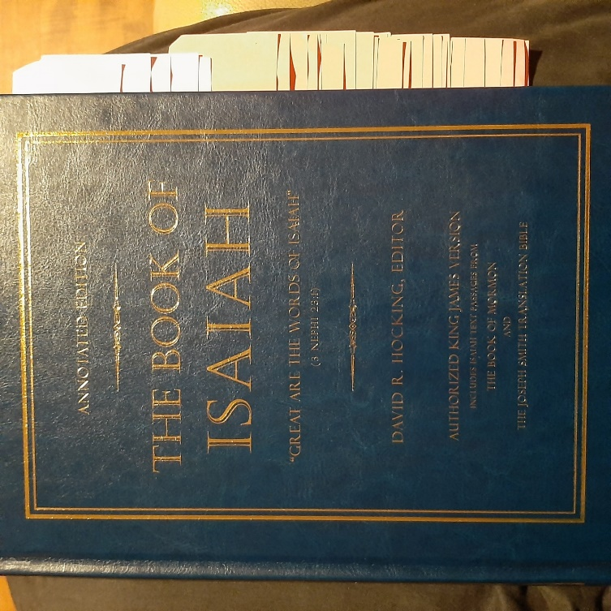

Hocking: Full Annotated Isaiah Contents

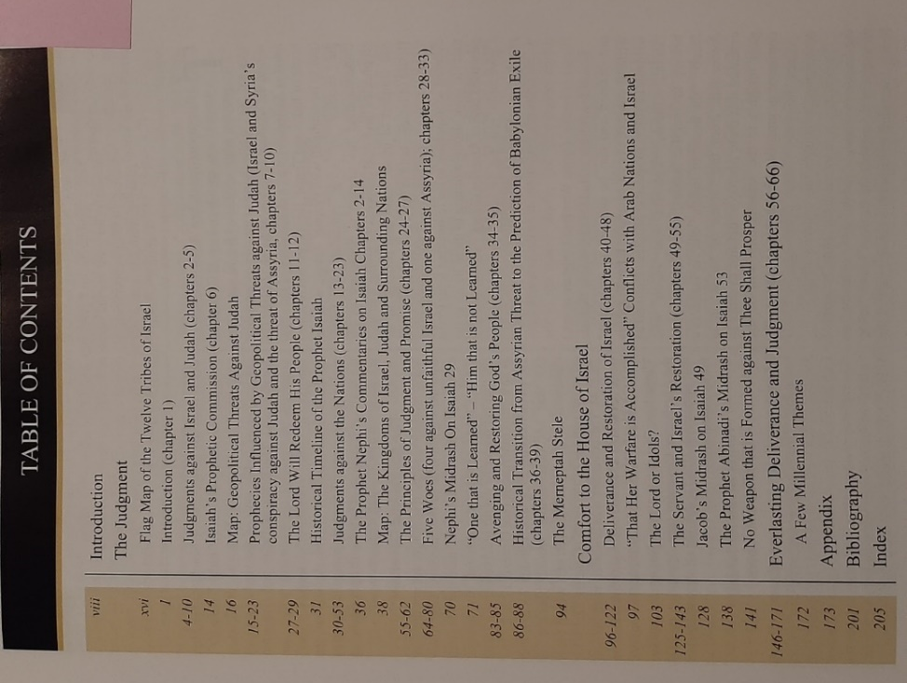

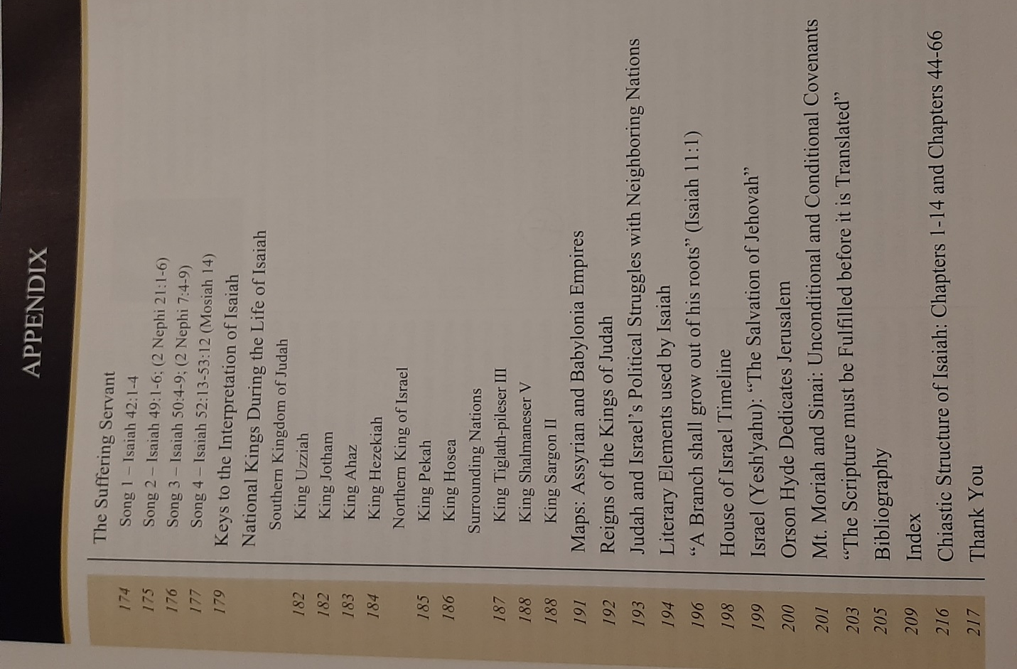

Hocking: Isaiah 4, Joseph Smith on Safety only to be in Zion’s Stakes, Un-Married Status Frowned upon in Israel

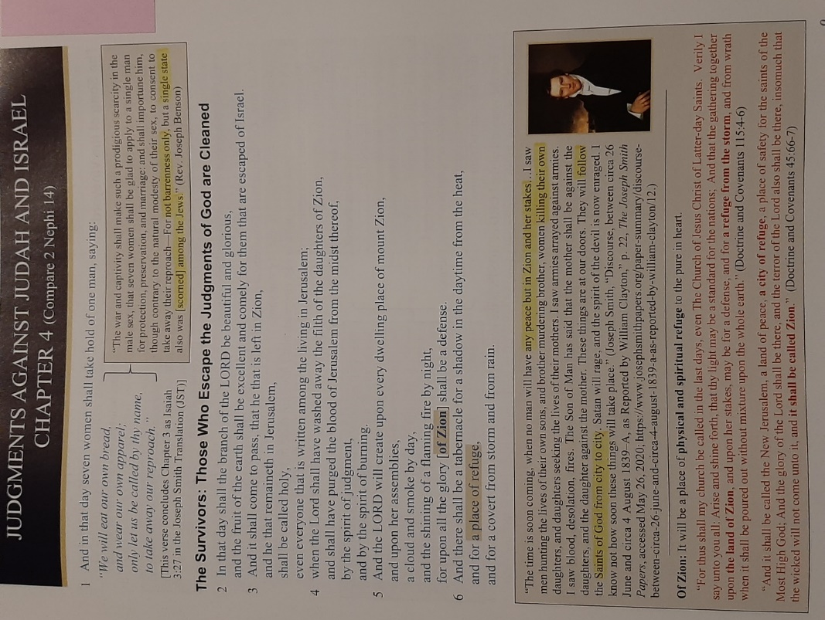

Hocking: Gathering Israel: Gordon B. Hinckley on Ensign to the Nations

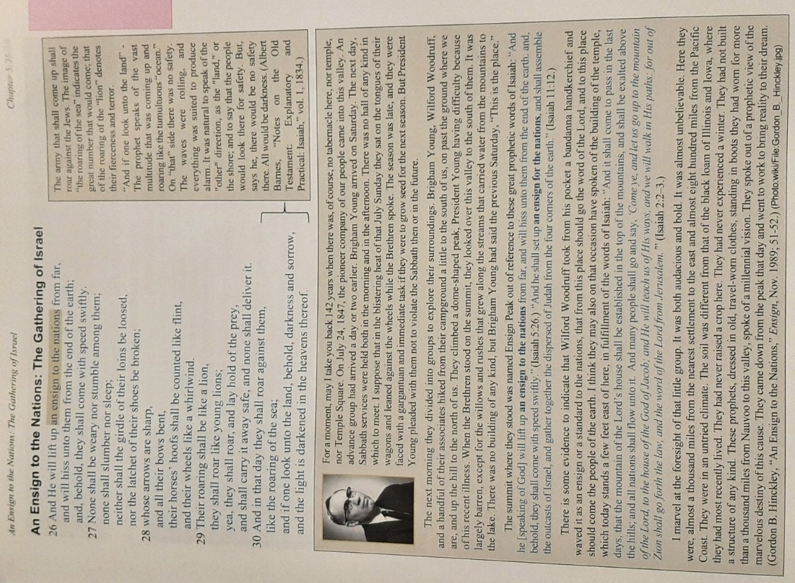

Hocking: Isaiah 10 Chiasm: Remnant Shall Return

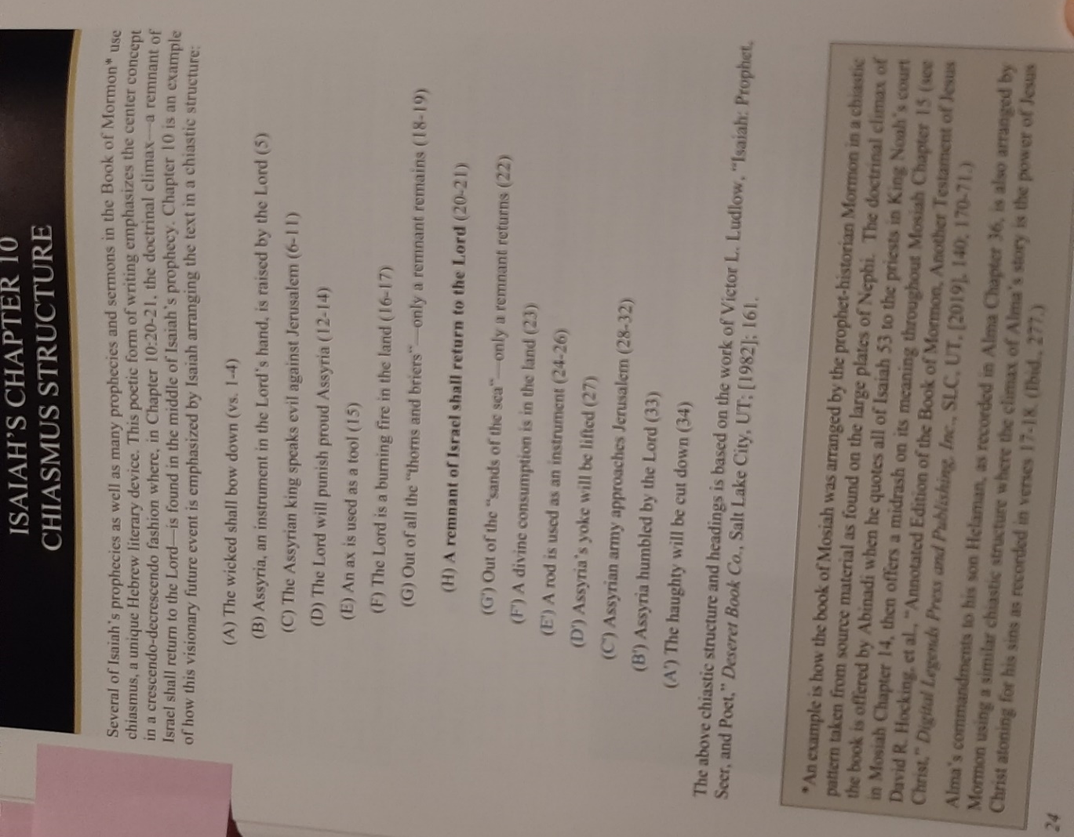

Hocking: Isaiah 11, Stem (Jesus Christ) & Rod/Root (Joseph Smith) of Jesse

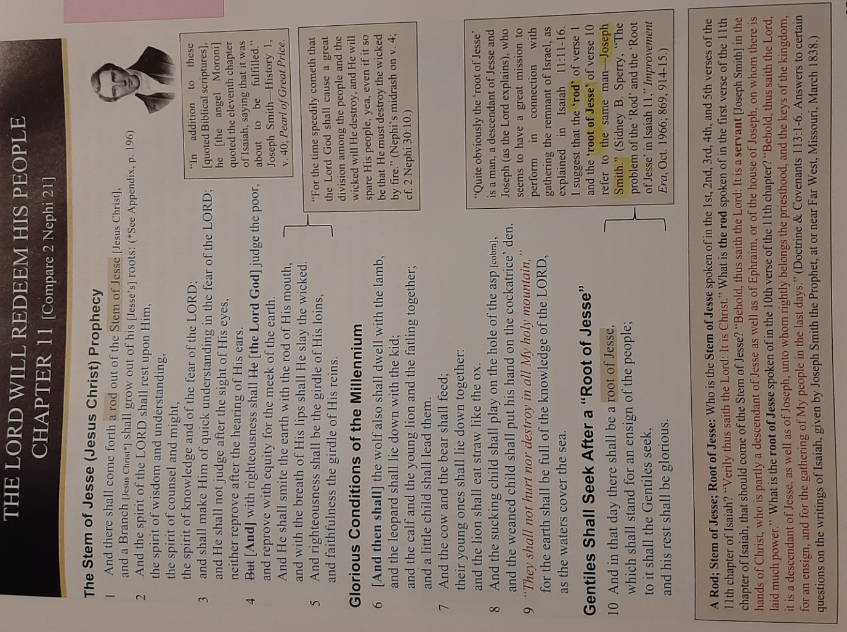

Hocking: Ensign Gather Israel, Book of Mormon Western Indians says Joseph Smith

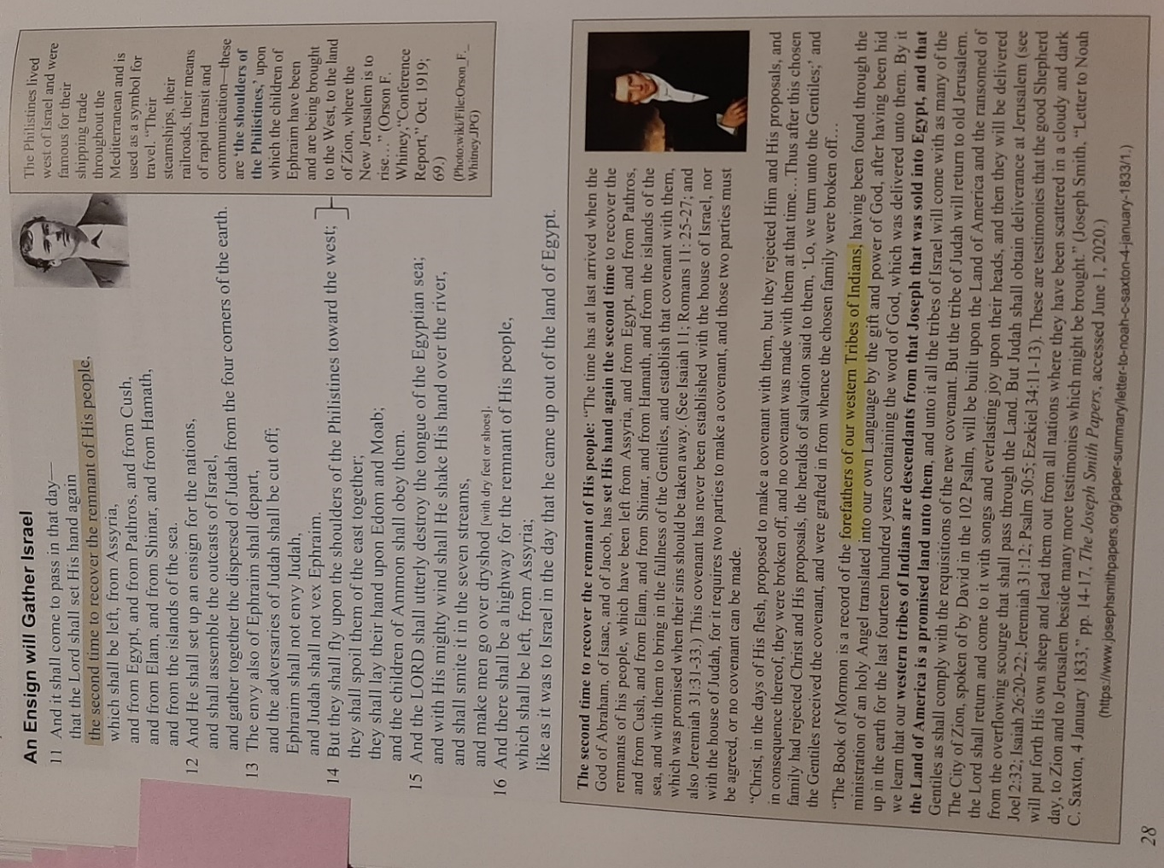

Hocking: 5 Woes to them that Go to Egypt, Divine Protection for Zion & Jerusalem, Nibley on Weakness of Egypt vs God etc.

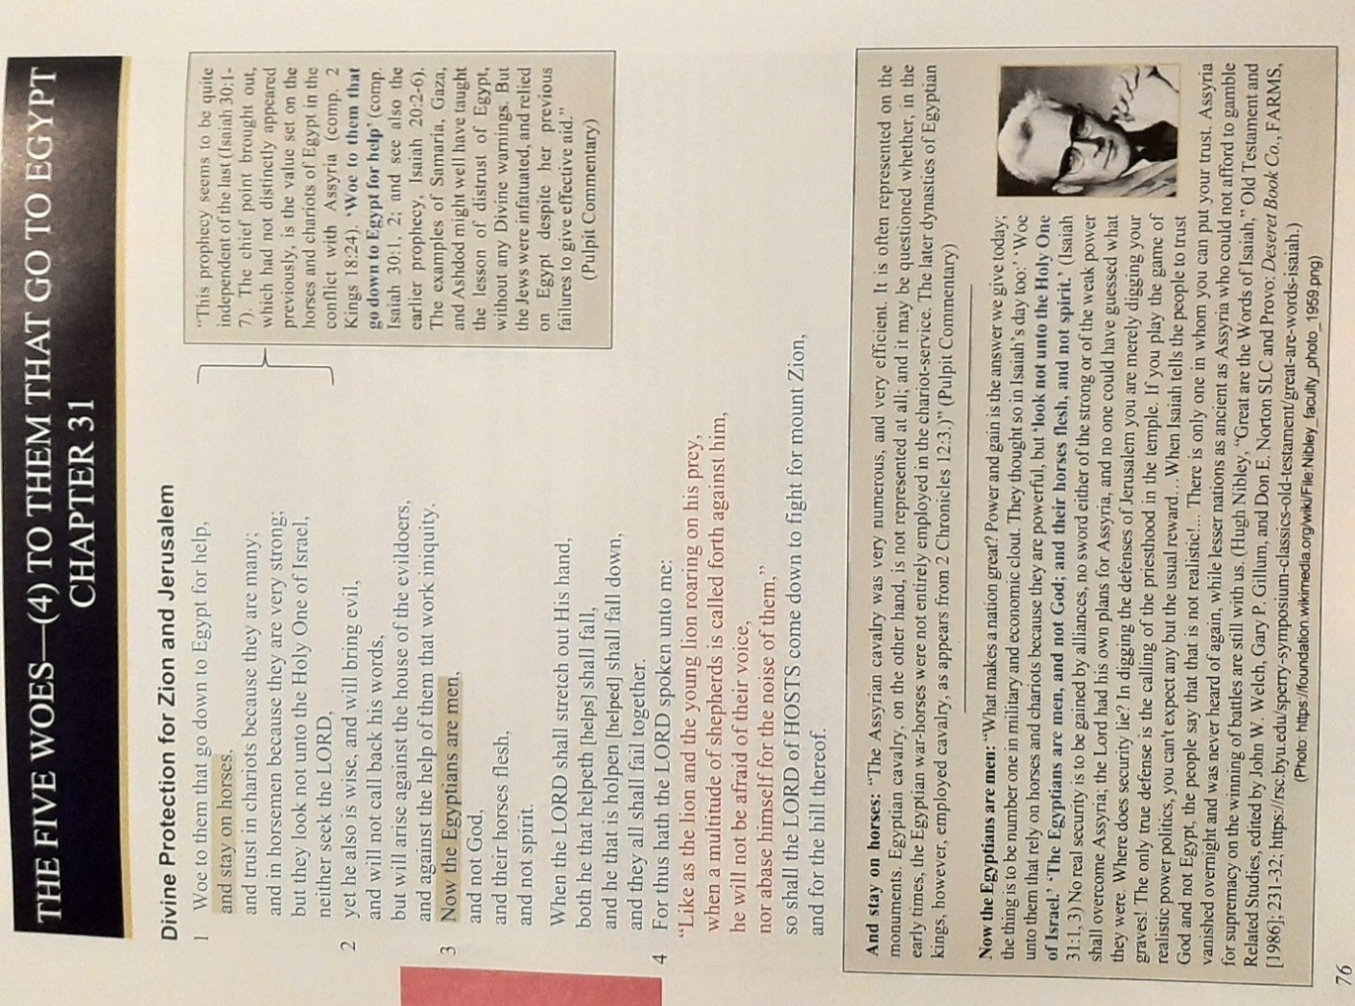

Hocking: “That Her Warfare Is Accomplished”: Conflicts with Arab Nations & Israel (HistoryGuy.com)

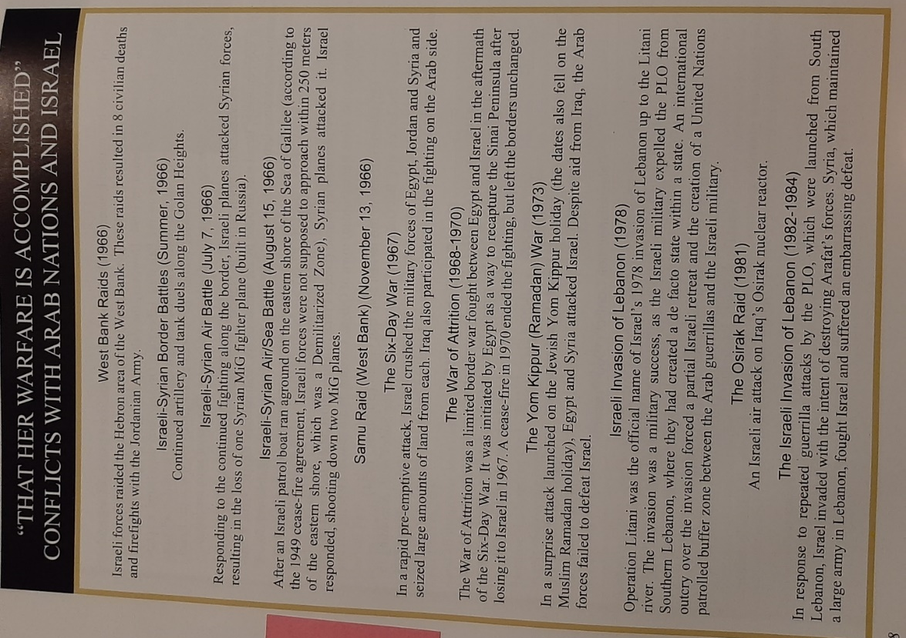

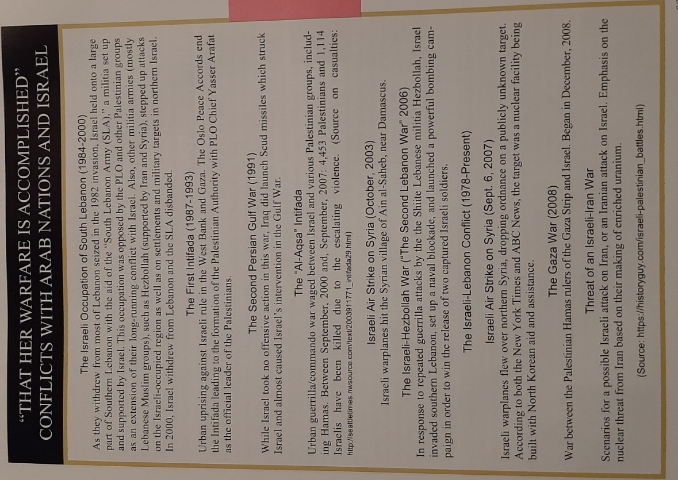

Hocking: Isaiah 49: Song of the Lord’s Latter-Day Servant Joseph Smith: Woodruff Proclaims its Fulfillment

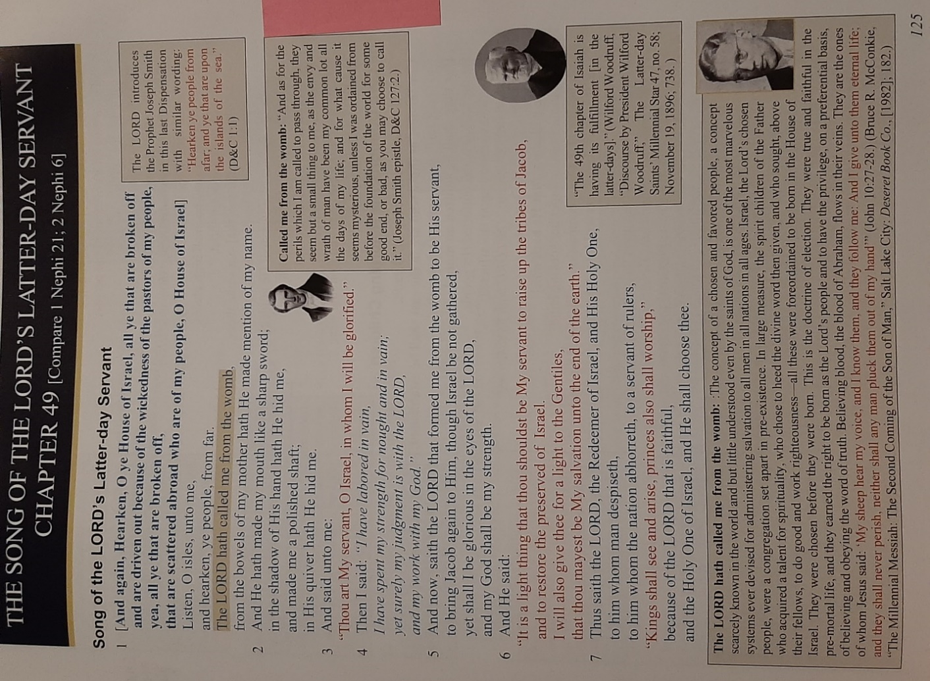

Hocking: Israel’s Prominence in the Last Days, Lord Comforts His Returning Children
Note: The gospel going to them that sit in darkness can refer to the time when the church went global in the 20th century.

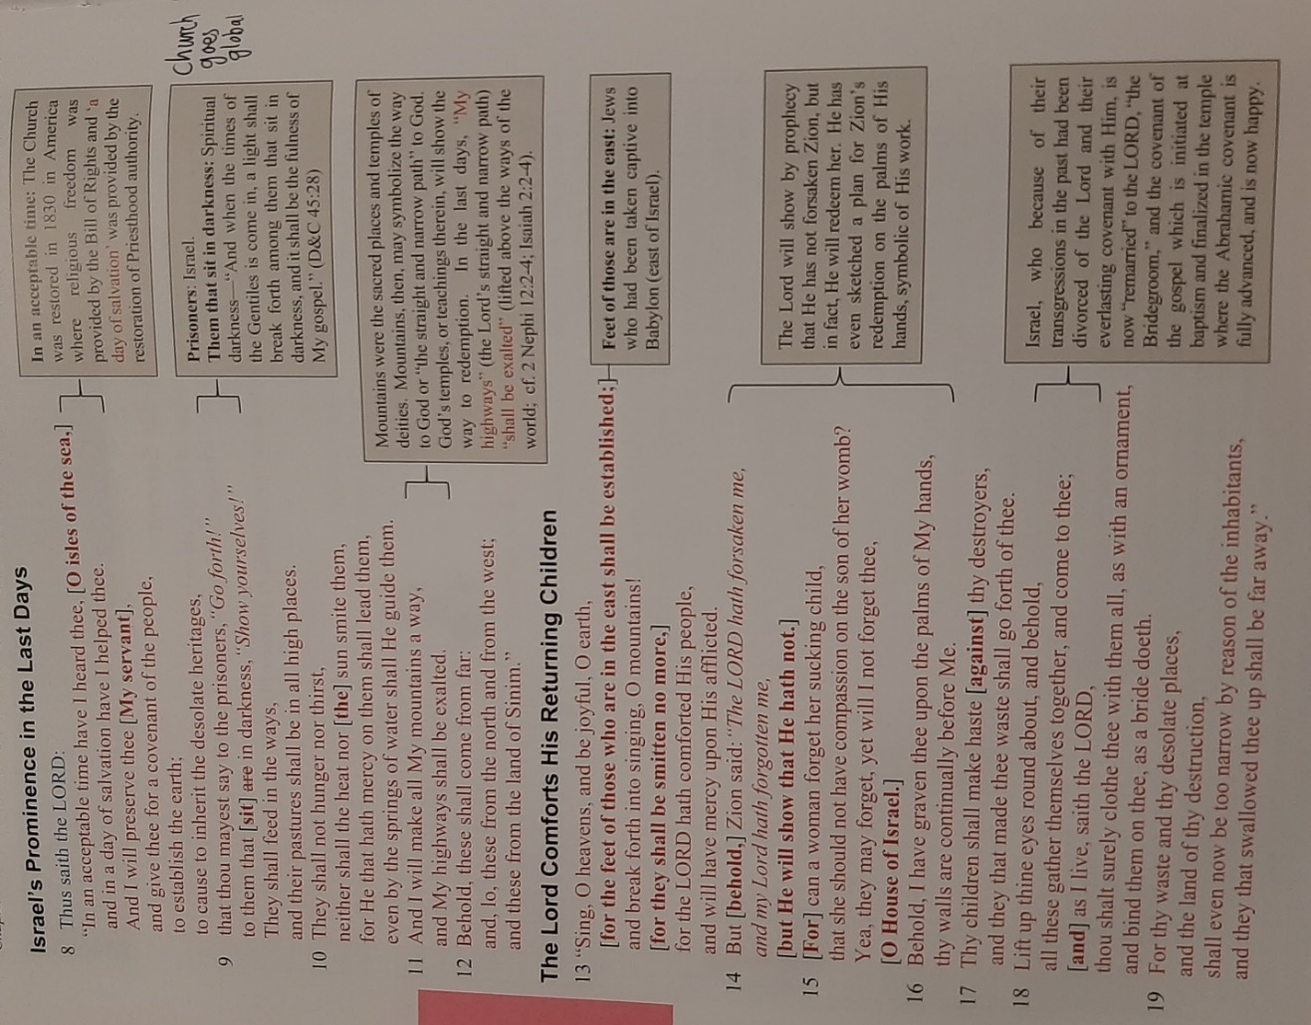

Hocking: Jacob on Isaiah 49: Fulfillment of Promises to Israel

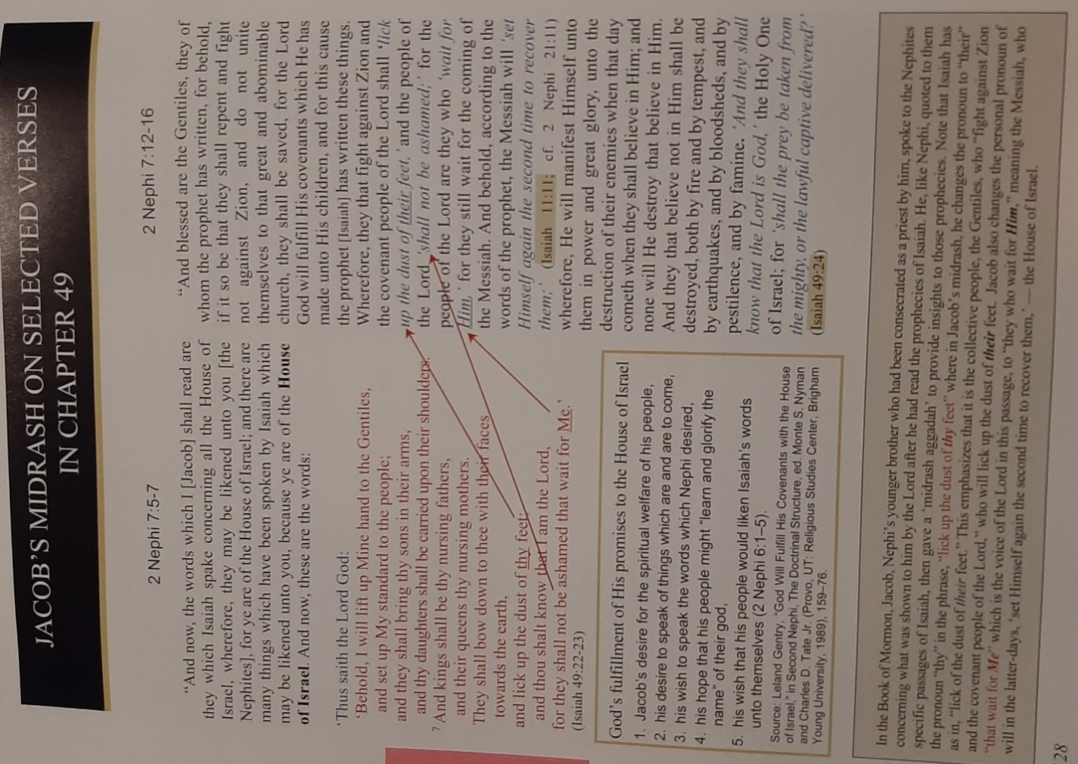

Hocking: Isaiah 53: Suffering & Triumph of Messiah, & New Testament Fulfillment of Isaiah Prophecy
Note: There were prophecies of the Messiah as being persecuted and killed, and other prophecies of the Messiah being a triumphant ruler. Jews didn’t like the prophecies of Messiah being killed, they didn’t see how that was possible. They took those passages out. Isaiah 53 however remains as a faithful witness of Jesus Christ as the Messiah, whose first coming culminated in his death and resurrection, and whose second coming will bring in the political triumph of Israel. Both of the prophecies were true. There are several prophets referenced in the Book of Mormon which have since been removed from the bible, those would have referred to Christ’s first coming which the scribes didn’t like.

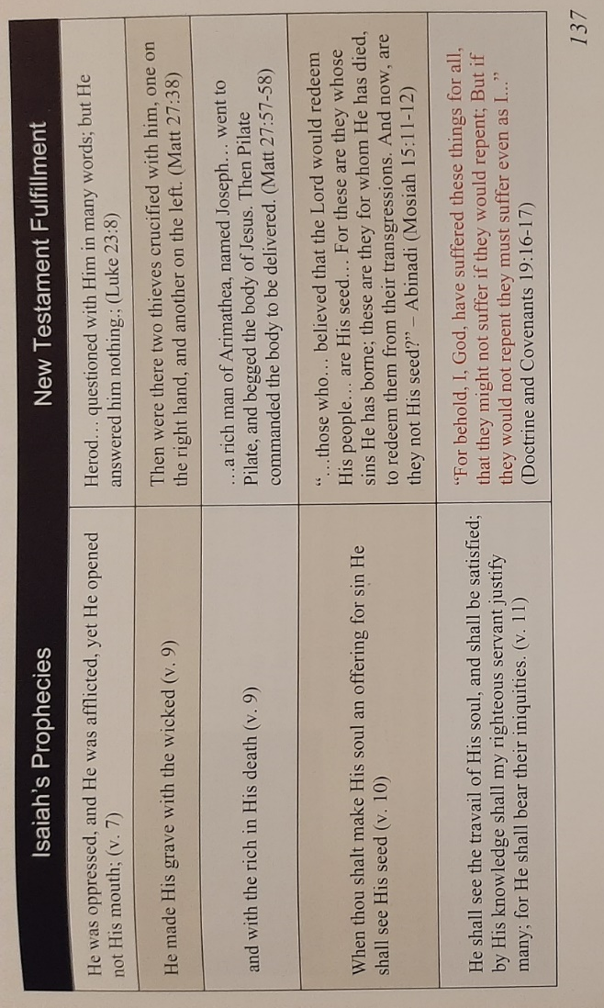
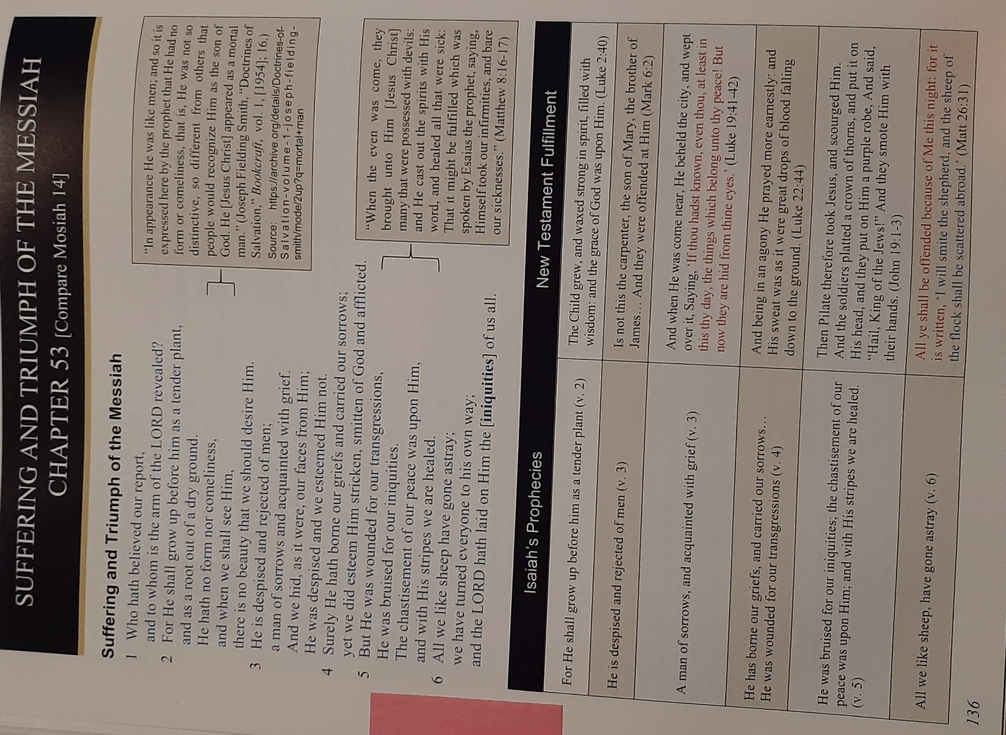

Hocking: Abinadi on Isaiah 53

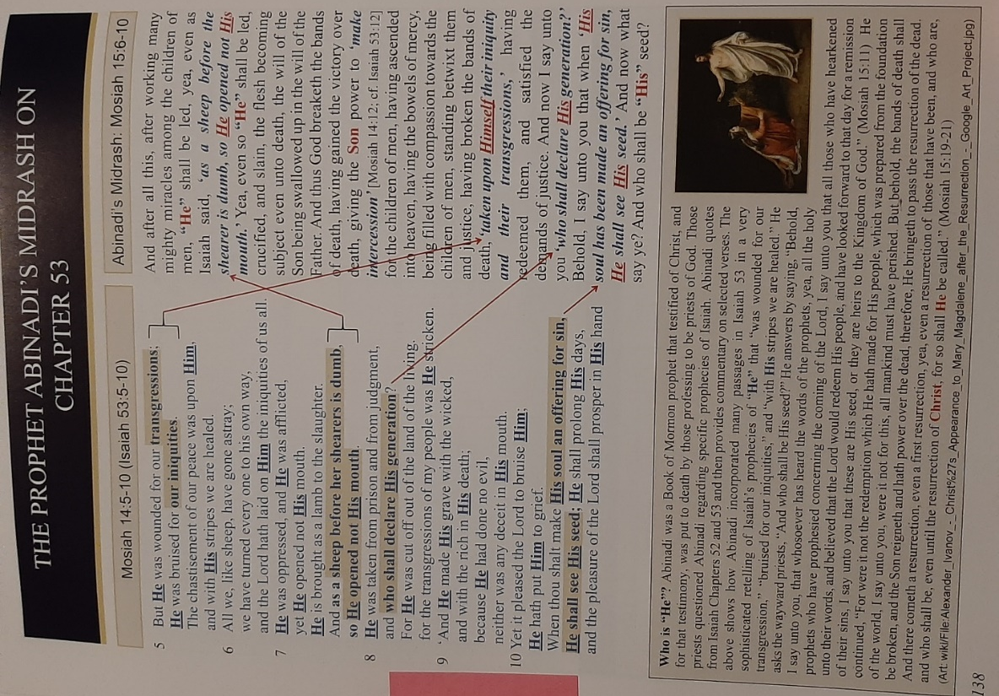

Hocking: Isaiah 54: Zion Shall be Established & God’s Covenant Protection

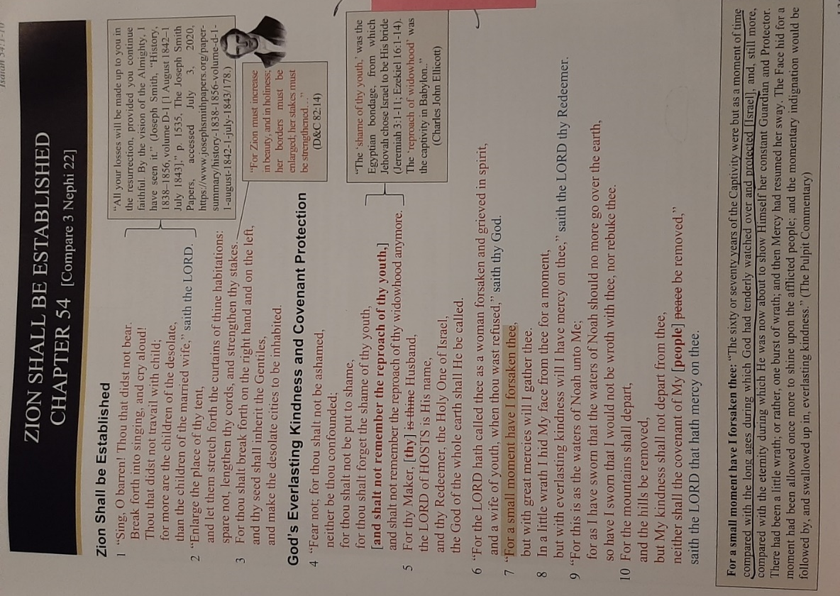

Hocking: Glory of New Jerusalem, & Joseph Smith is “the smith that bloweth the coals in the fire”

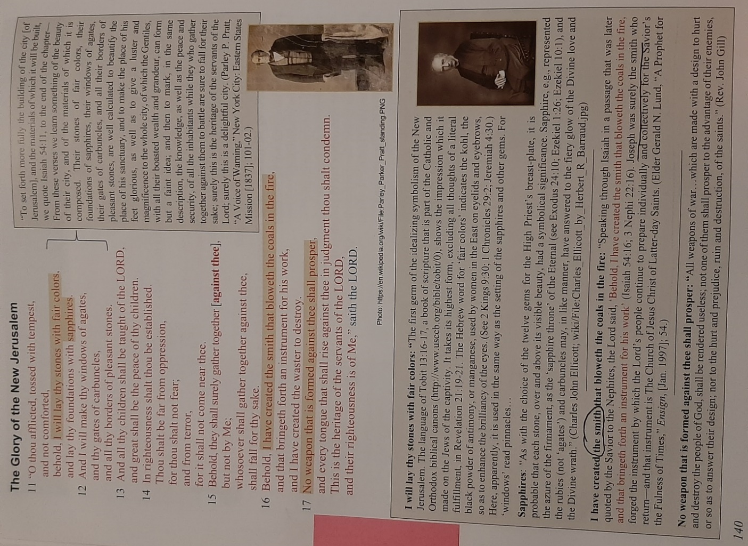

Hocking: No Weapon Formed Against Thee Prosper: Modern Israel Miracles

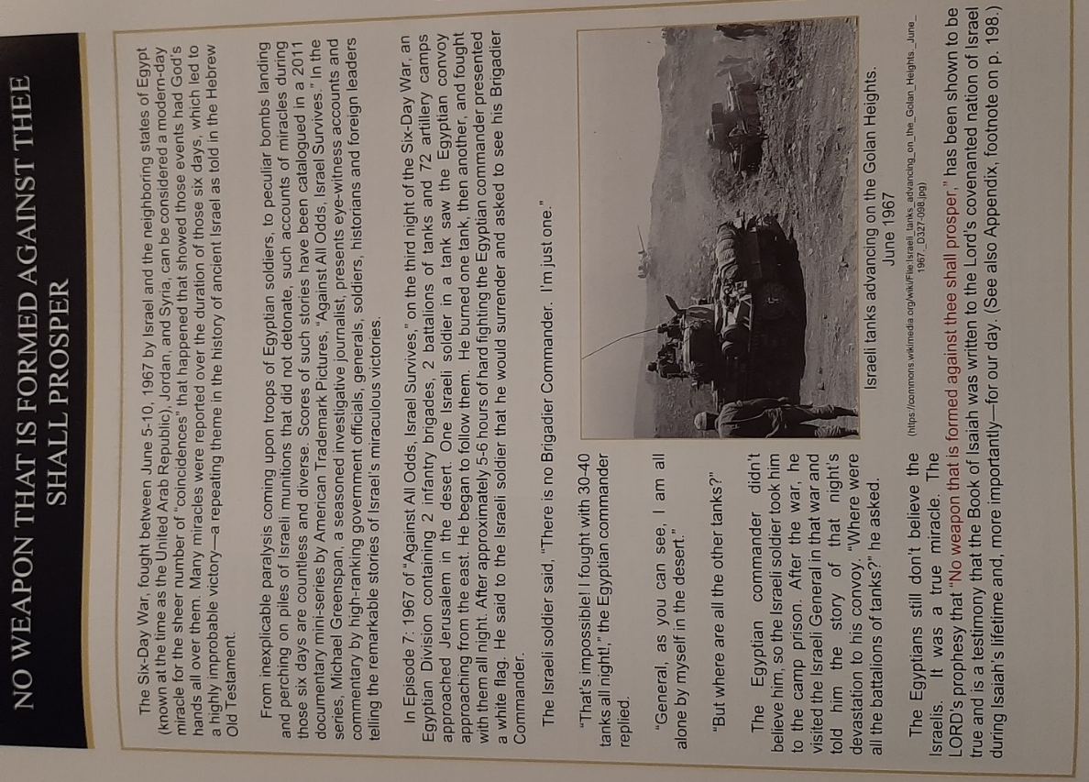

Hocking: Gentiles Welcomed to the Covenant

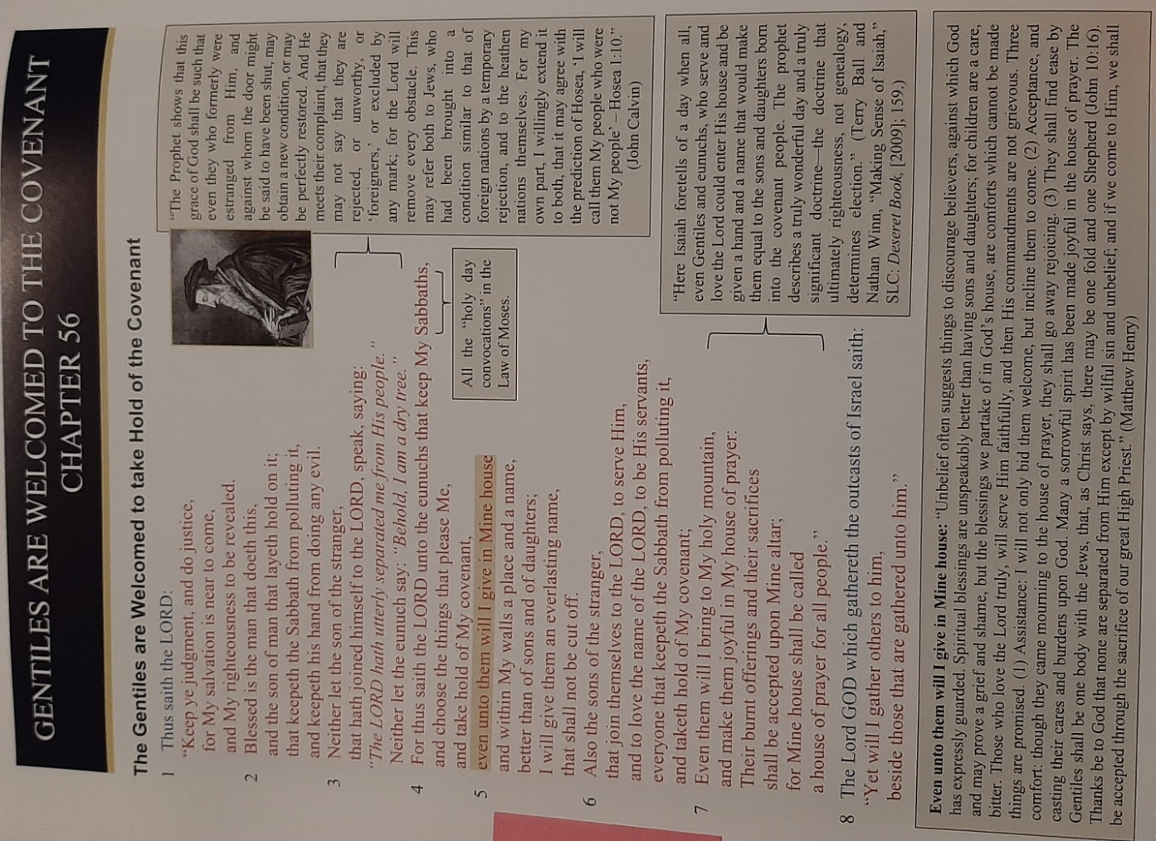

Hocking: Blessings for Who Trust the Lord

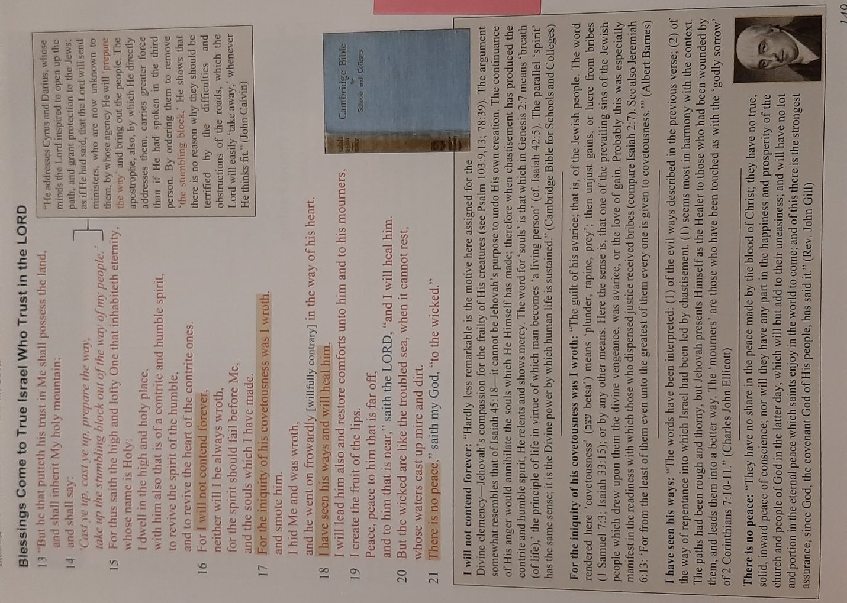

Hocking: Millennial Themes (Bryan Richards)

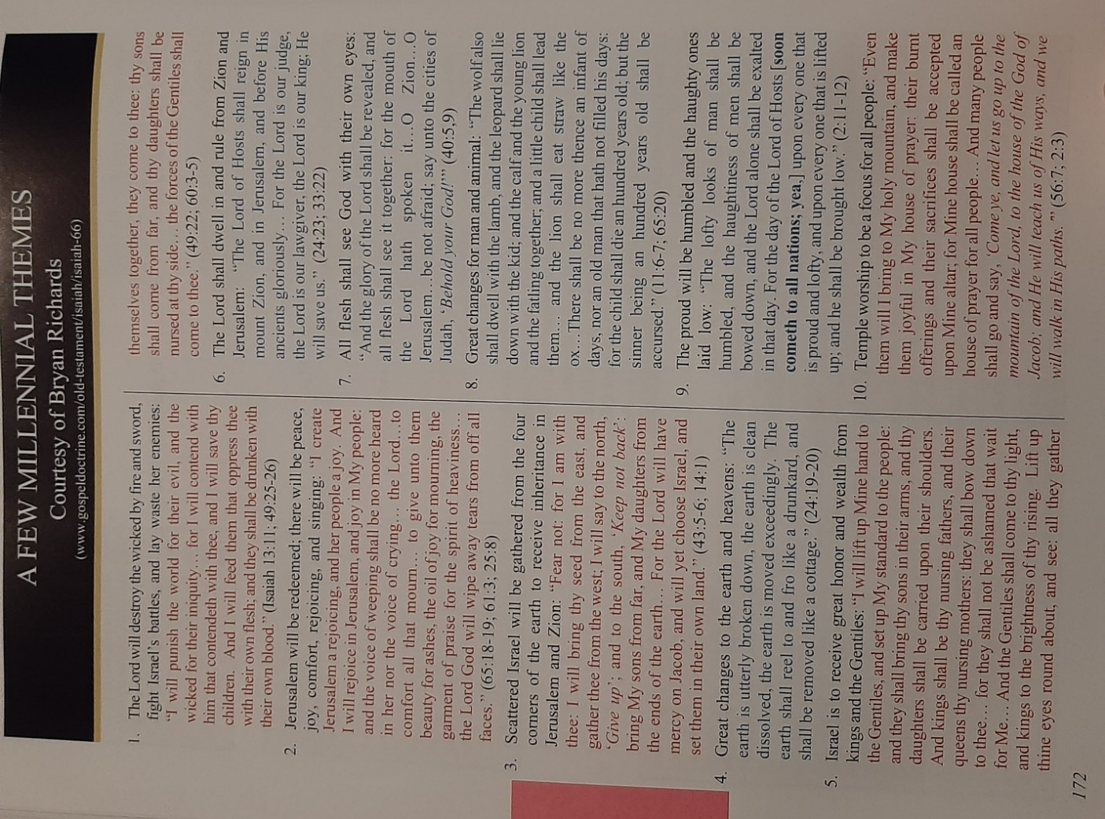

Hocking: Key Events to Interpreting Isaiah (Bruce R. McConkie)

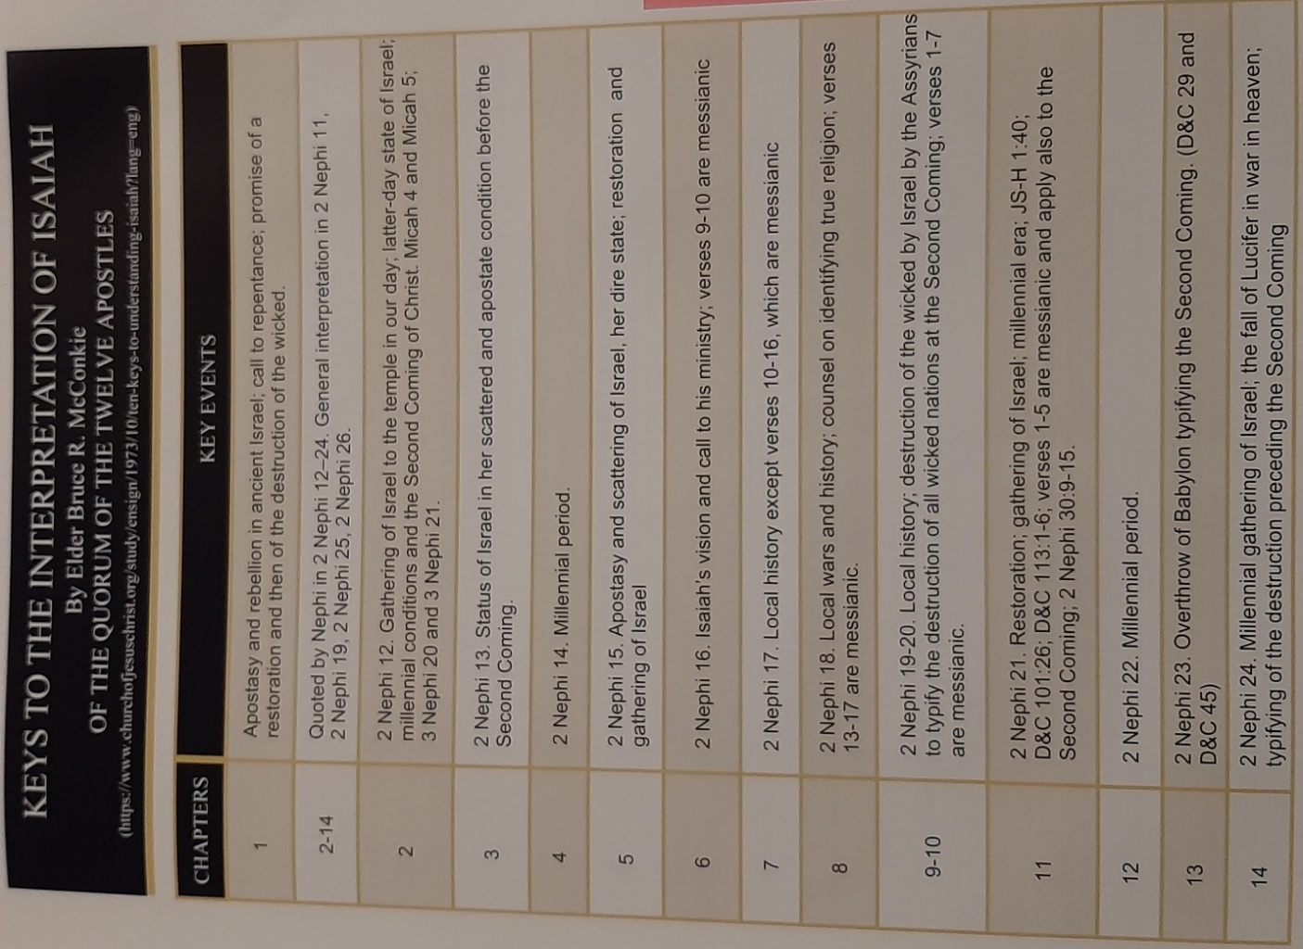
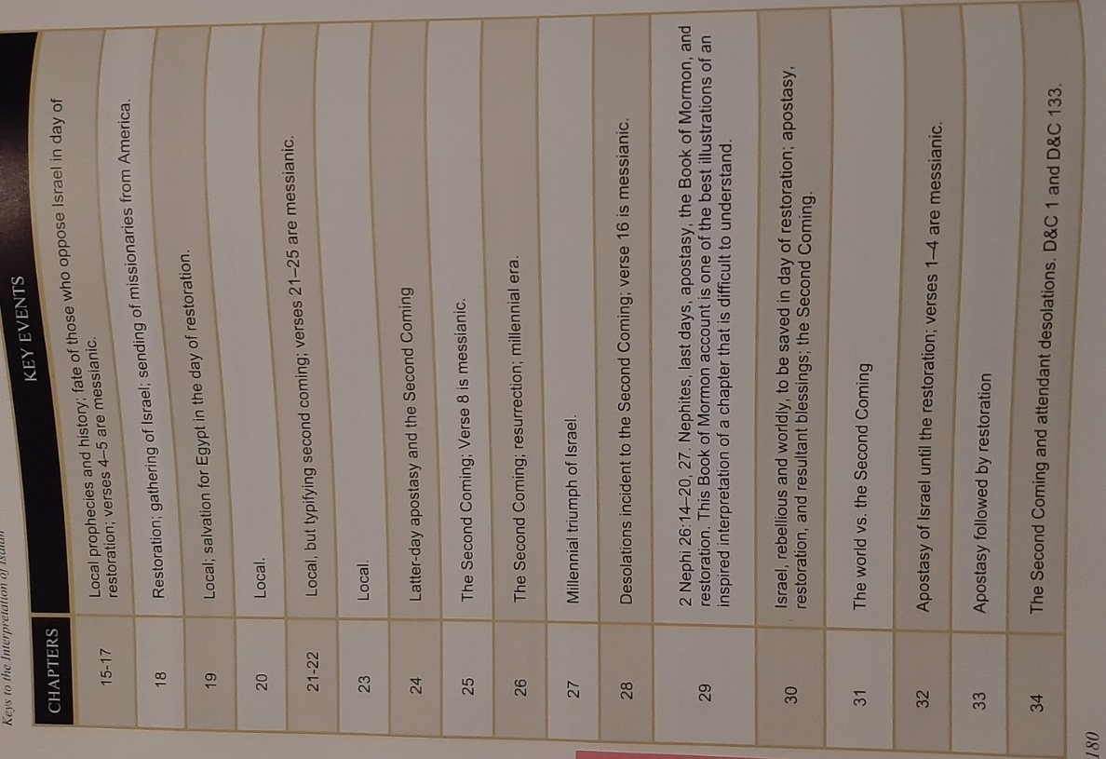

`
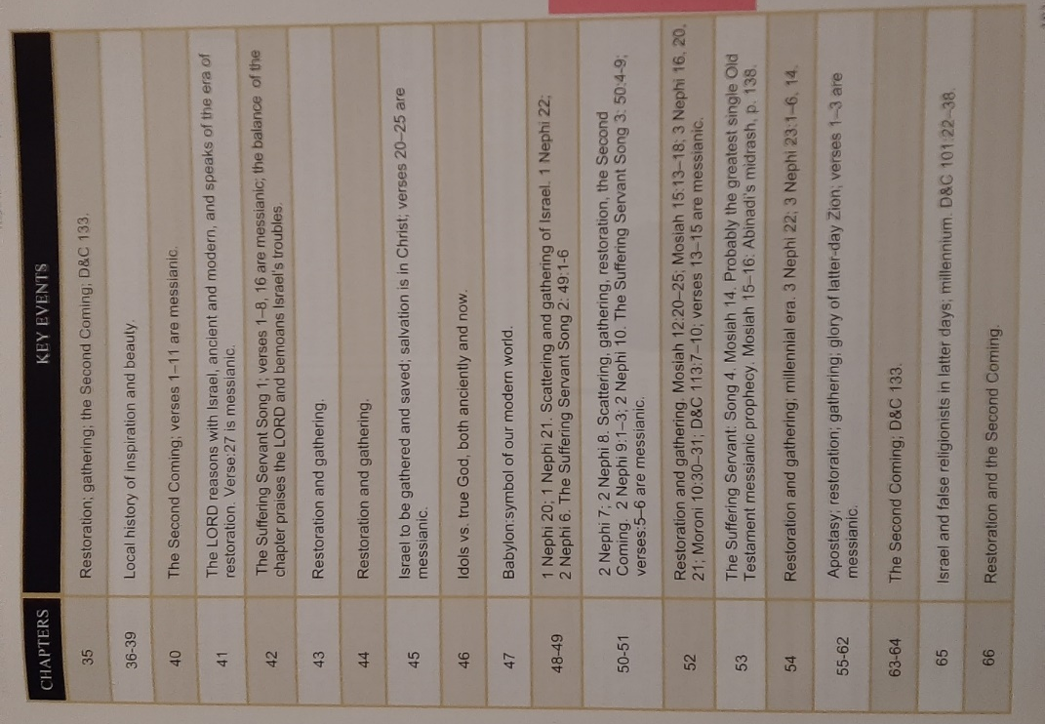

Hocking: Reigns of Kings of Judah

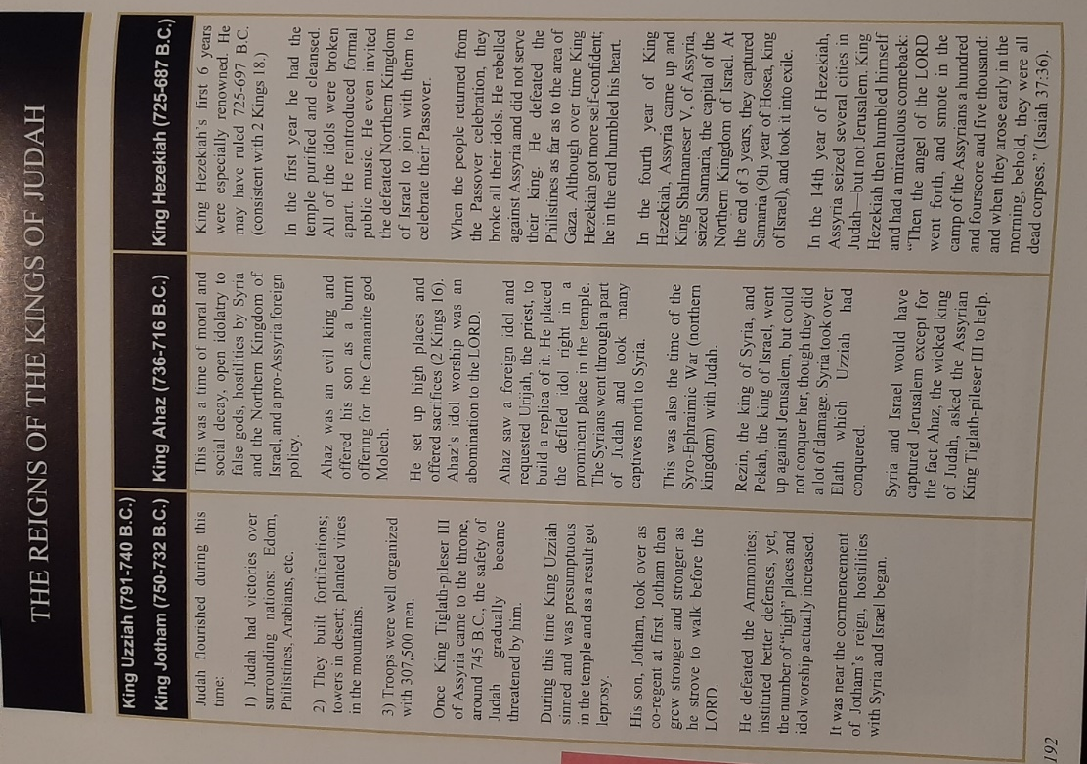

Hocking: Israel Political Struggles with Neighboring Nations
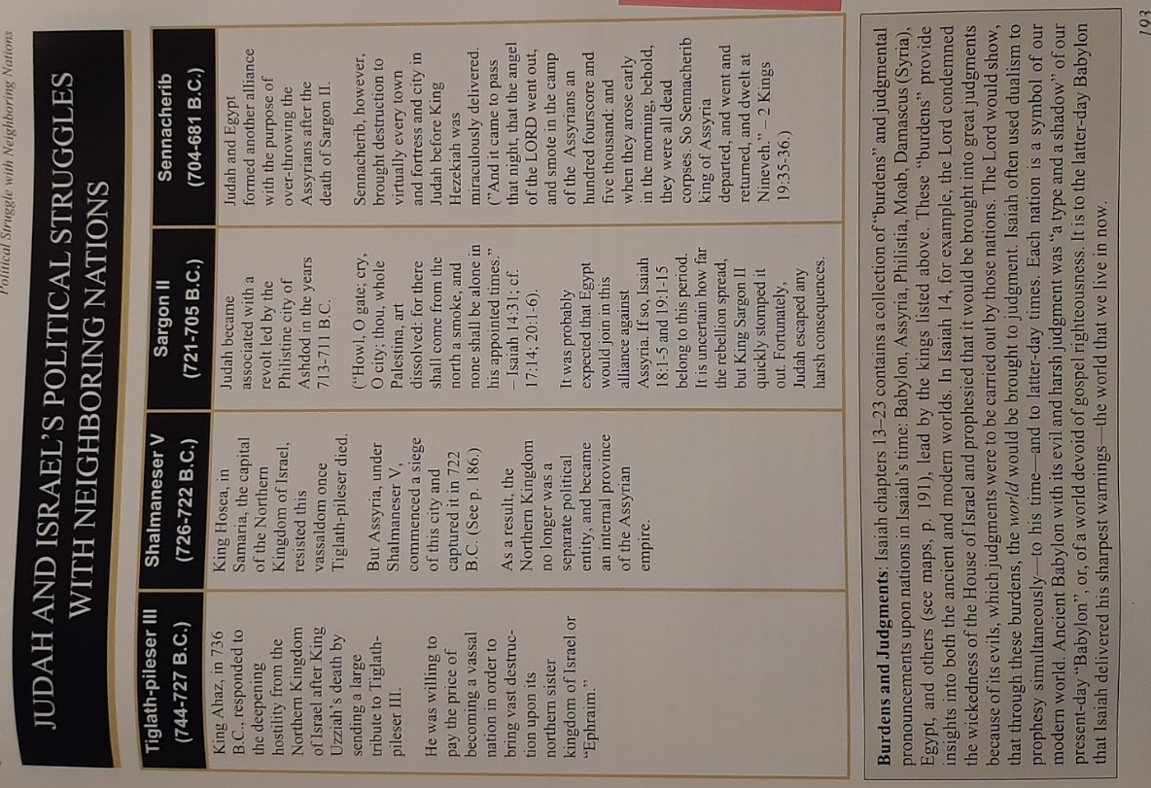

Hocking: Isaiah’s Literary Elements

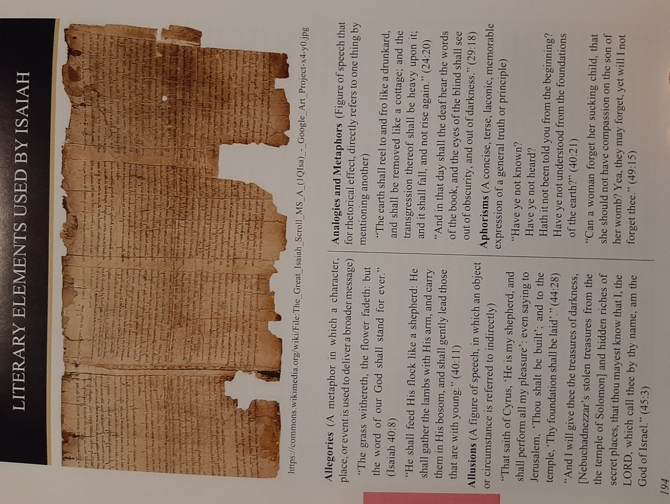

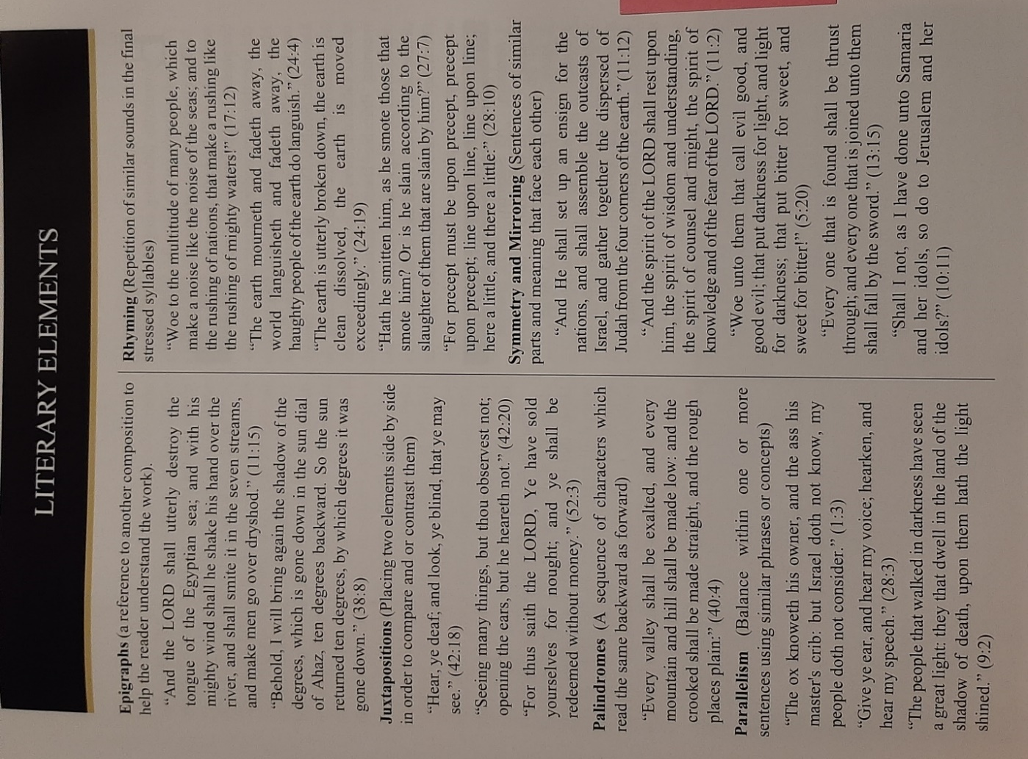

Hocking: Isa. 11:1 Branch Grow Out of His Roots: Genealogy of Christ, Analysis from McConkie, etc.

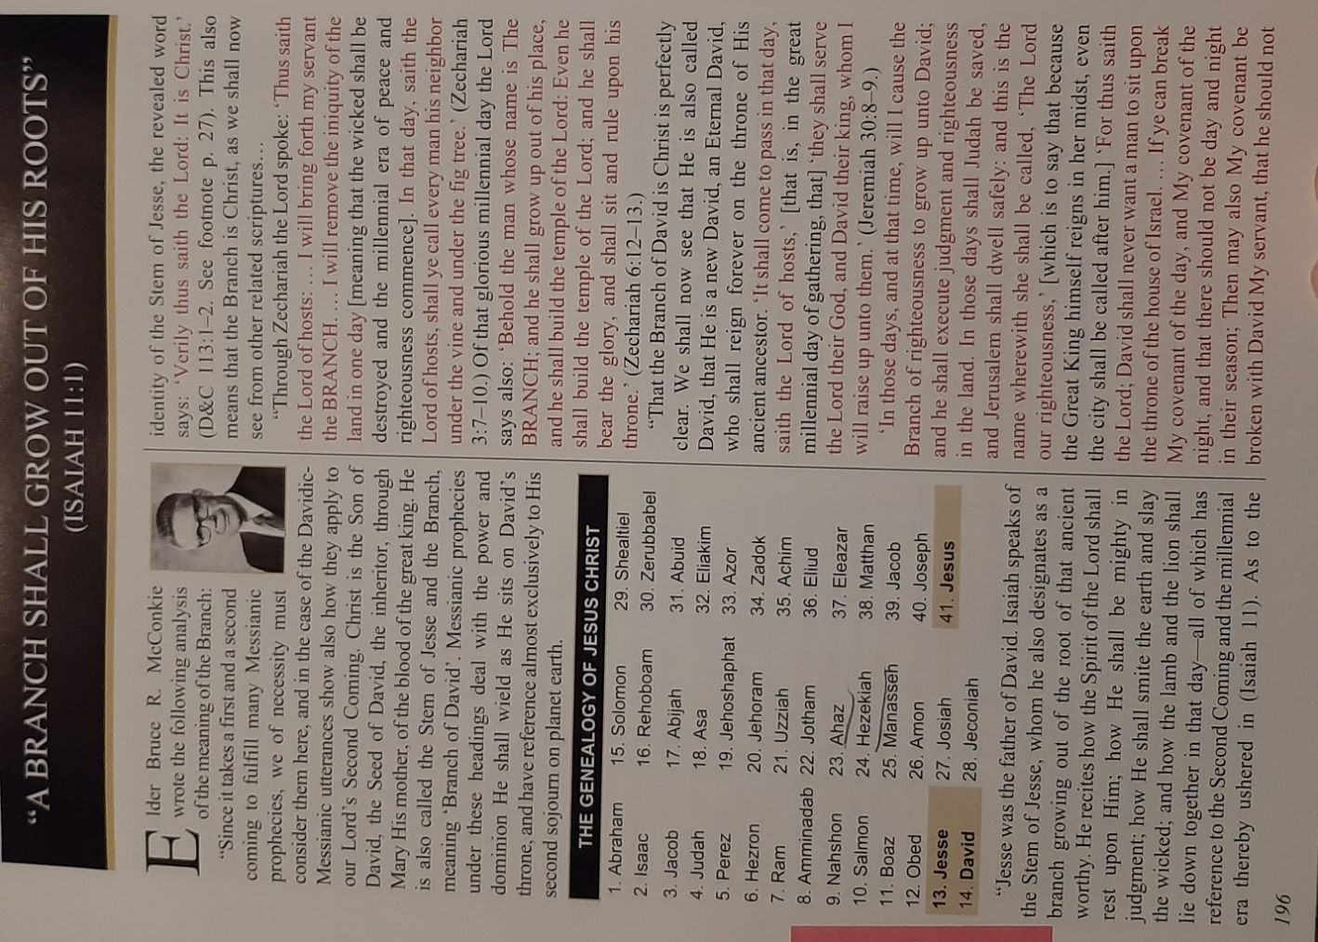

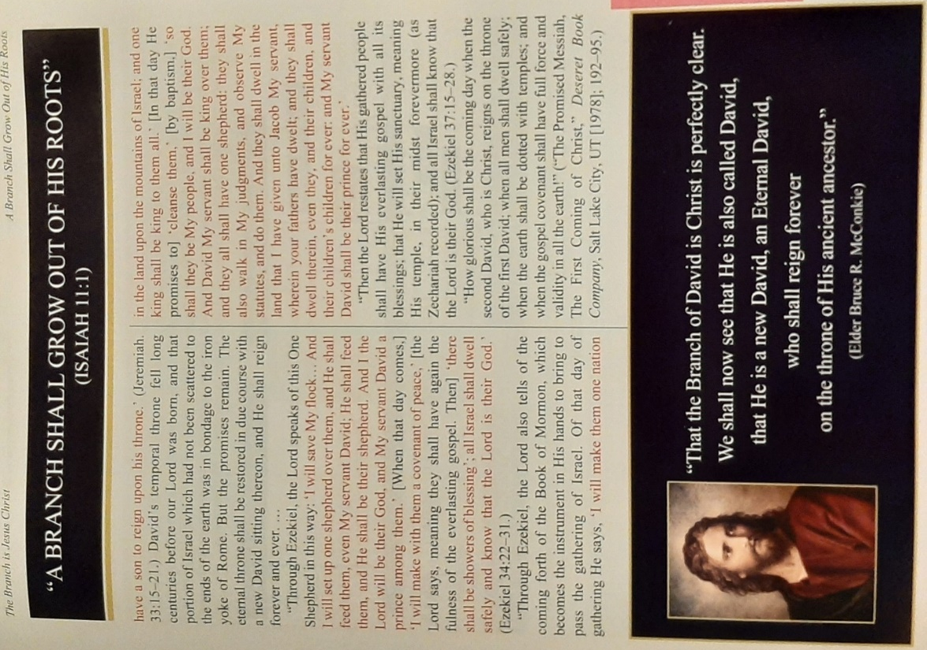

Hocking: House of Israel Timeline

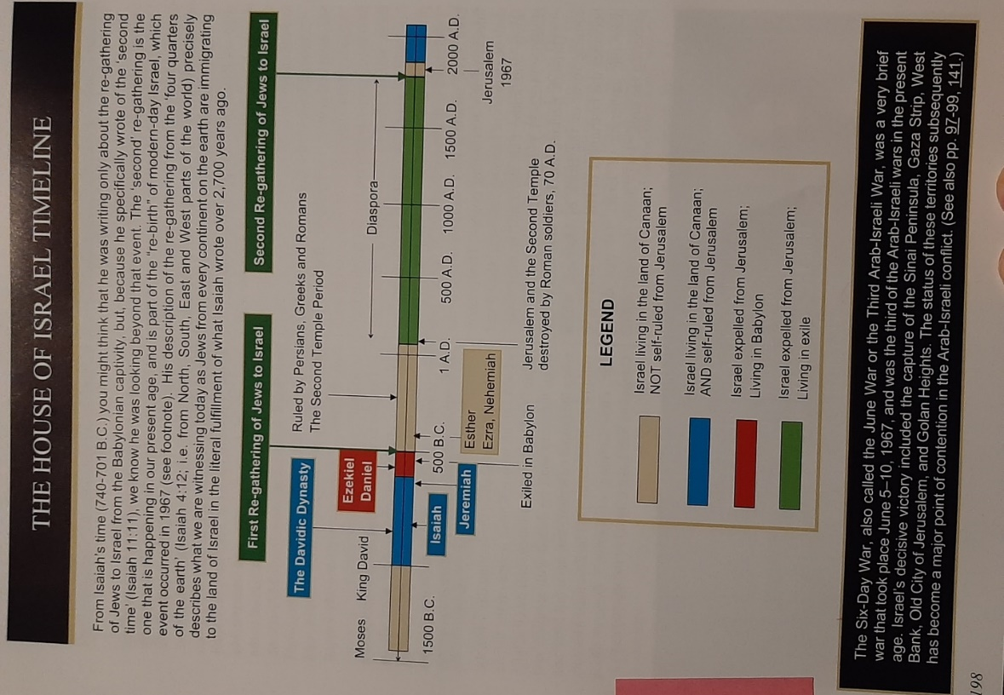

Hocking: Isaiah Division: 1-39 Jehovah’s Judgement/Character, 40-66 Jehovah’s Comfort/Redemption

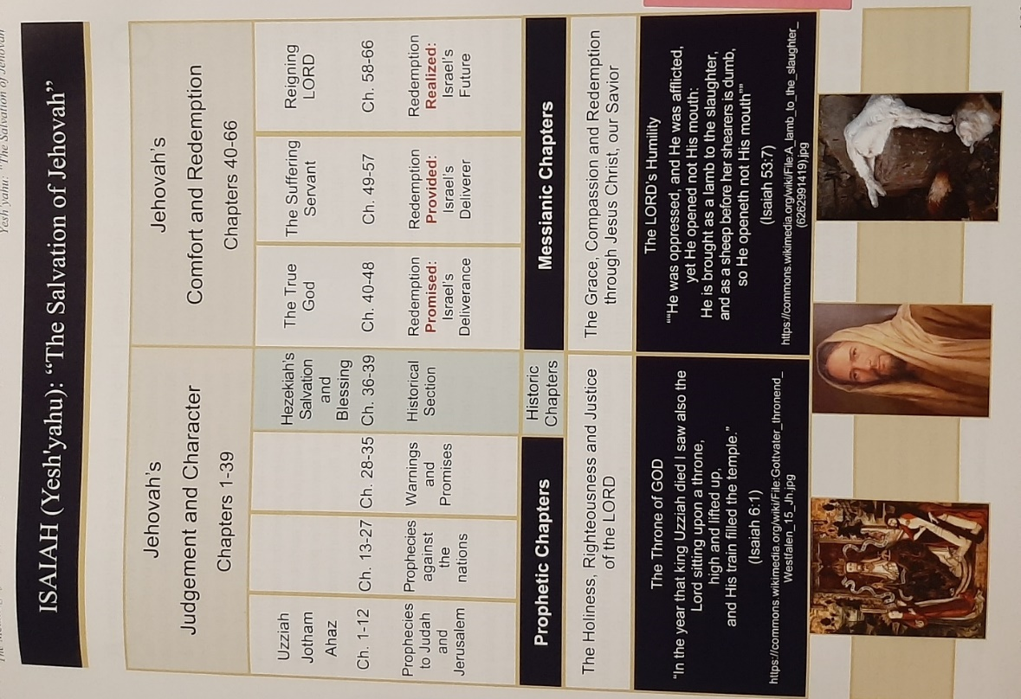

Hocking: Mount Moriah & Sinai: Unconditional & Conditional Covenants: The 4 P’s: Promised Land, Posterity, Prosperity, Protection/Security
Note that these may be being revoked from the US each shmita (7 year) period:
2001: Protection/Security: 9/11 Terrorism on US Soil
2008: Prosperity: Large market crash
2015: Posterity: Homosexual marriage legalized in US
2022: Promised land: will be we swept from the land? Will the prophesied 2nd US civil war begin?

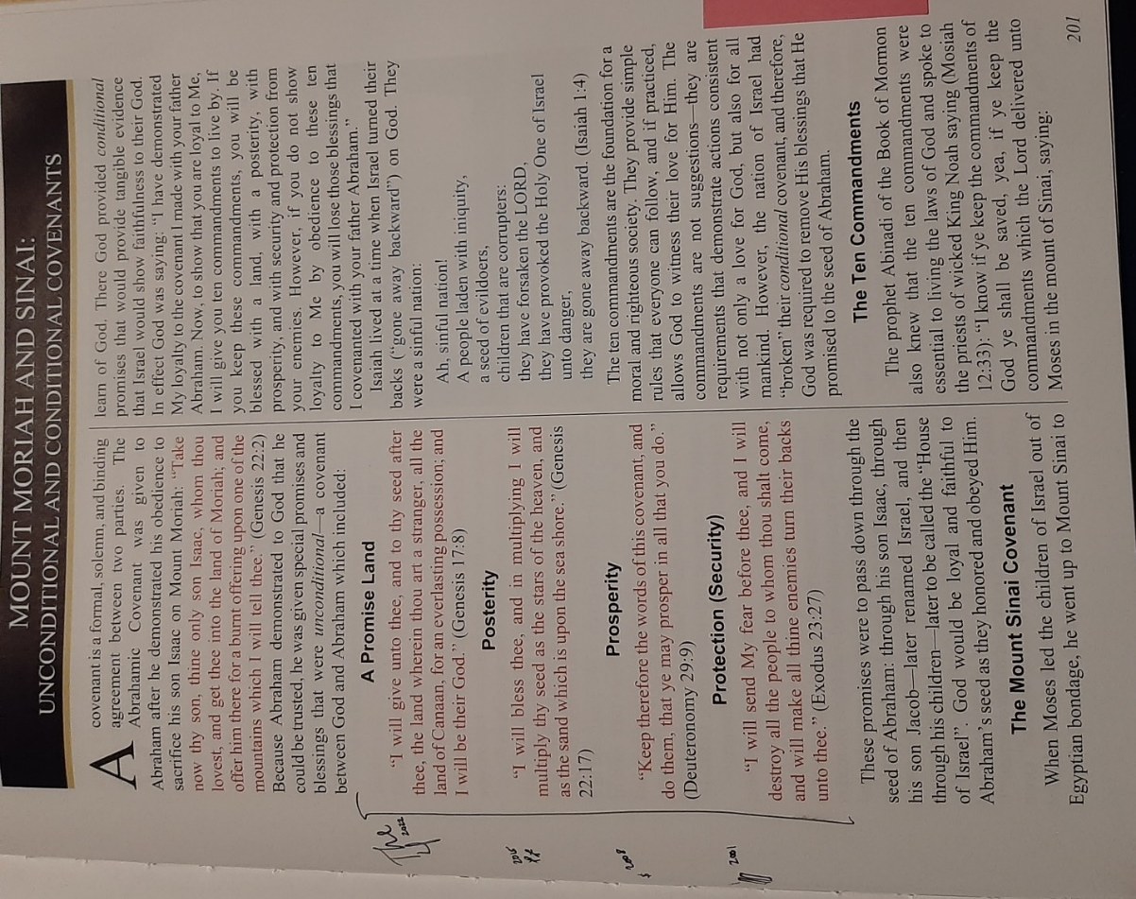

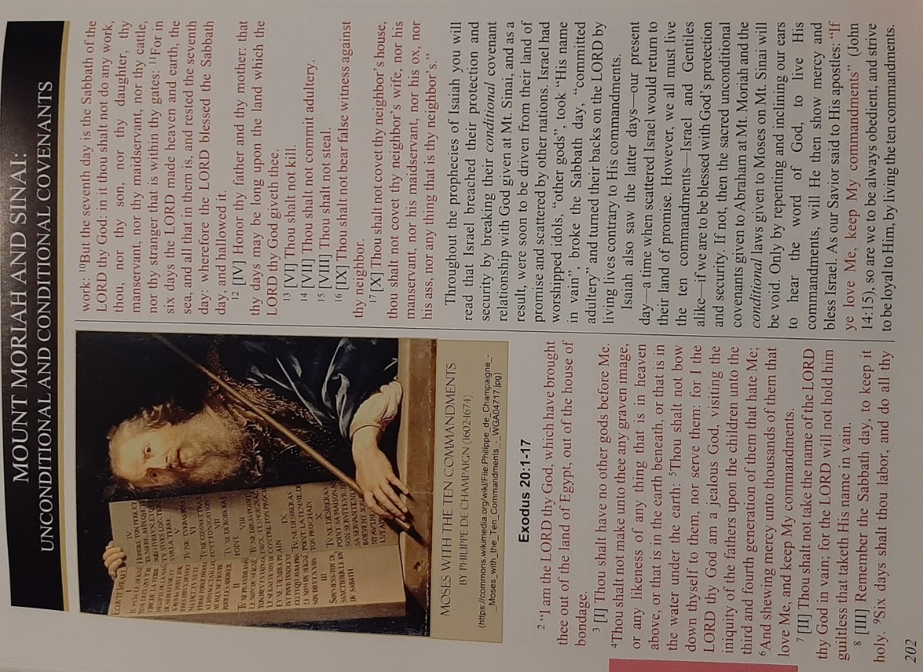

PART 3: JASHER ANNOTATED BY DAVID HOCKING - HIGHLIGHTS

Shared with Permission of the Author
Please visit www.beaconlightbooks.com for more information.
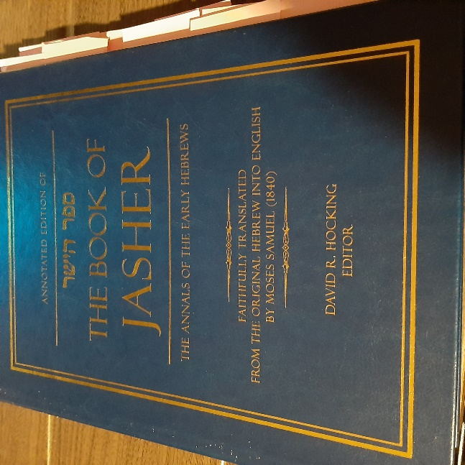

Hocking: Jasher Annotations Full Contents & Appendixes
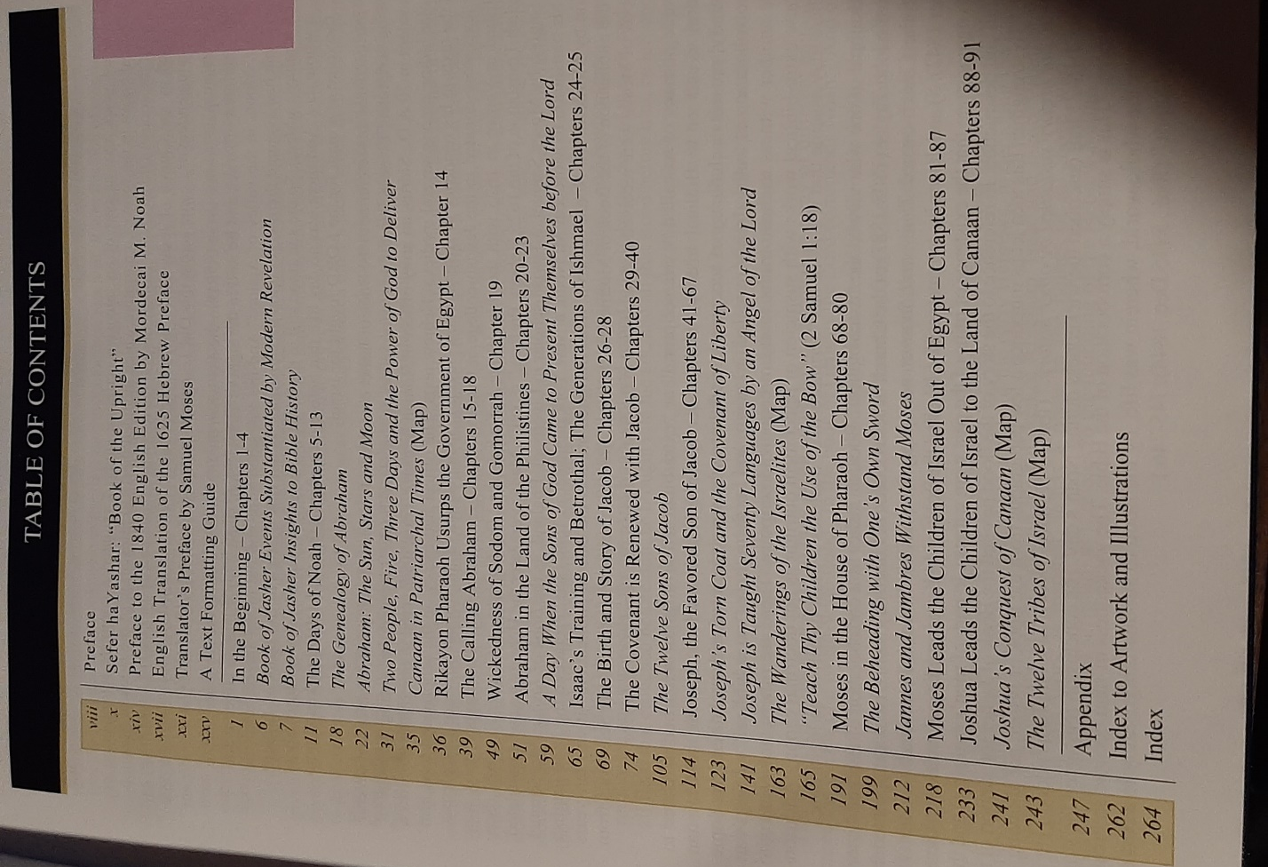

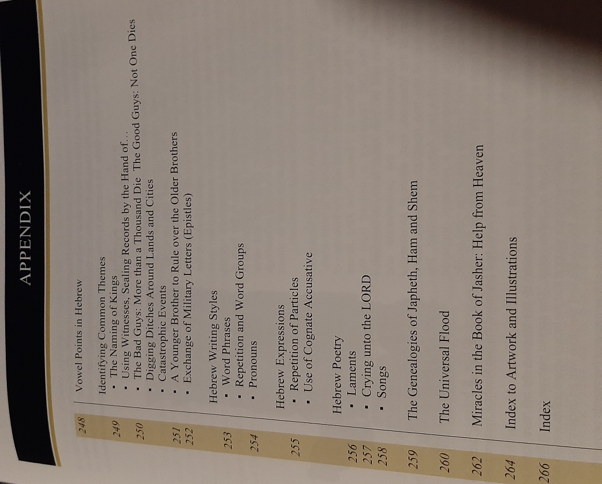

Hocking: Book of Jasher Referred to in the Bible

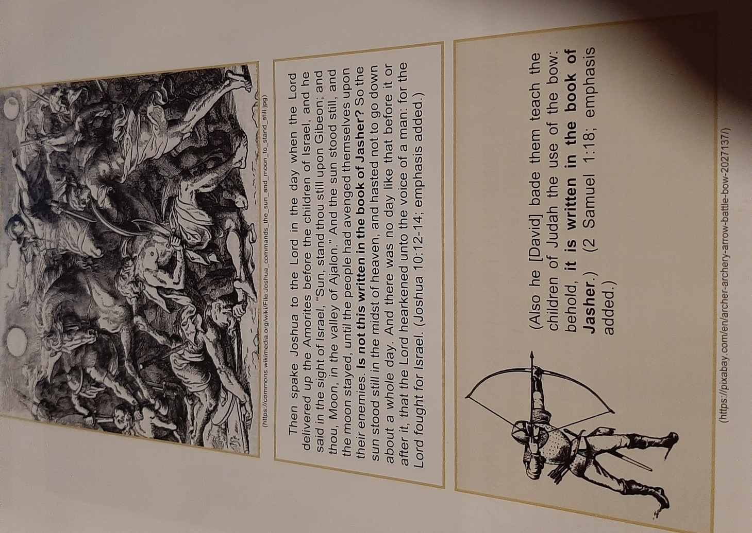

Hocking: Book of Jasher Gives Insights to Bible History

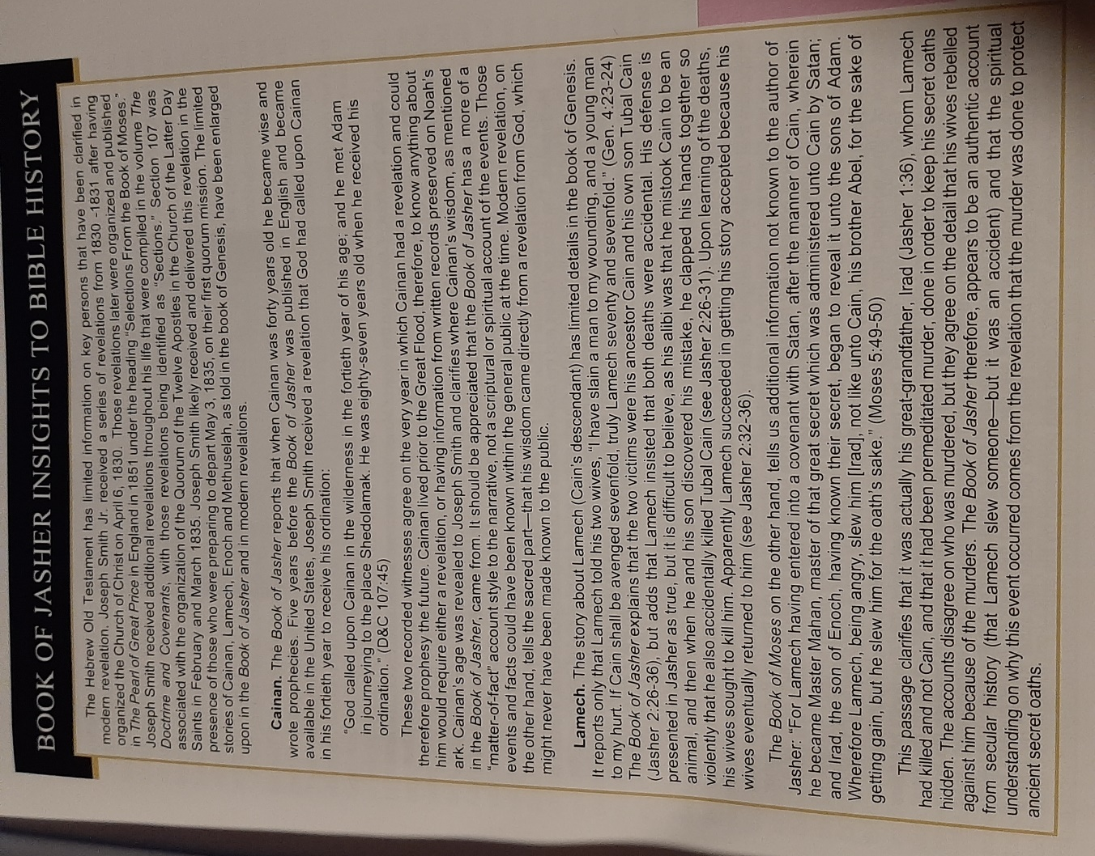

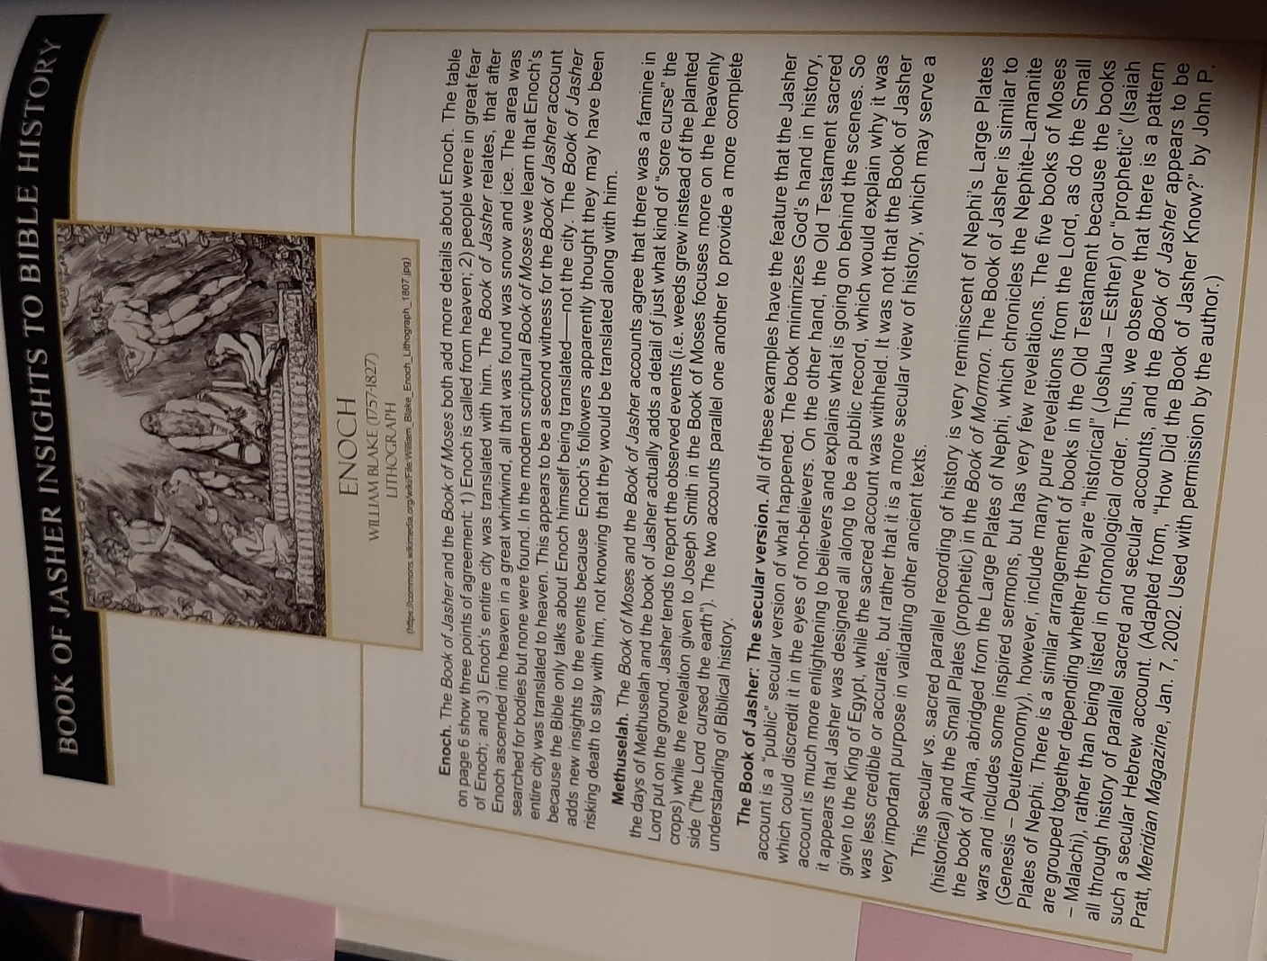

Hocking: The Flood was in the Spring: Jasher & Other Evidence

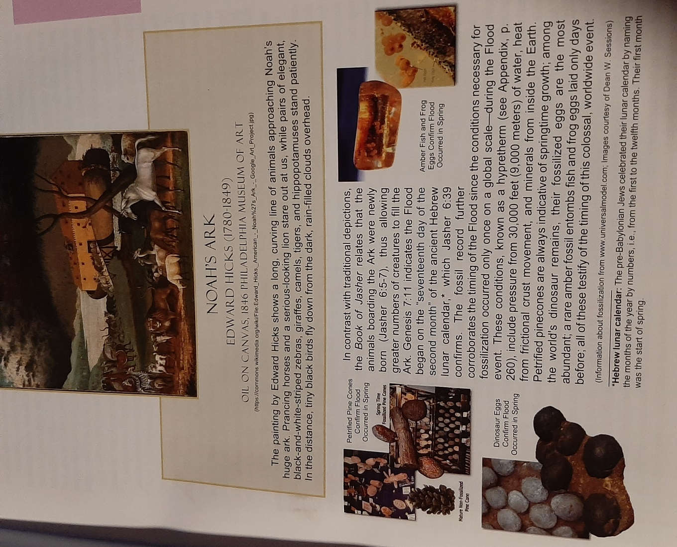

Hocking: Genealogy of Noah to Abraham to Israel: Added Detail Such as Abraham’s 8 Children

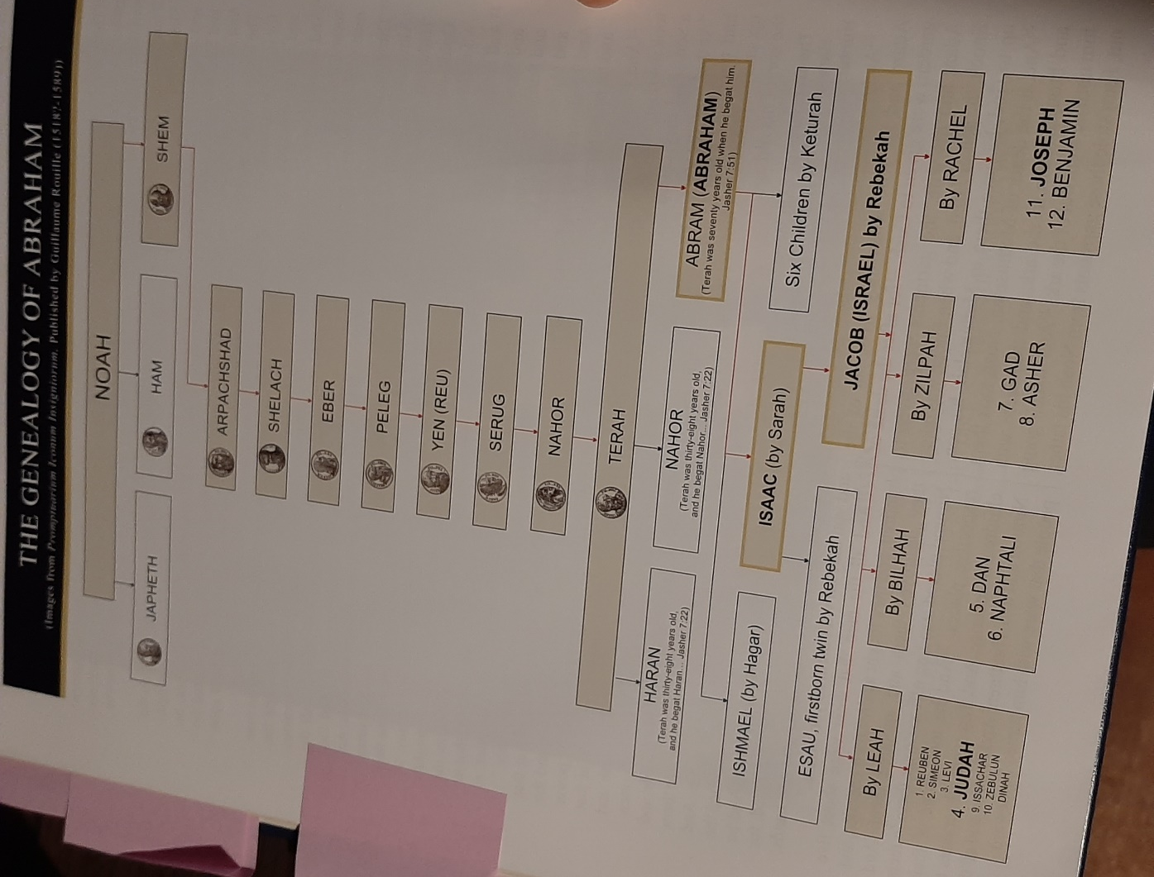

Hocking: 2 People, 3 Days, Power of God to Deliver: Jasher & Alma Side-By-Side

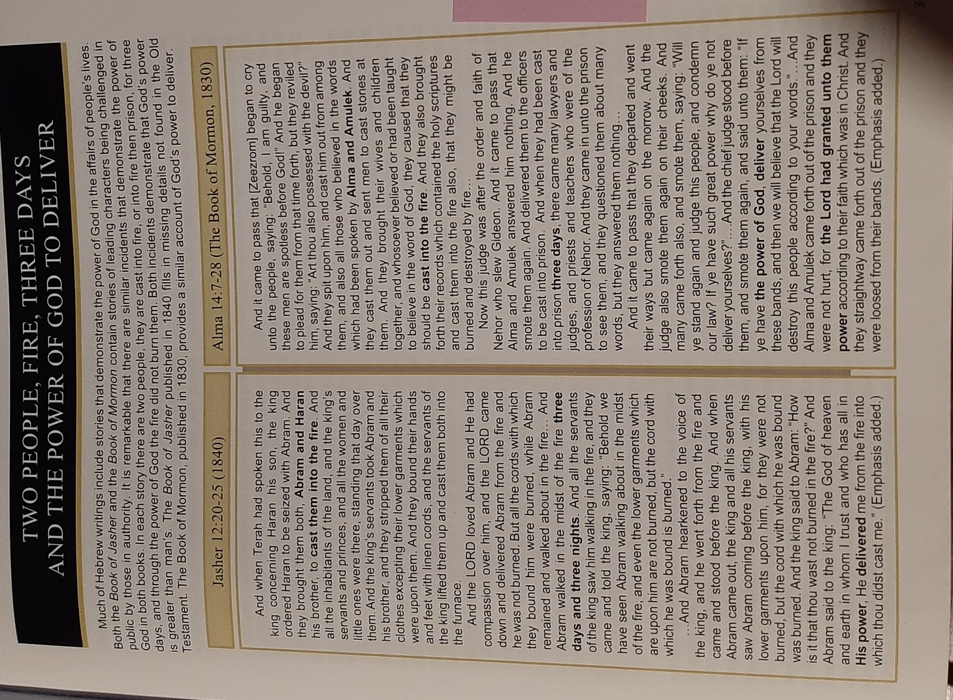

Hocking: Melchizedek = Shem
Note: I believe there’s a statement from Joseph Smith on this too.
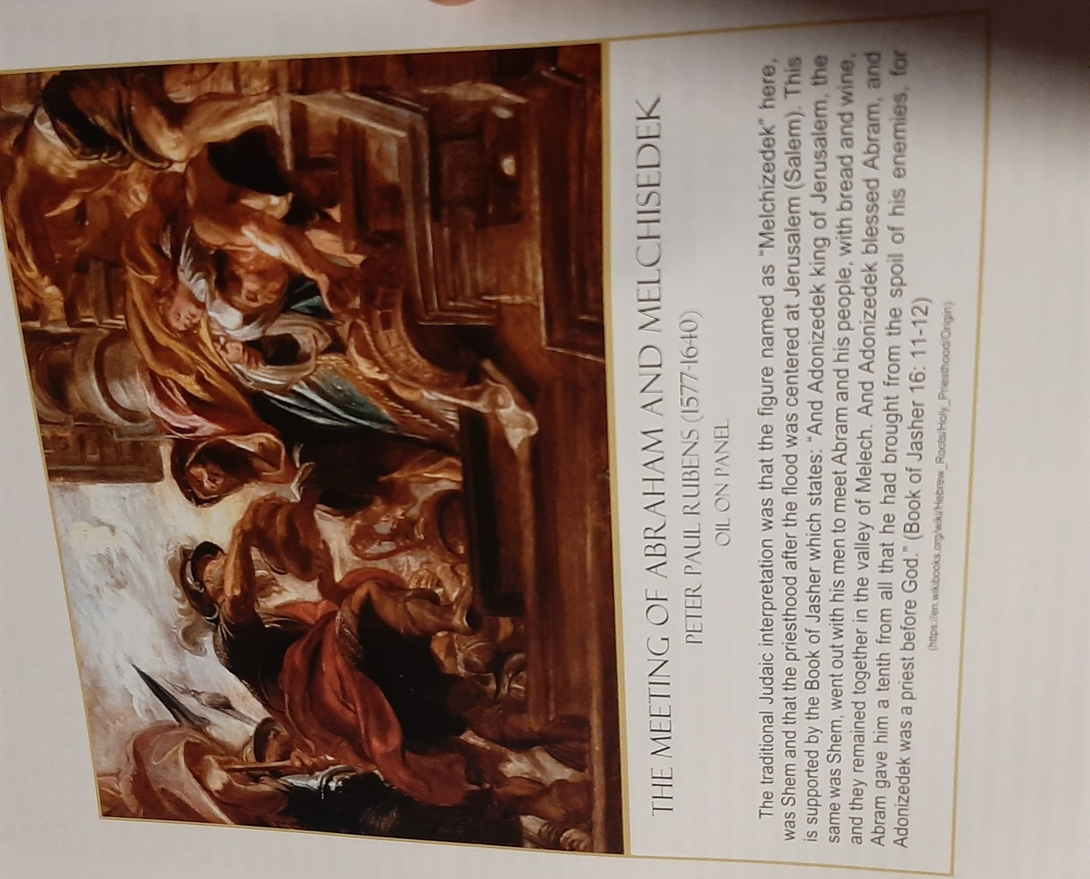

Hocking: Joseph’s Torn Coat & The Covenant of Liberty

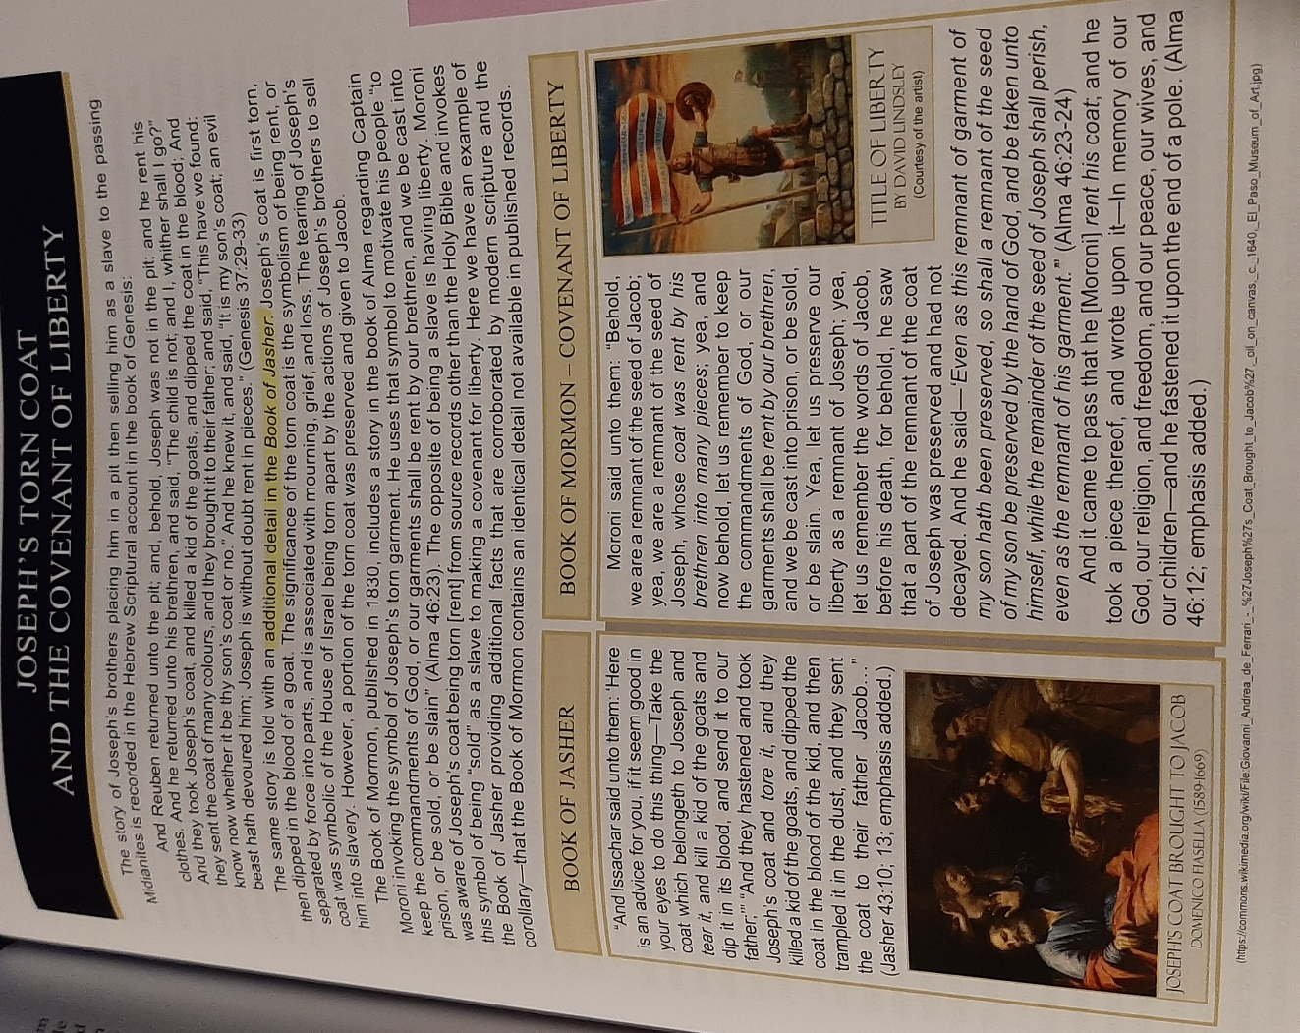

Hocking: Joseph Taught 70 Languages by Angel to become Qualified Ruler

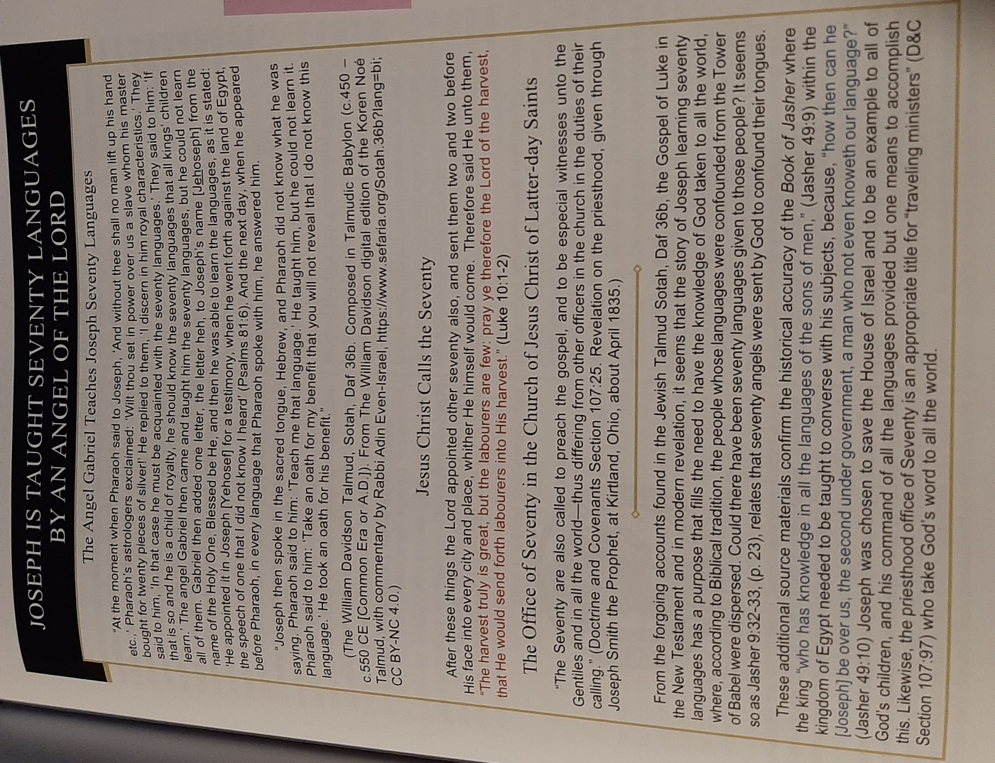

Hocking: 1 Sam. Refers to Jasher, “Teach…Bow”

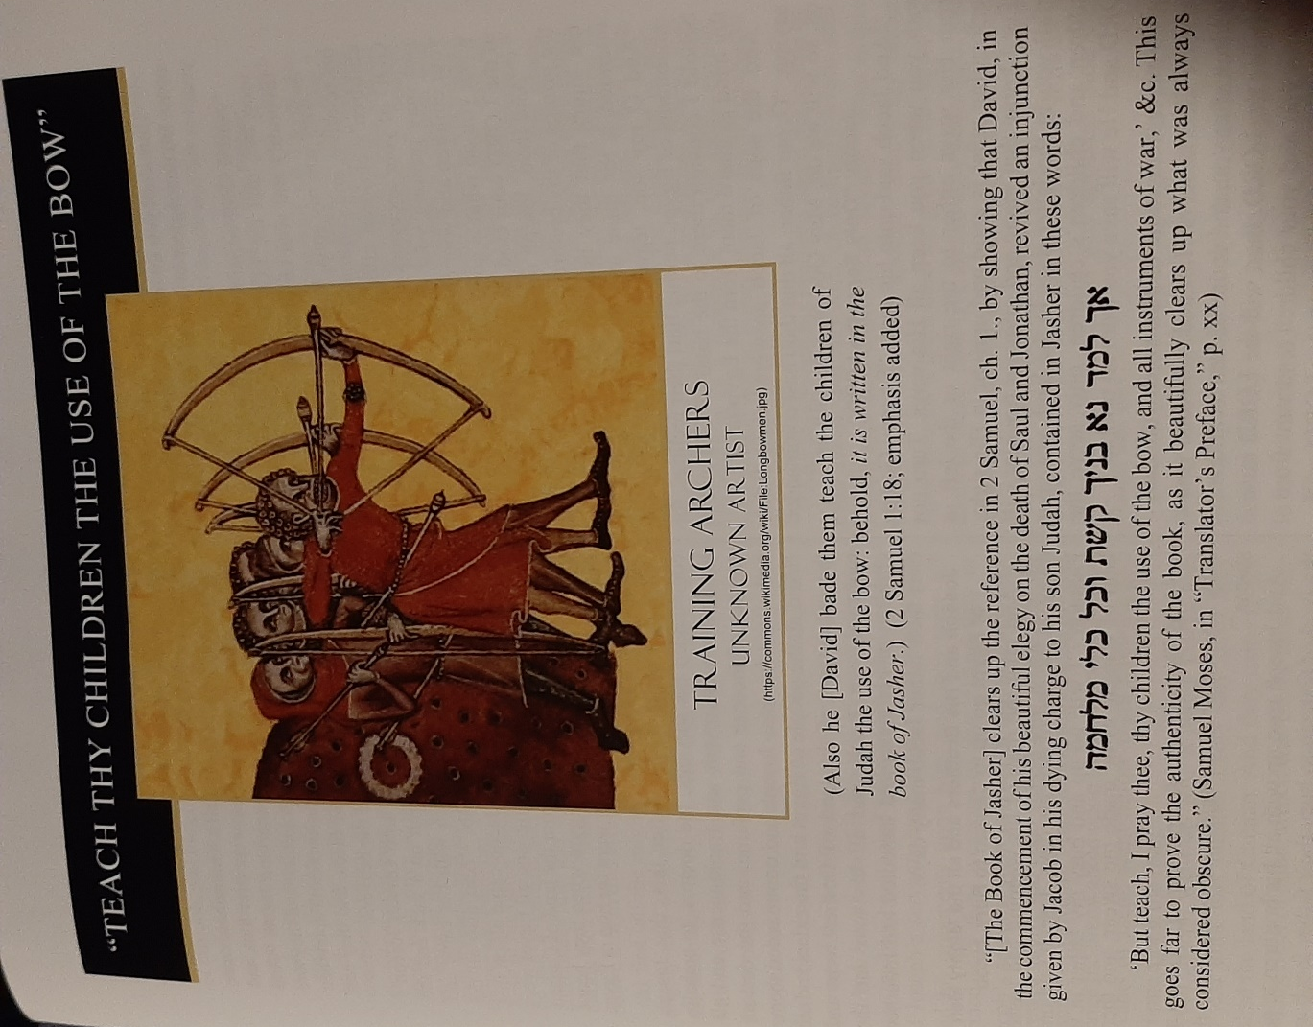

Hocking: Jasher/Nephi Parallel: Beheading with One’s Own Sword

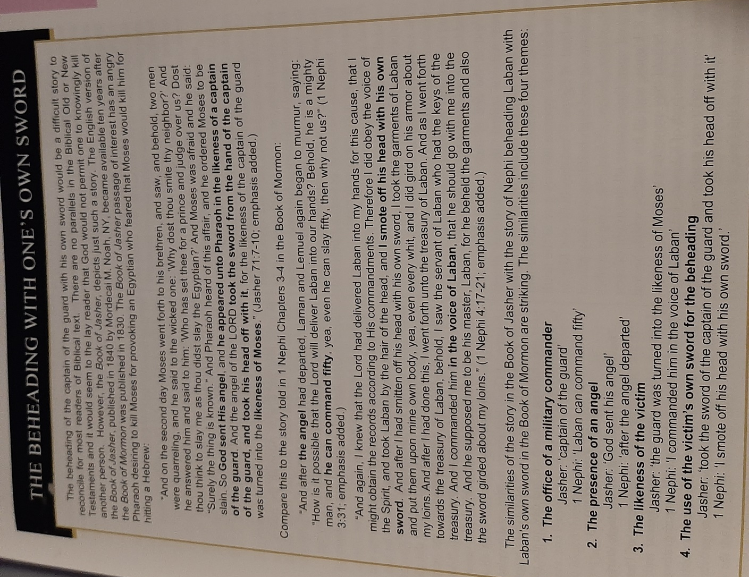

Hocking: Jasher & Book of Mormon: Matching Themes: Naming Kings, Witnesses & Sealing Records by Hand, 1000 Bad Die 0 Good, Ditches Around Cities, Catastrophic Events, Exchange Military Letters

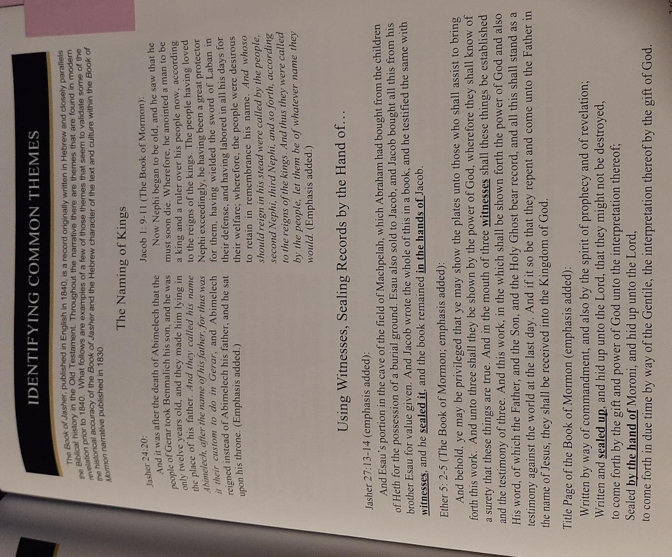

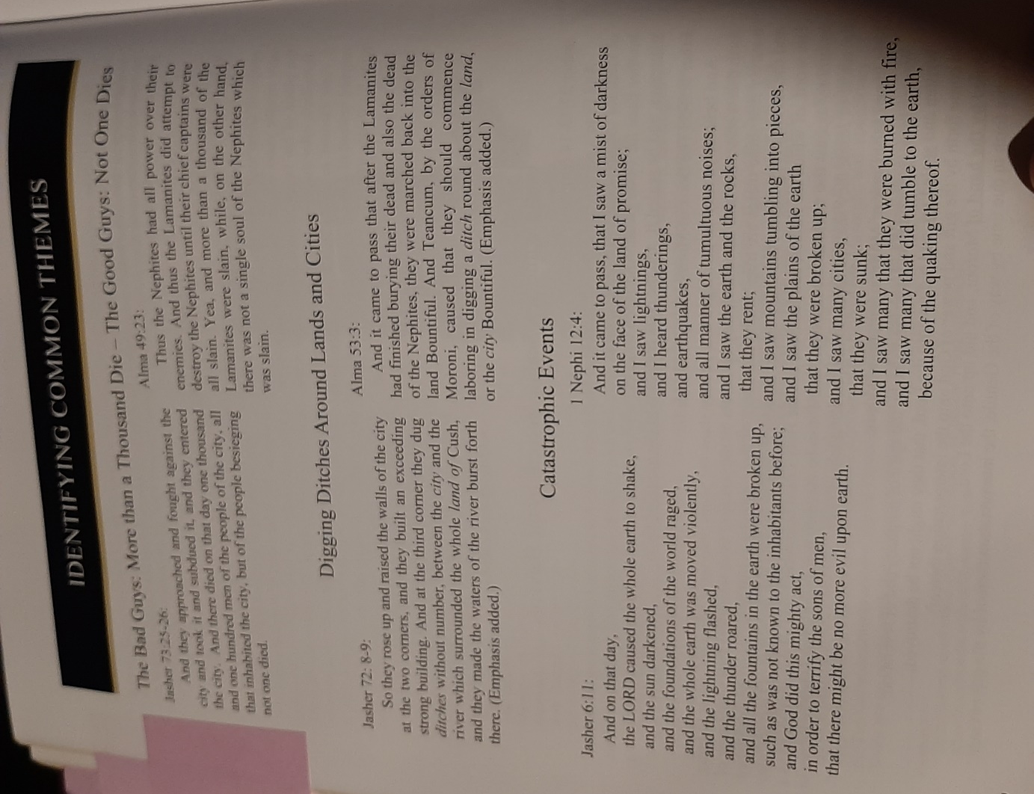

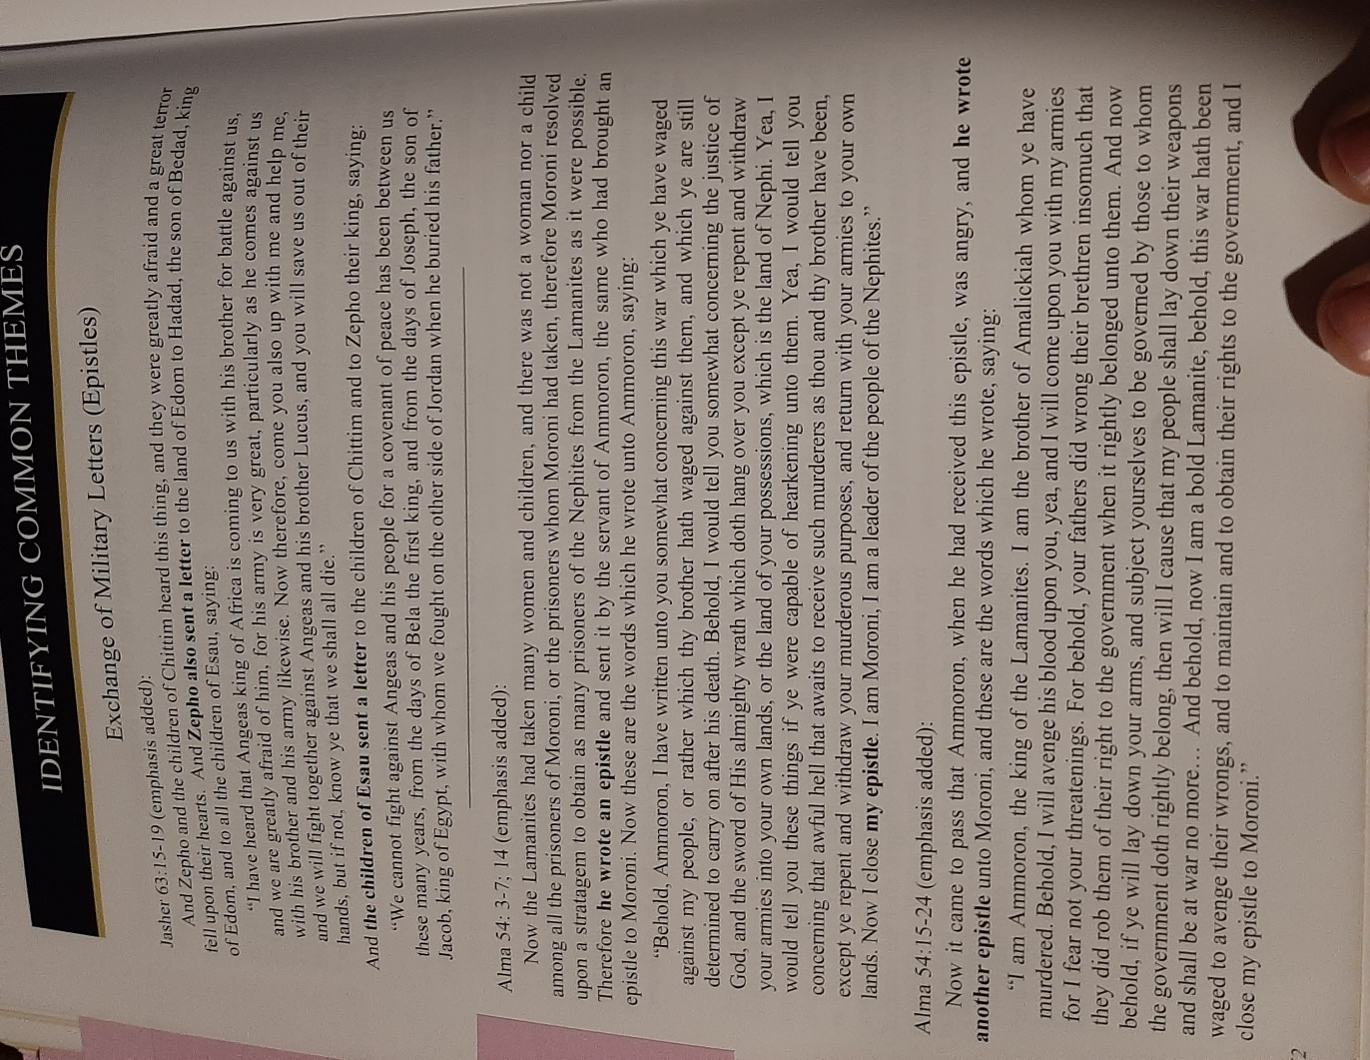

Hocking: Hebrew Writing Styles in Jasher & Book of Mormon: Word Phrases, Repetition/Word Groups, Pronouns

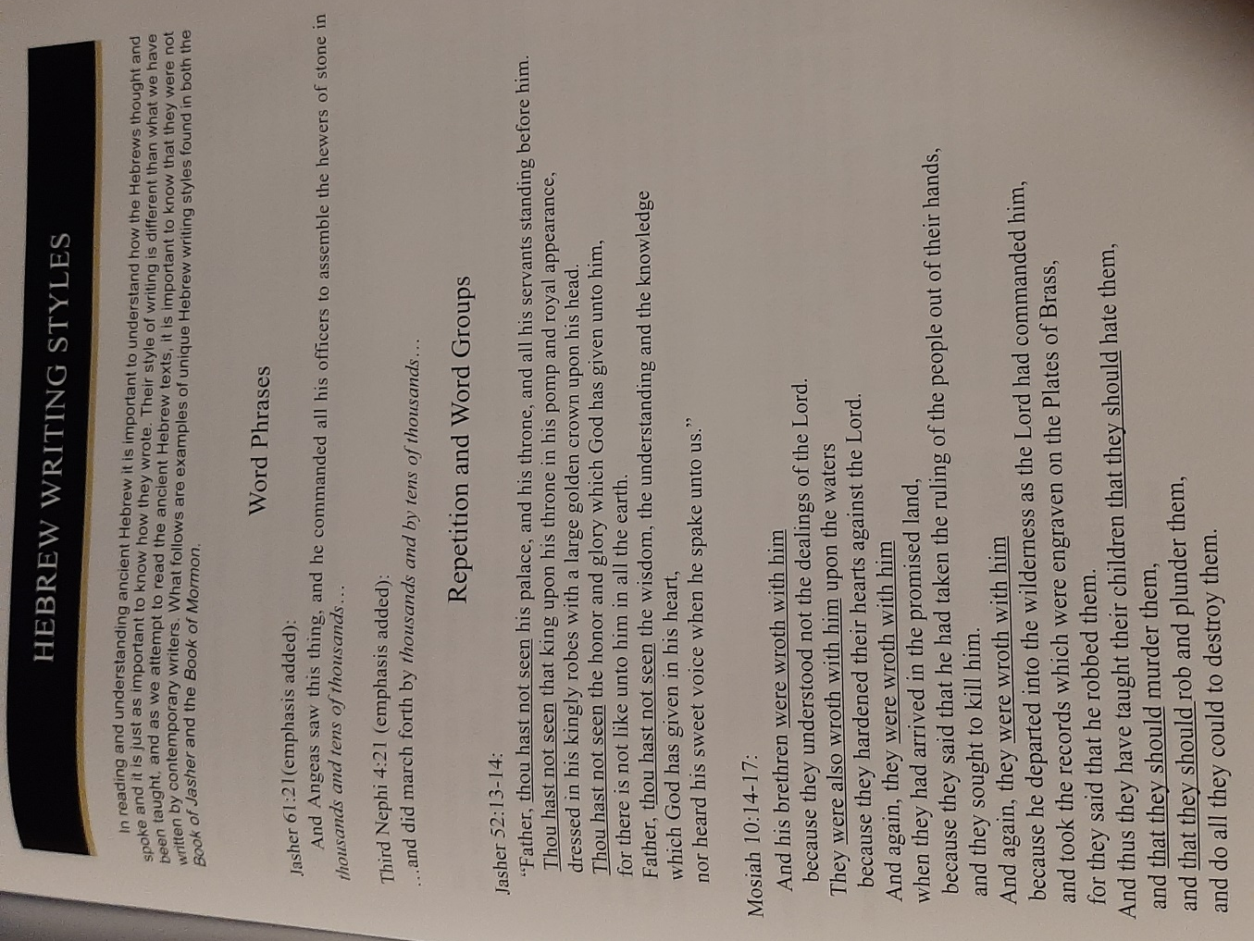

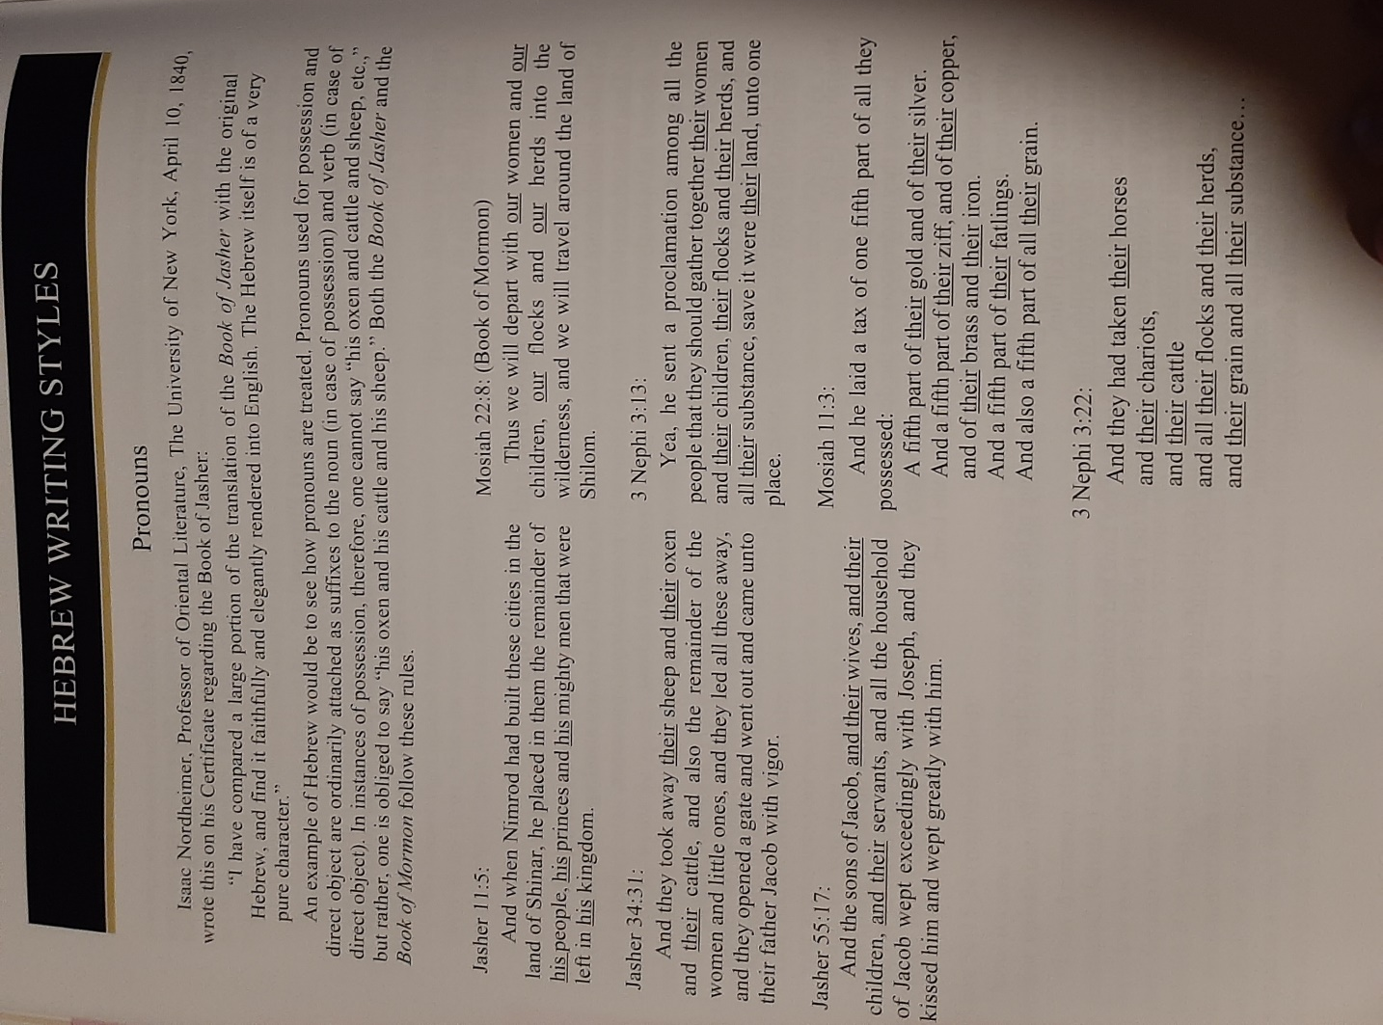

Hocking: Hebrew Expressions in Jasher & Book of Mormon: Repetition of Particles, Cognitive Accusative

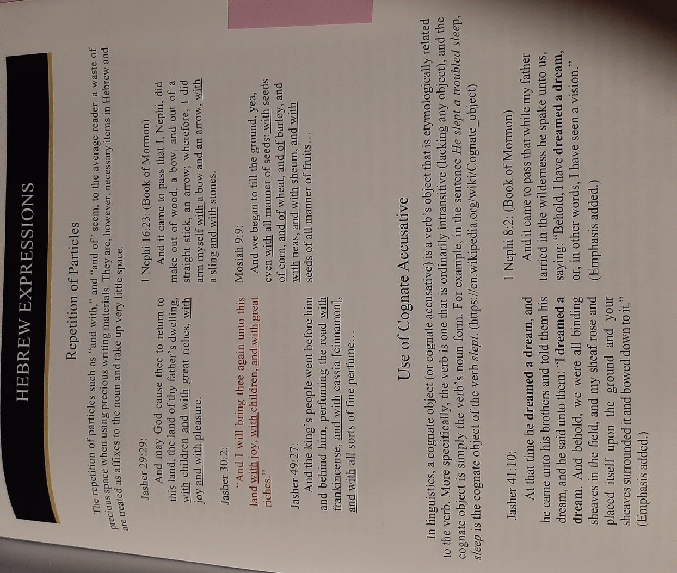

Hocking: Hebrew Poetry in Jasher & Book of Mormon: Laments, Crying unto the LORD, Songs

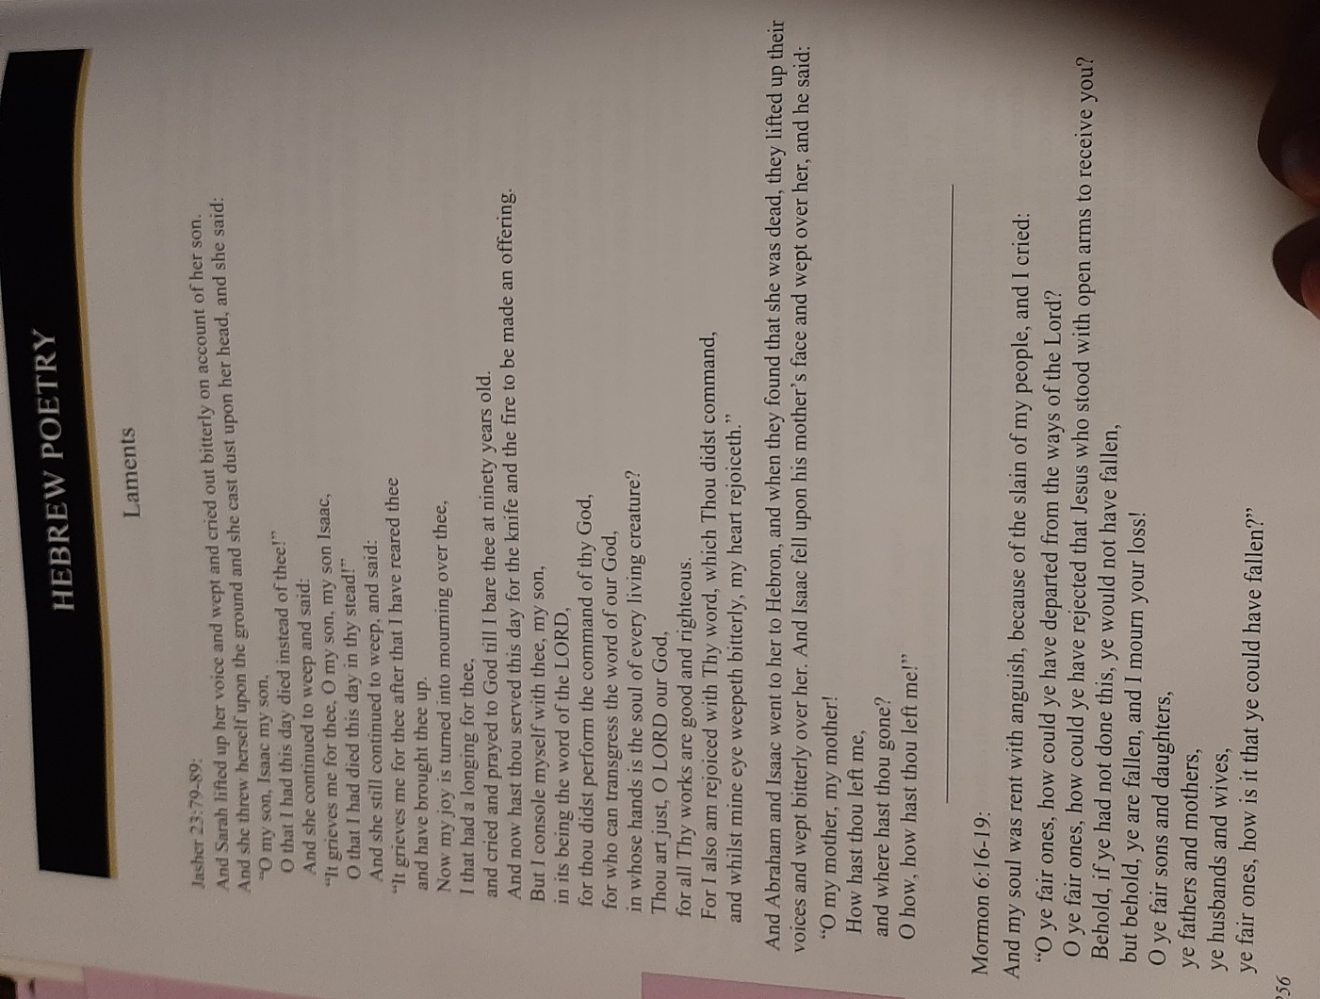

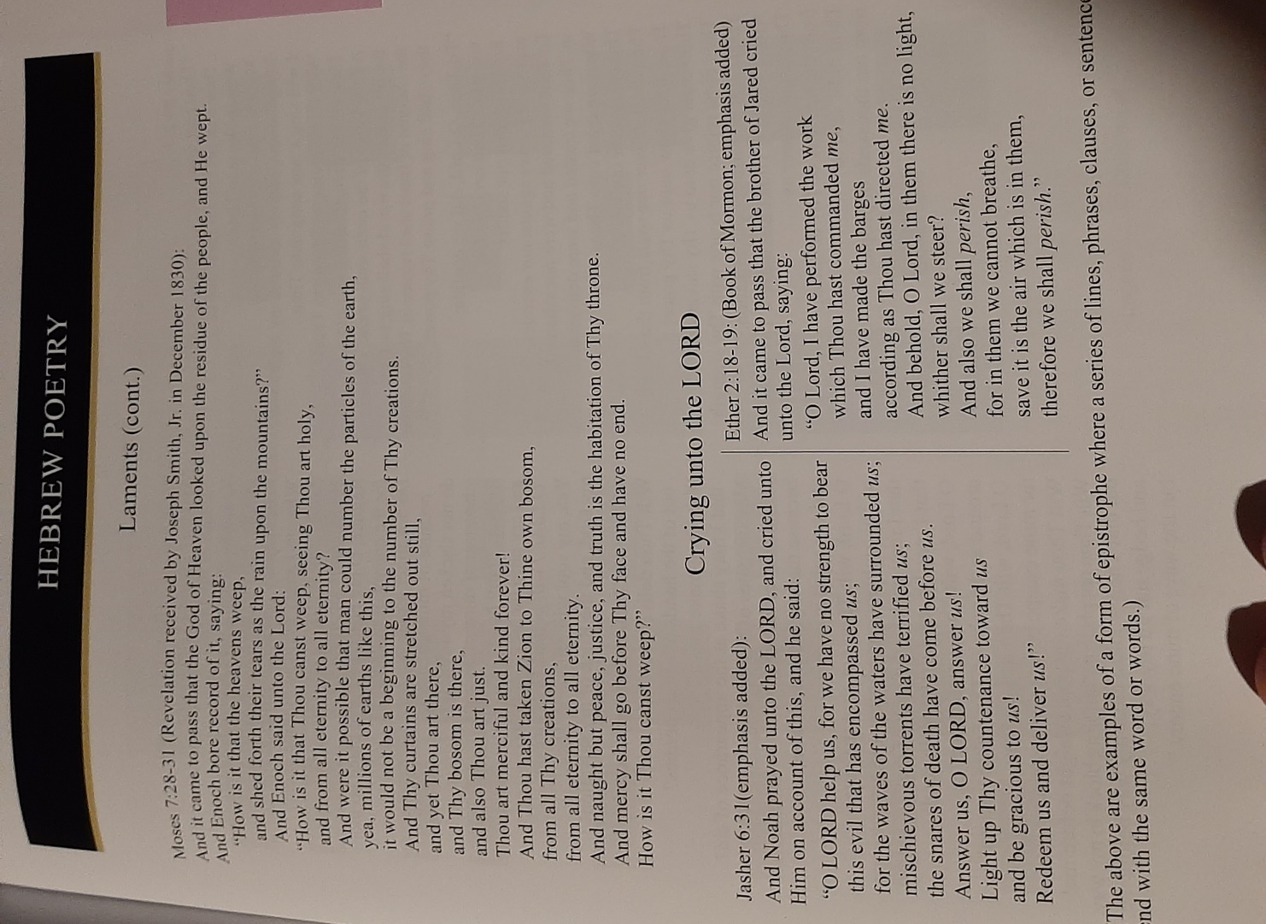

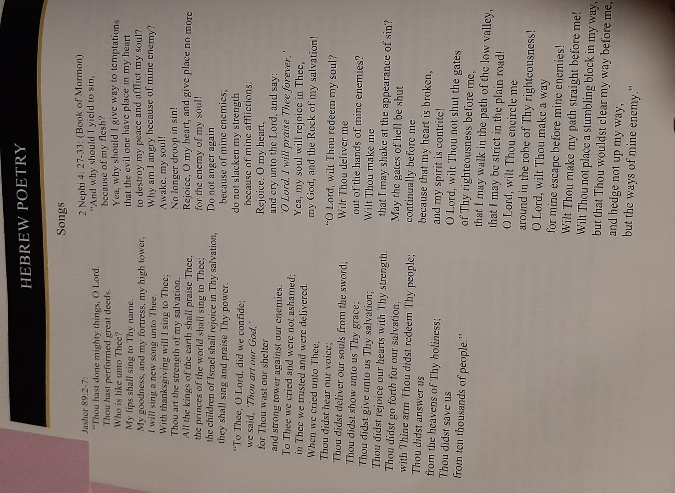

Hocking: Worldwide Flood of Noah: Hydroplanet, Hypretherm, Hydrofountains, etc. (Dean Sessions)

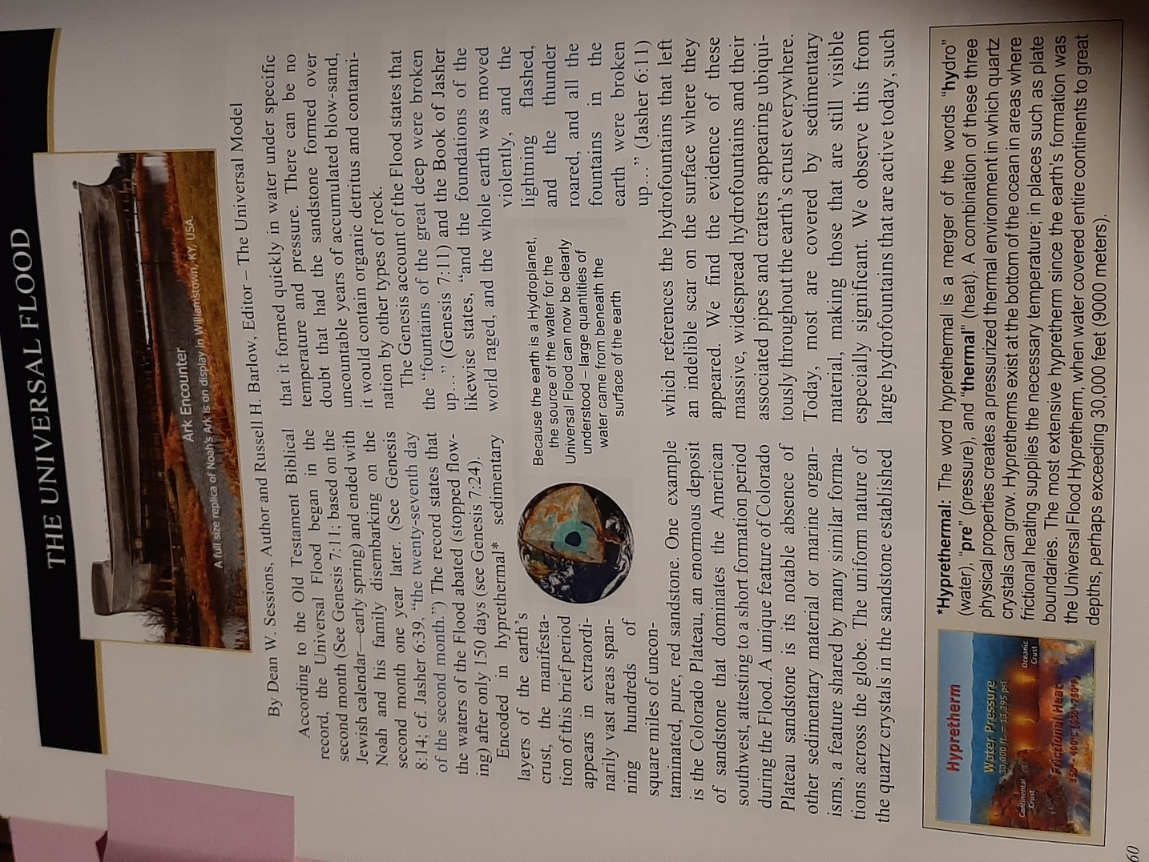

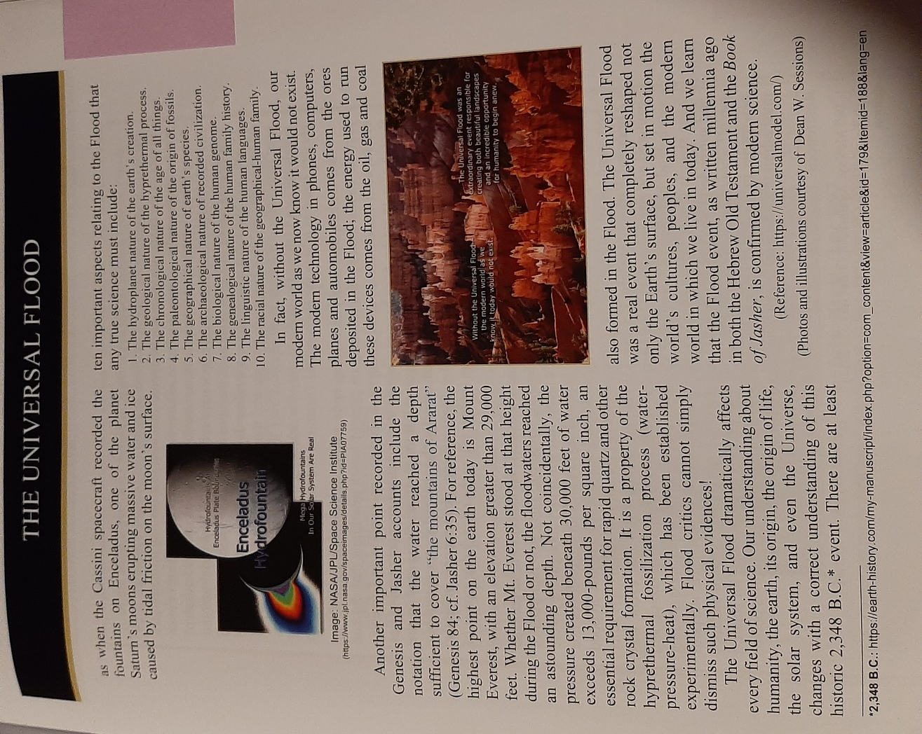

Hocking: Jasher Miraculous Miracles Are Possible: Comparing with Modern Israel Nation Miracles

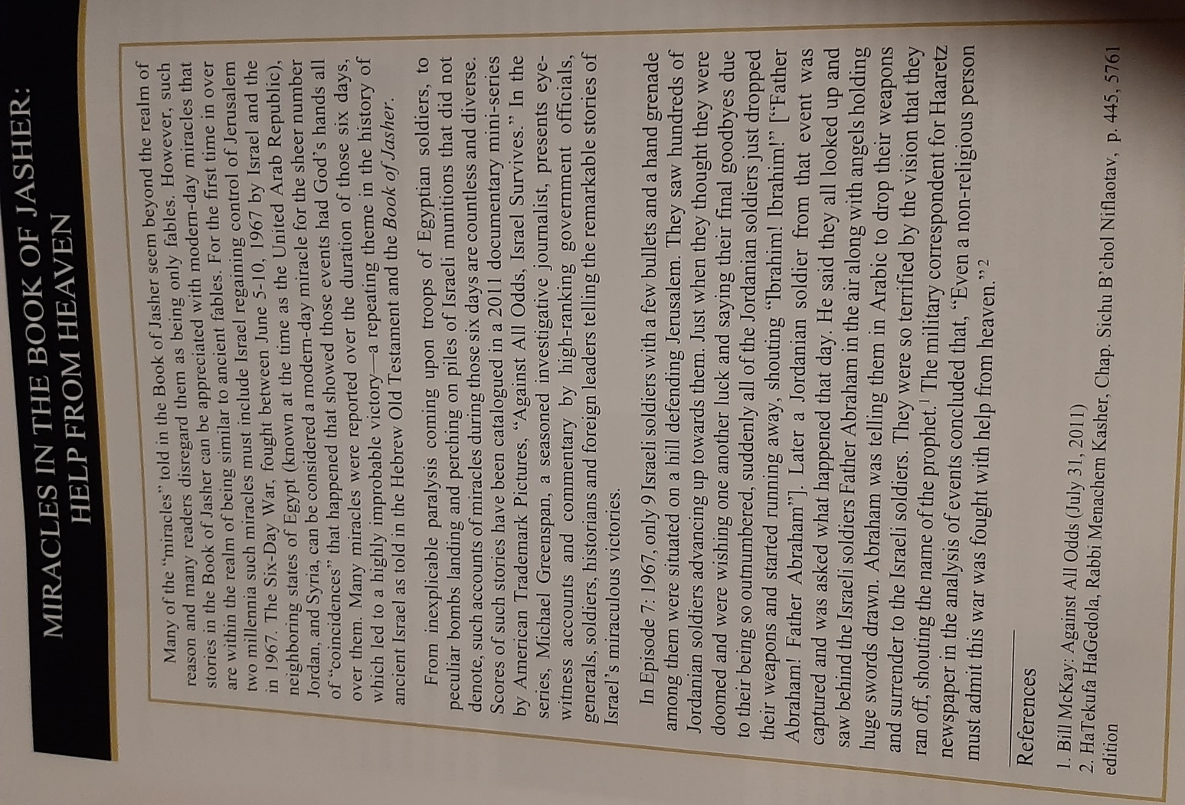

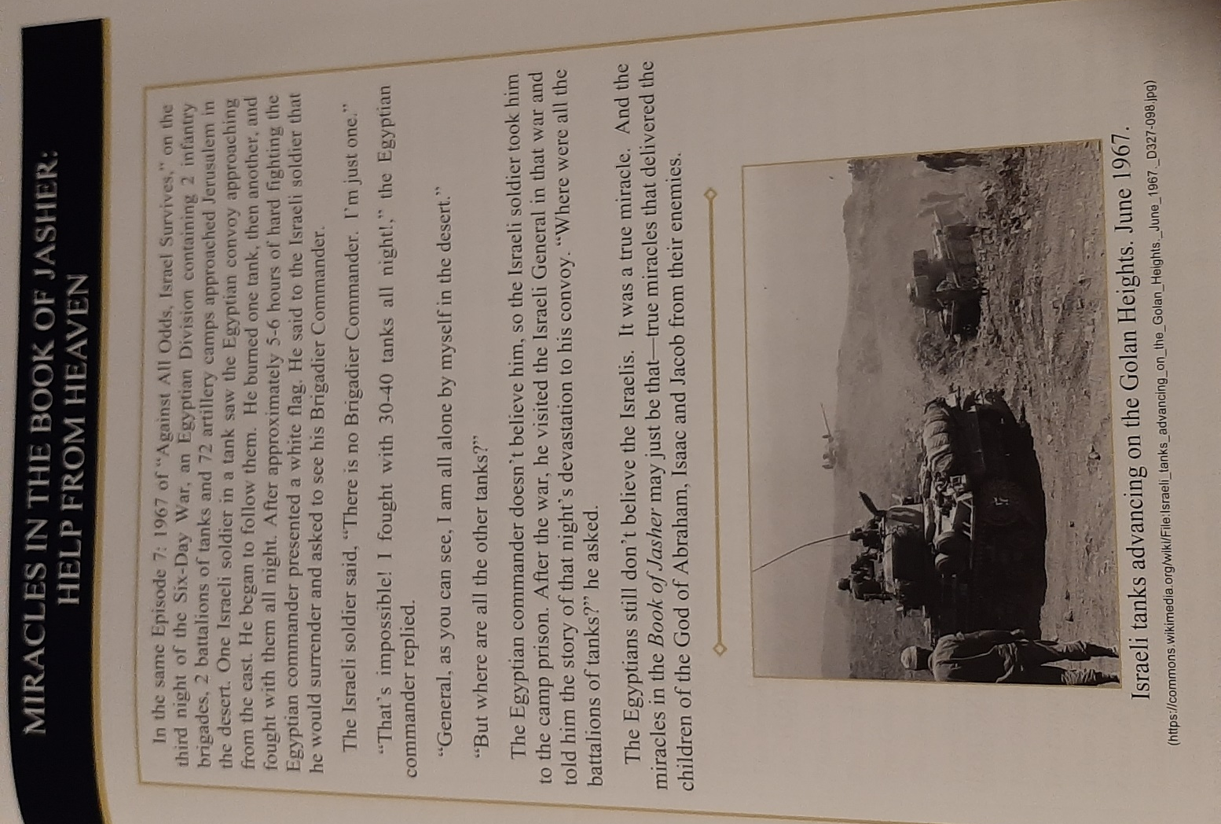

PART 4: ENOCH ANNOTATED BY DAVID HOCKING - HIGHLIGHTS

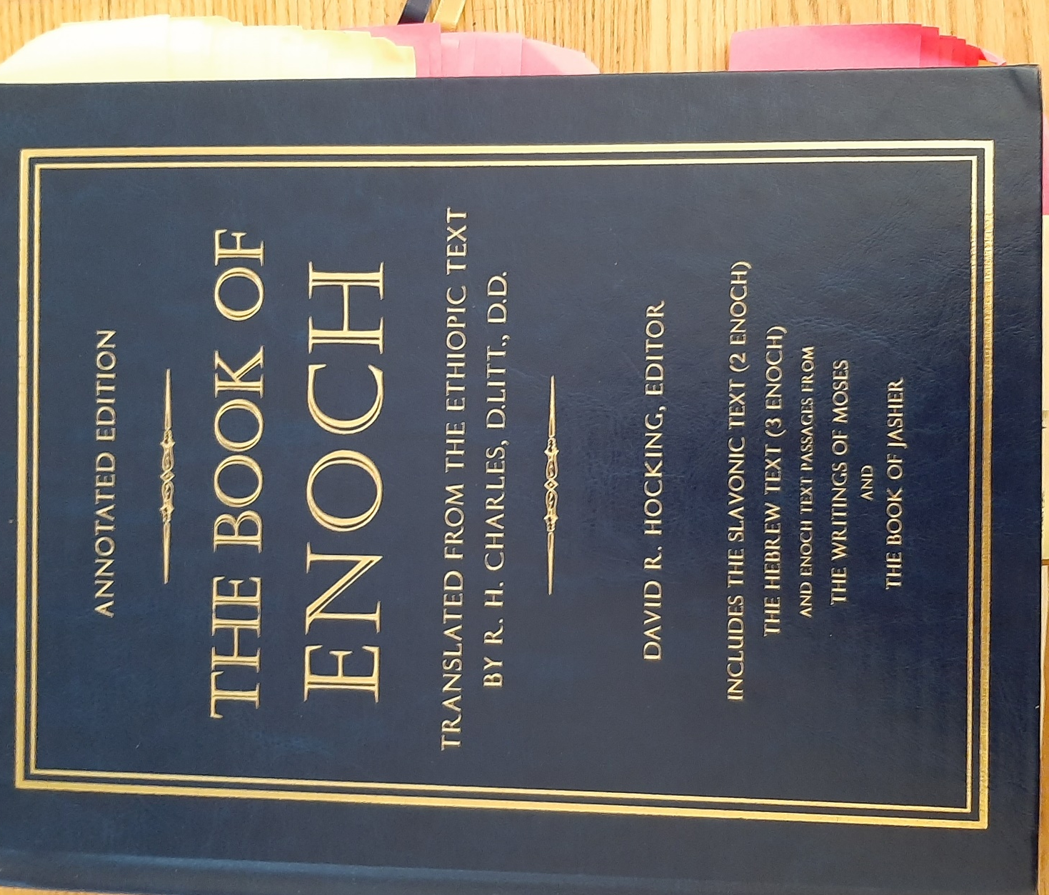
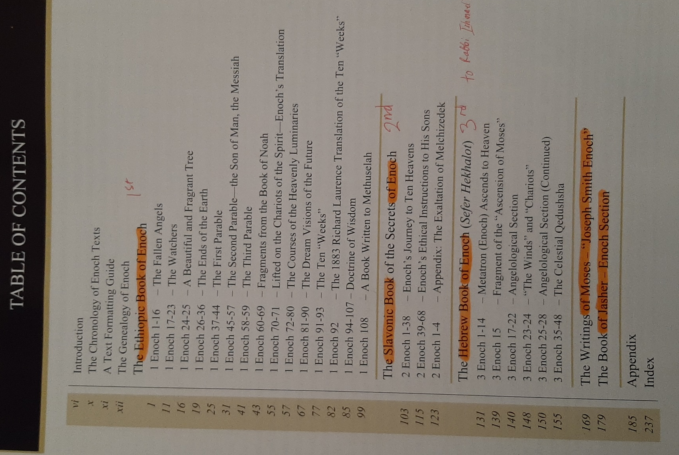

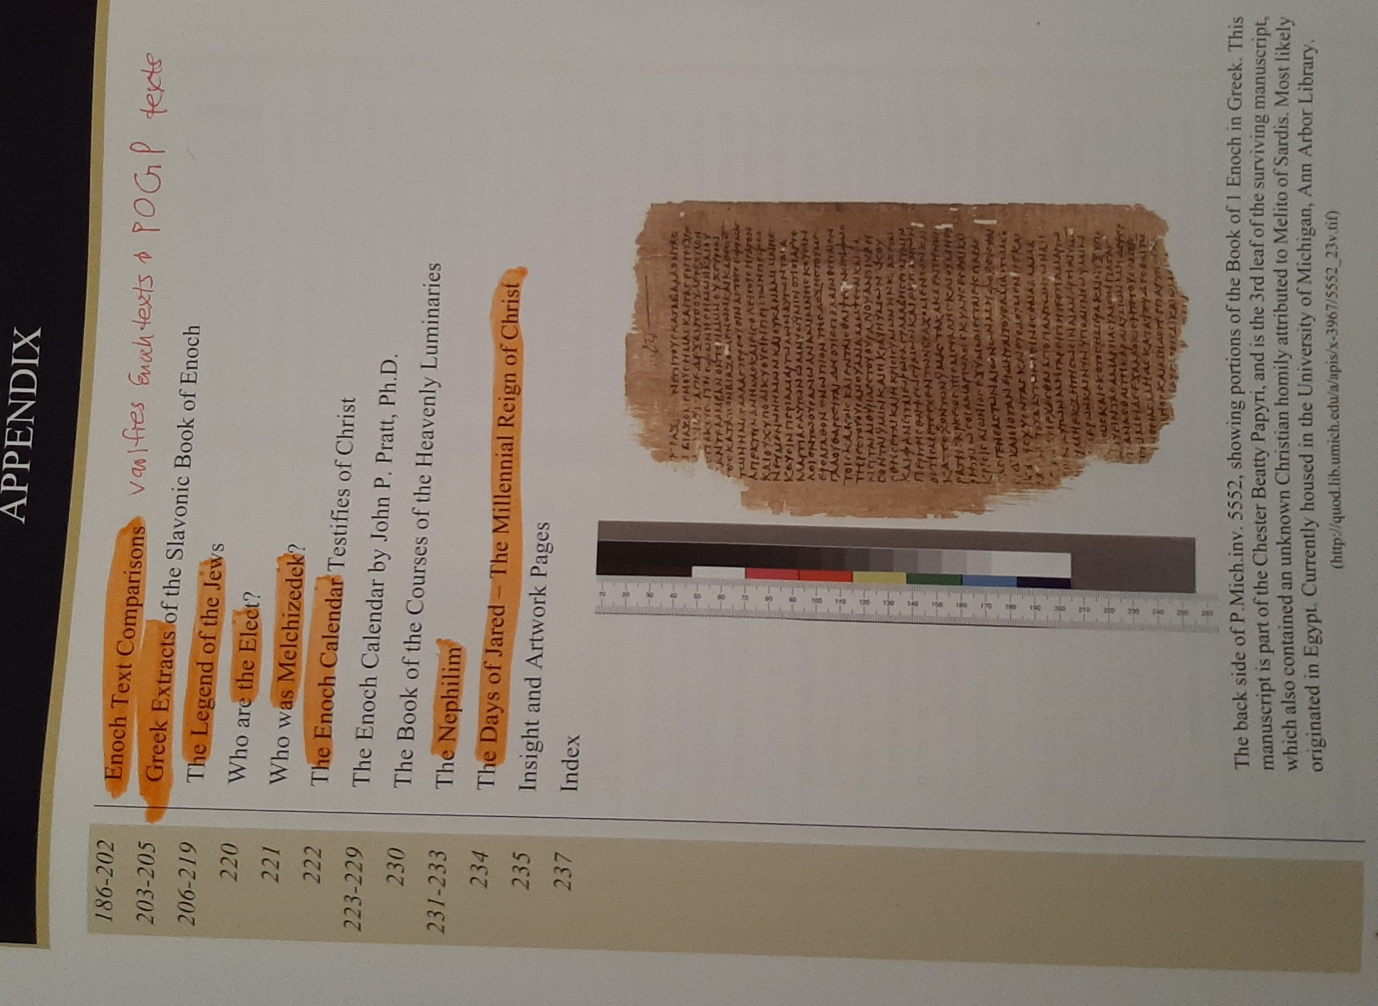
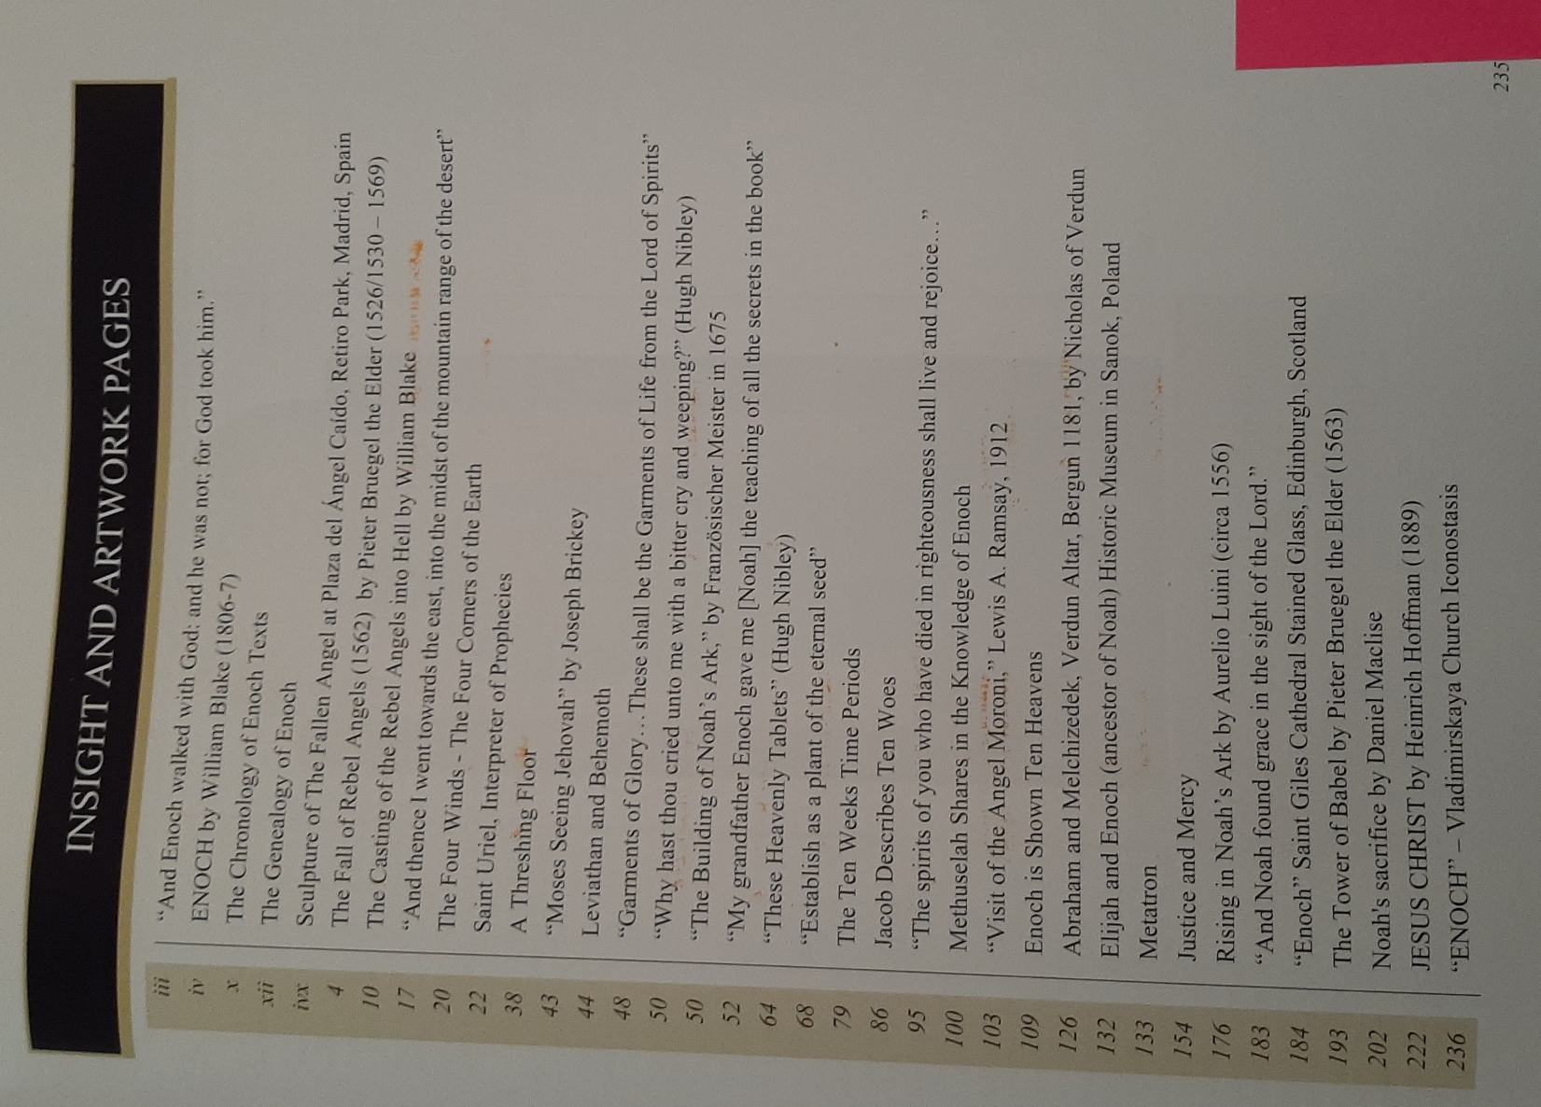

Hocking: Chronology of Enoch Texts
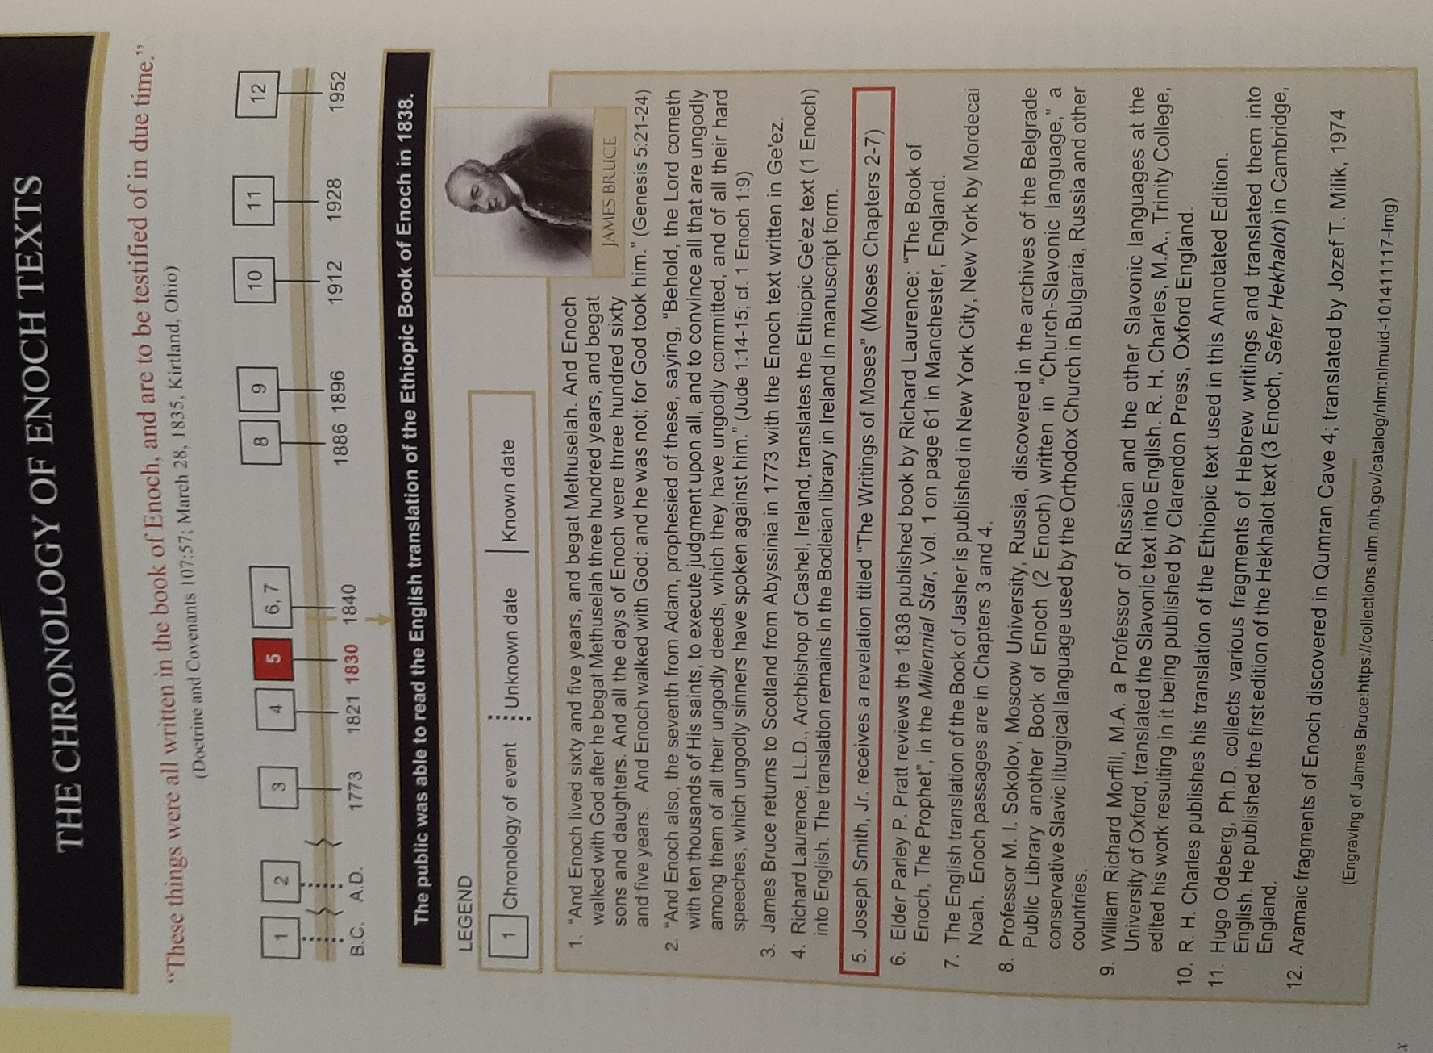

Hocking: Genealogy of Enoch
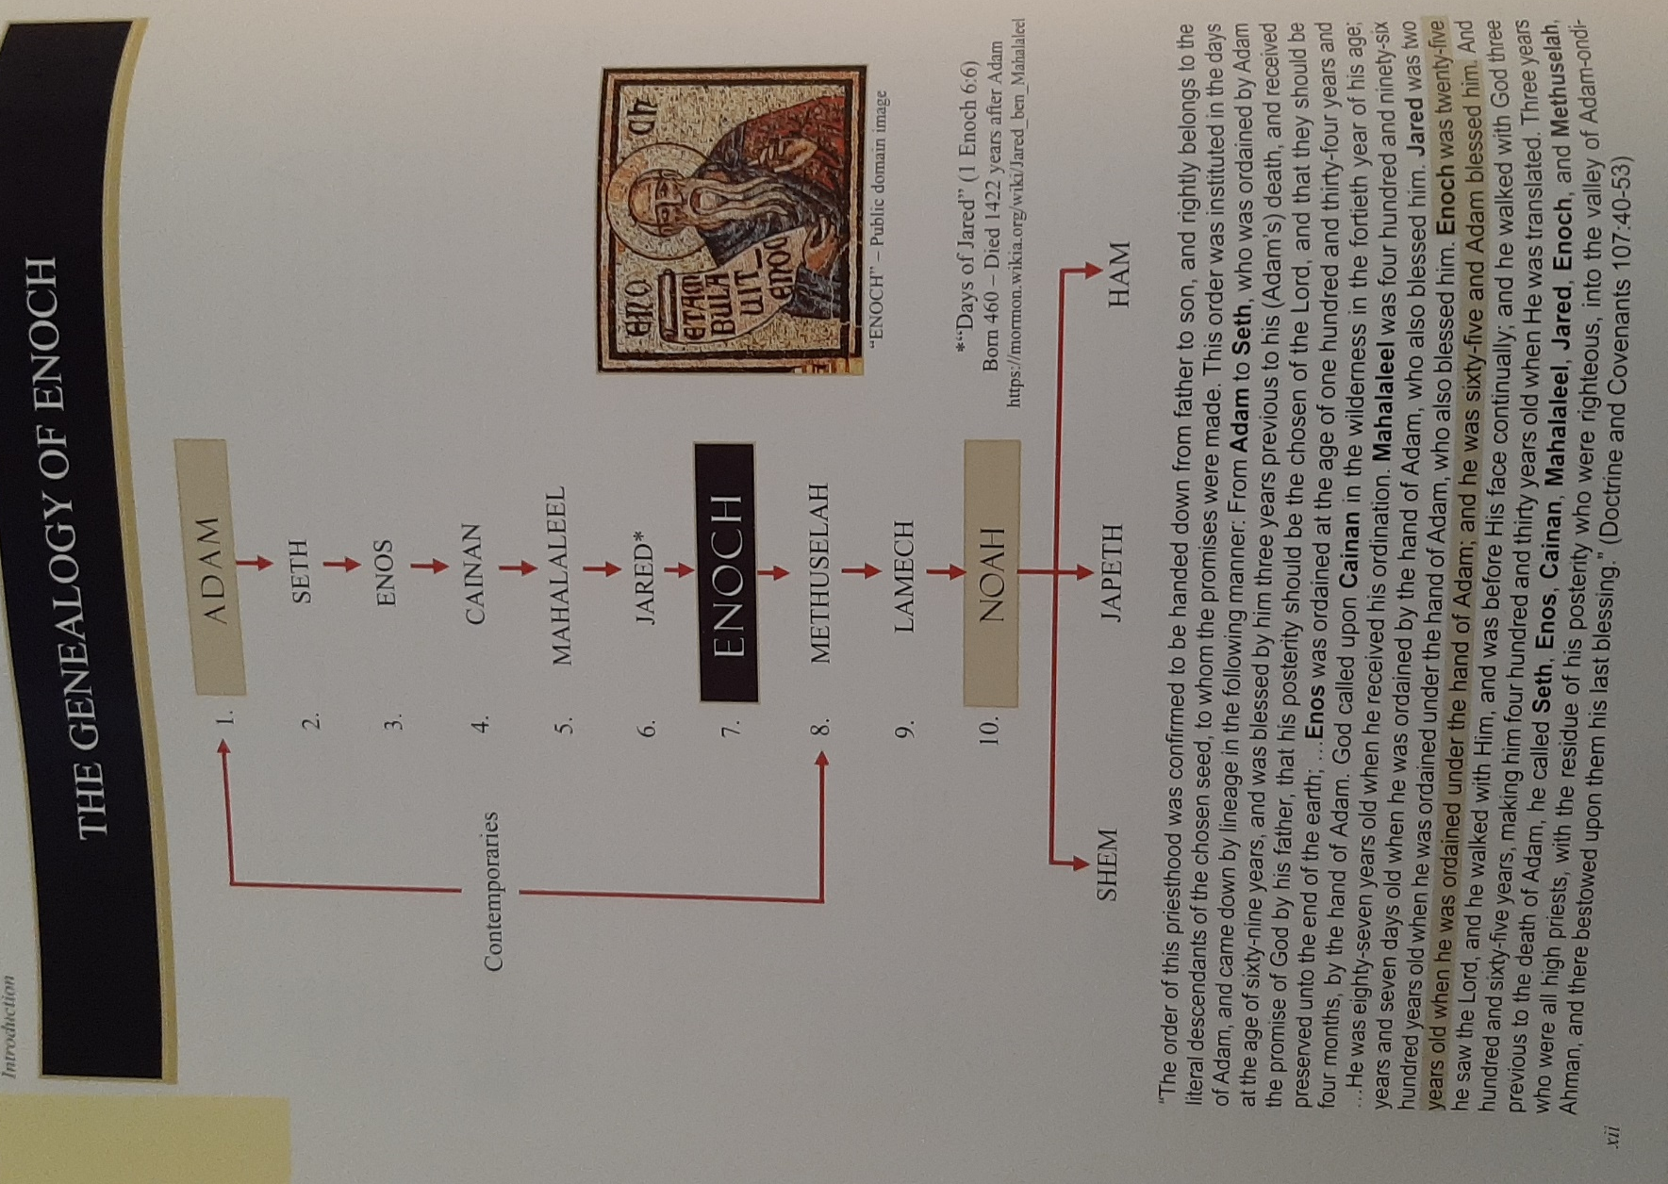

Hocking: Names of 7 Holy Watchers & Their Jobs
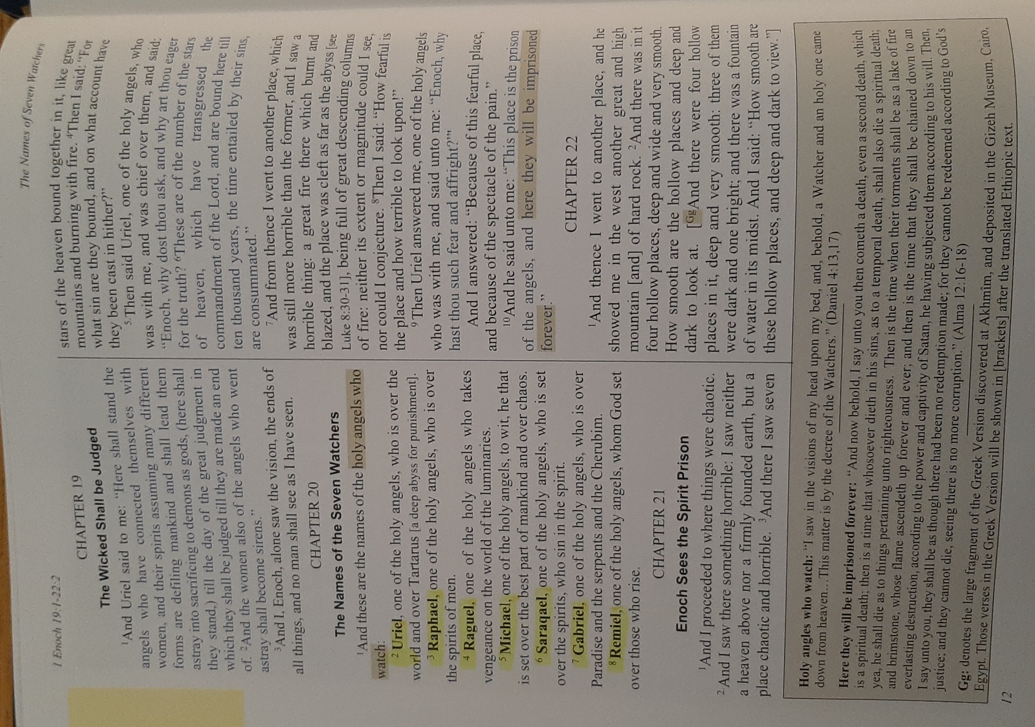

Hocking: The Beautiful Tree
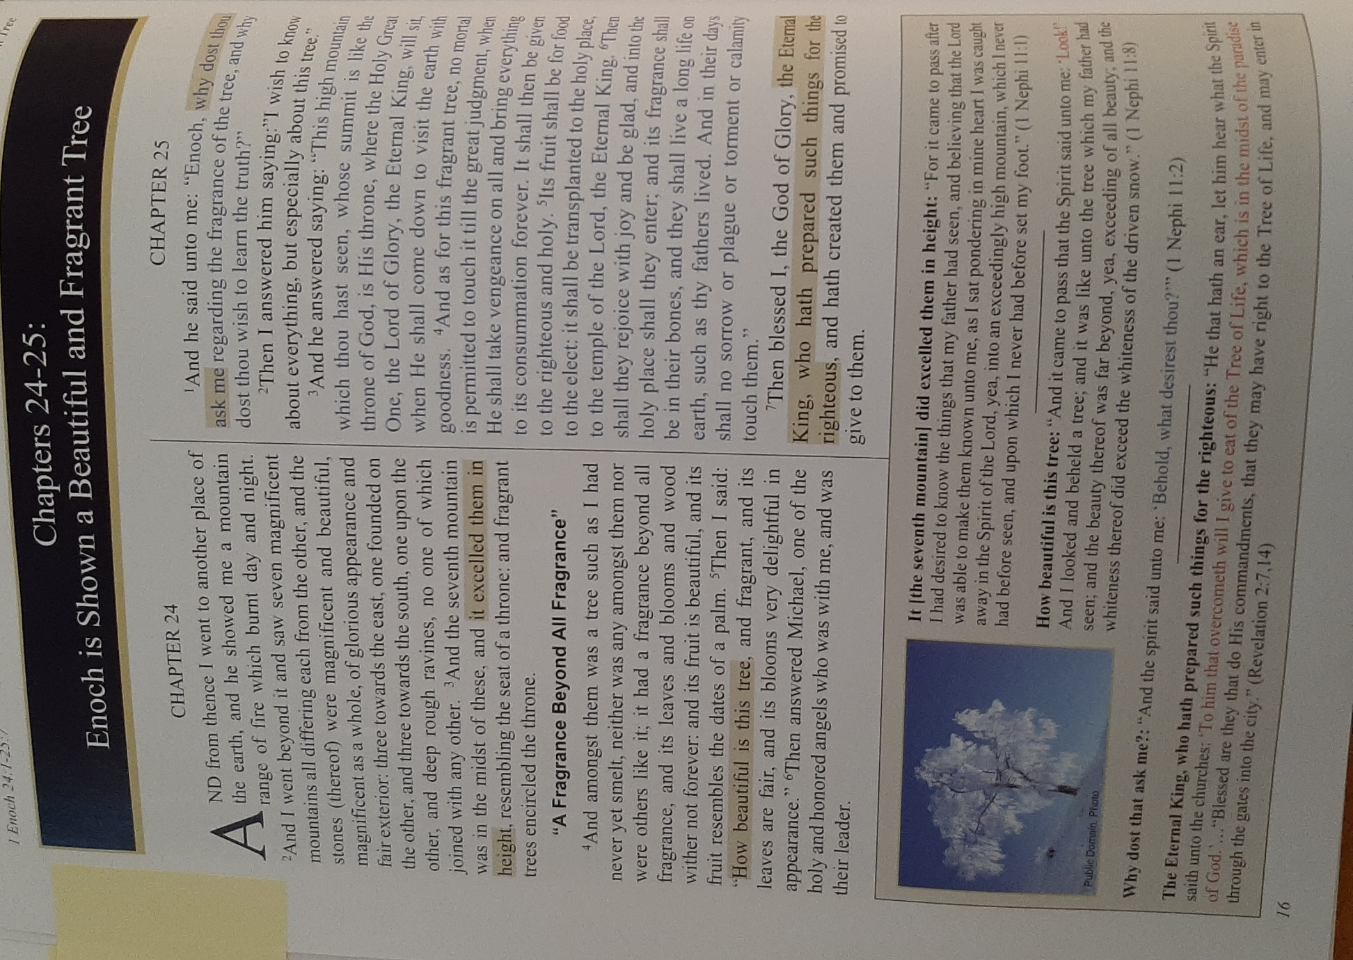

Hocking: 4 Winds, 4 Corners of Earth, Adam in America
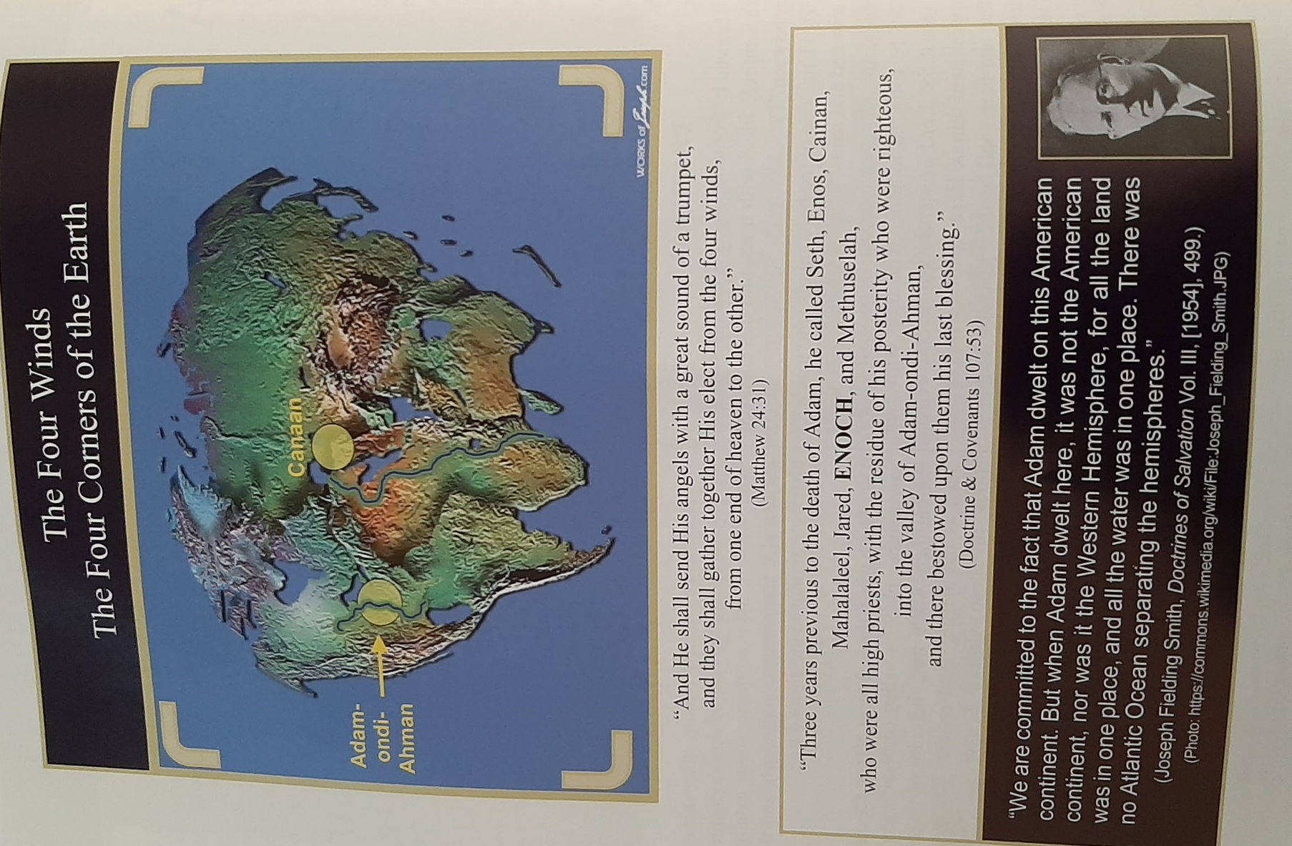

Hocking: The 3 Books of Parables, Elect One, Astronomical Secrets, 4 Angels, Ancient of Days, Azazel, Watchers, Angels of Punishment, Ancient of Days, Place of Punishment, Secret Oath
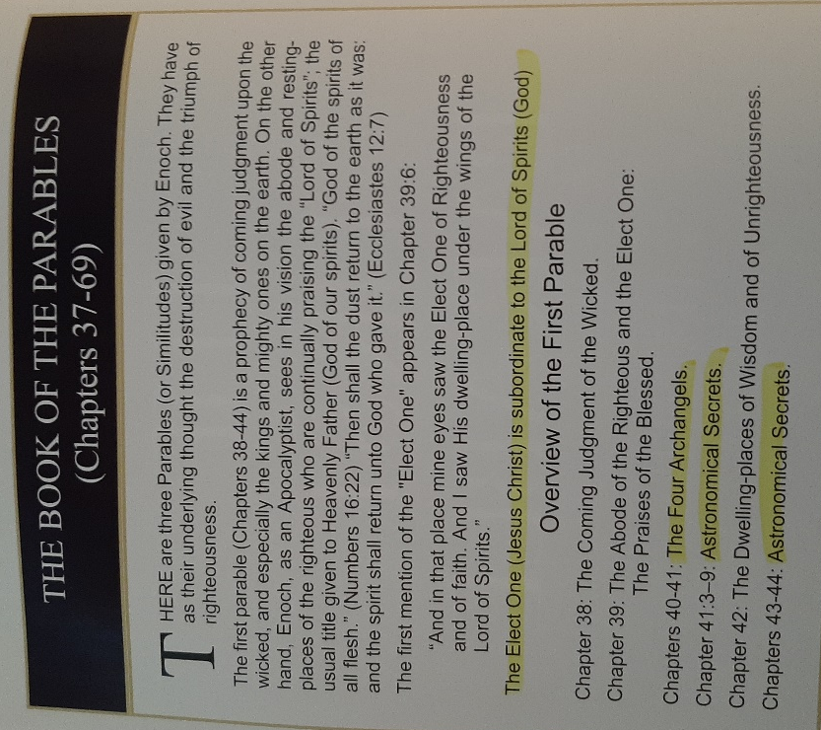
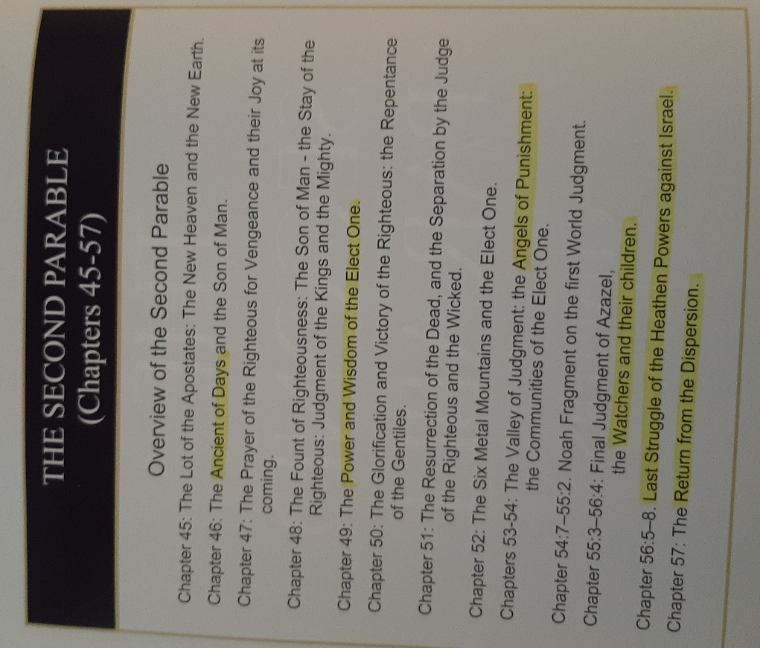

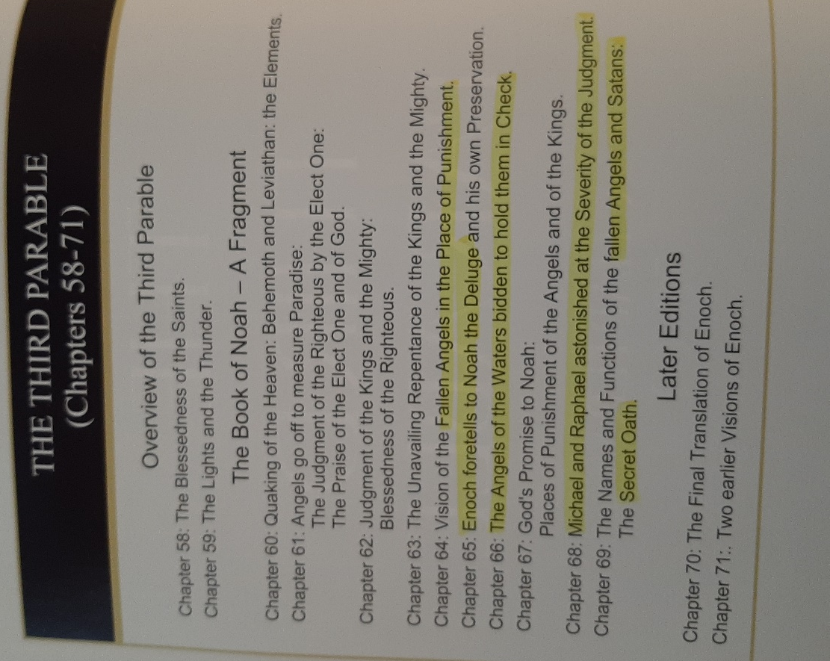

Hocking: Leviathan & Behemoth
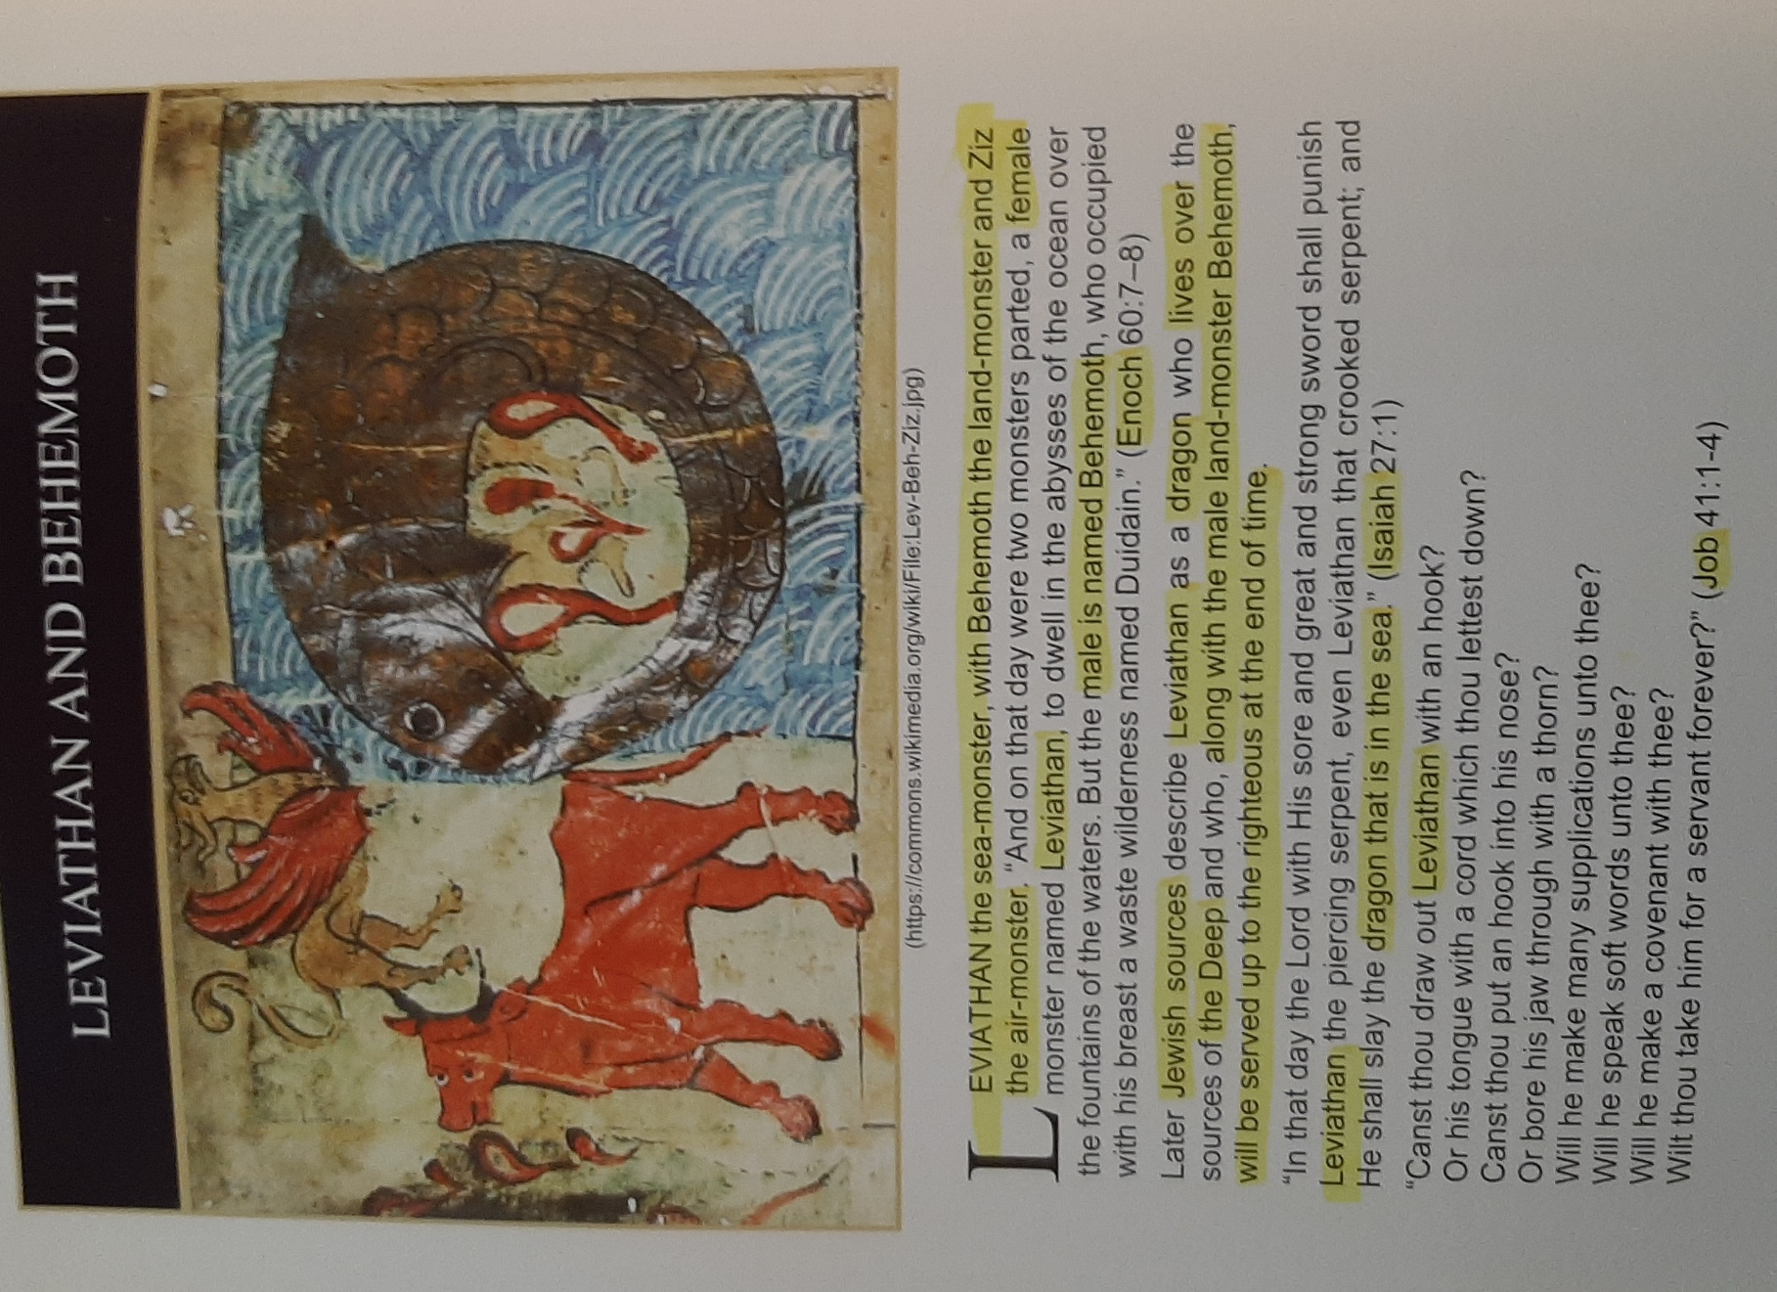

Hocking: Garments of Glory/Life from the Lord
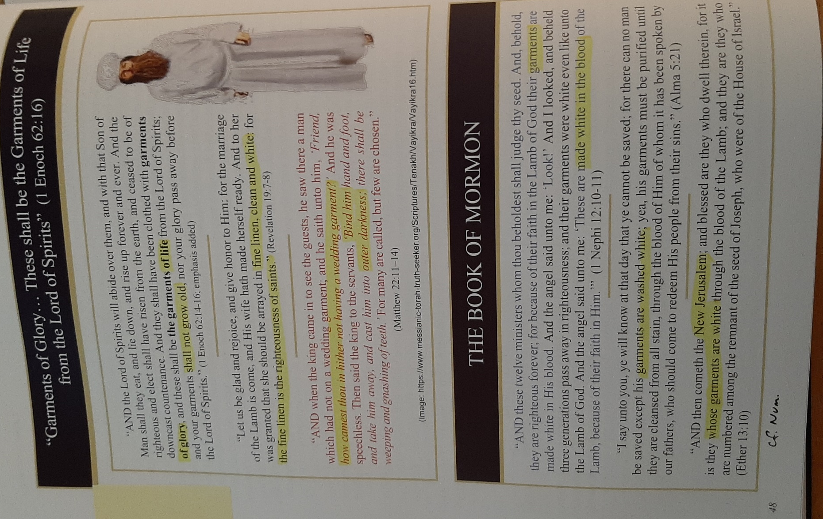
See also book of Numbers.

Hocking: God Weeping, Book of Enoch & Book of Moses
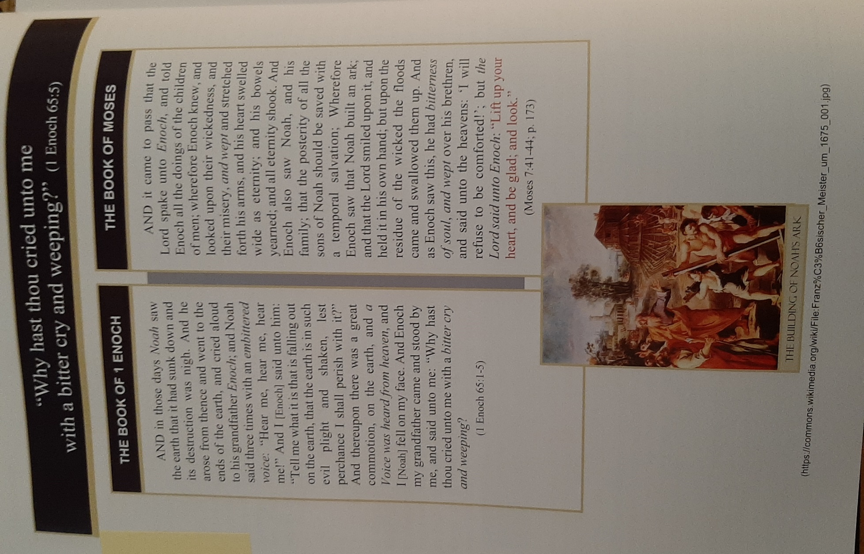

Hocking: Enoch’s Translation & Ascension
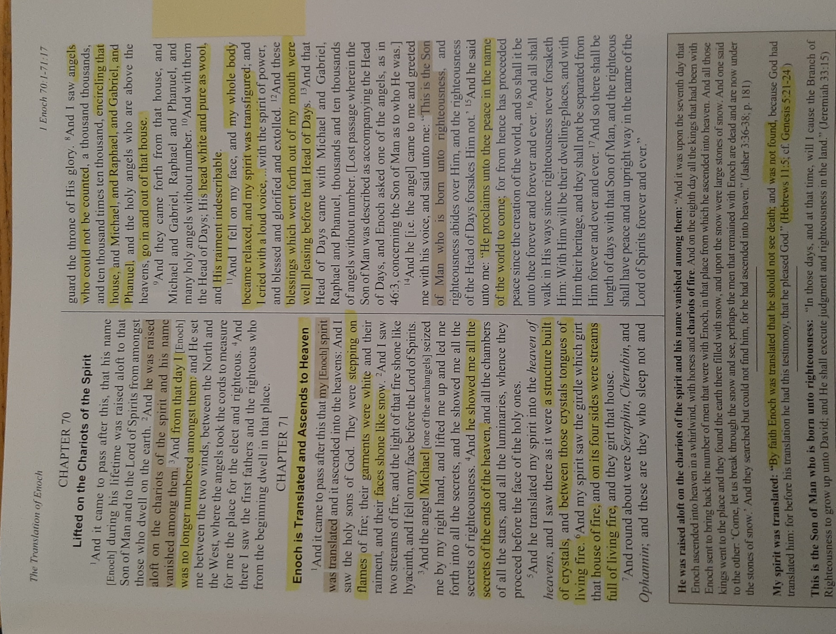

Hocking: The Heavenly Tablets, Earth Copies
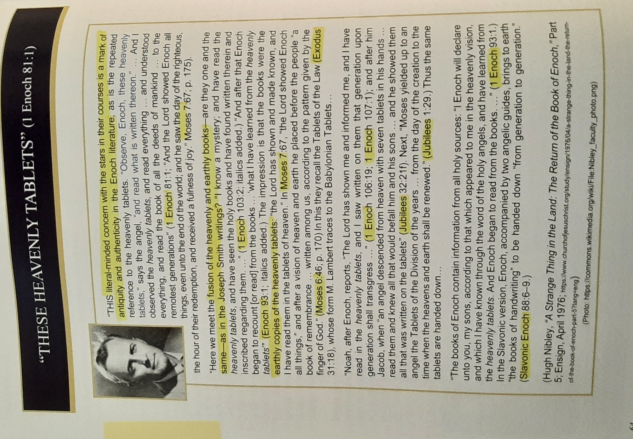

Hocking: Timeline: 10 “Weeks” as 10 Time Periods: Past & Future
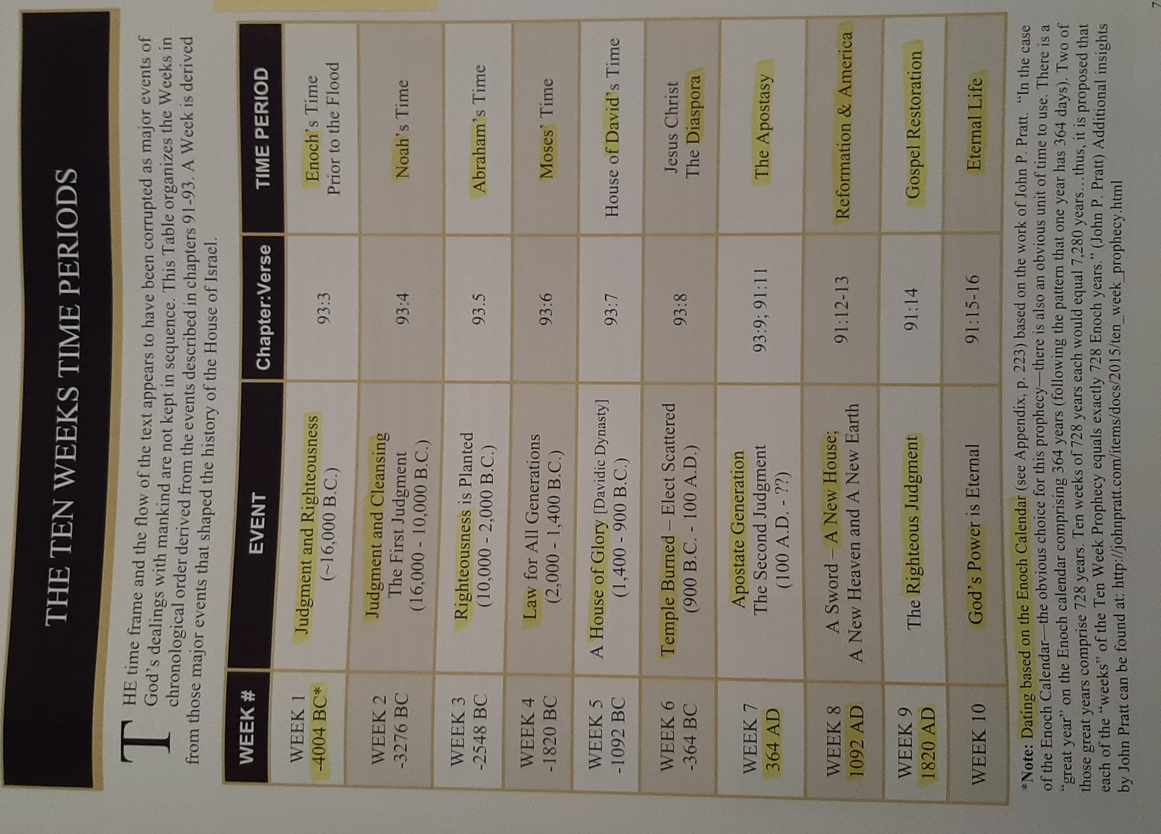

Hocking: Intro to 2nd Enoch (Slavonic)
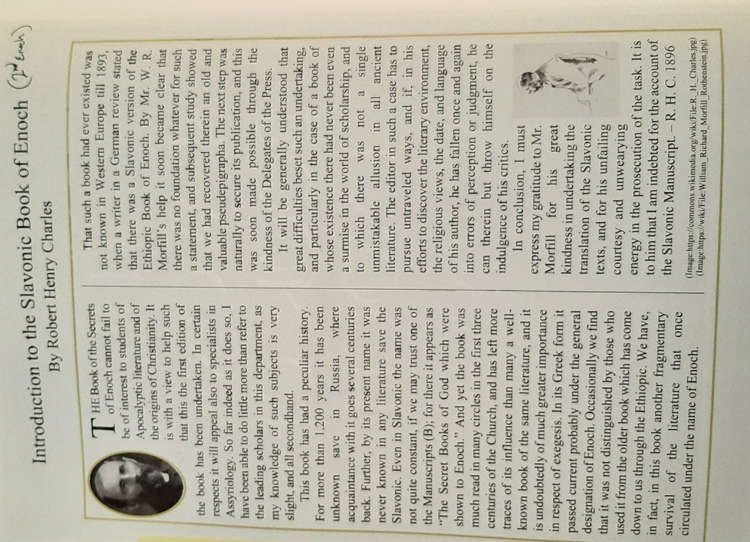

Hocking: Description of the 10 Heavens
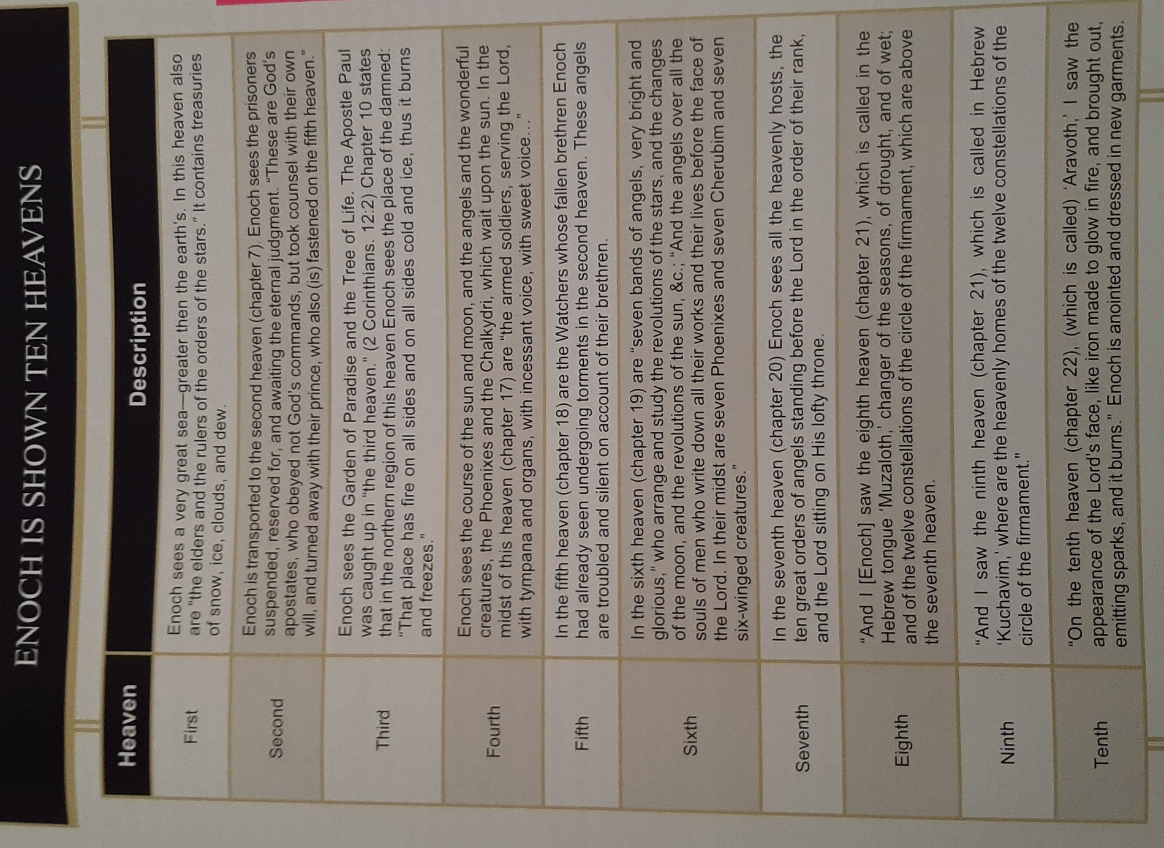

Hocking: Enoch as Metatron & Meaning
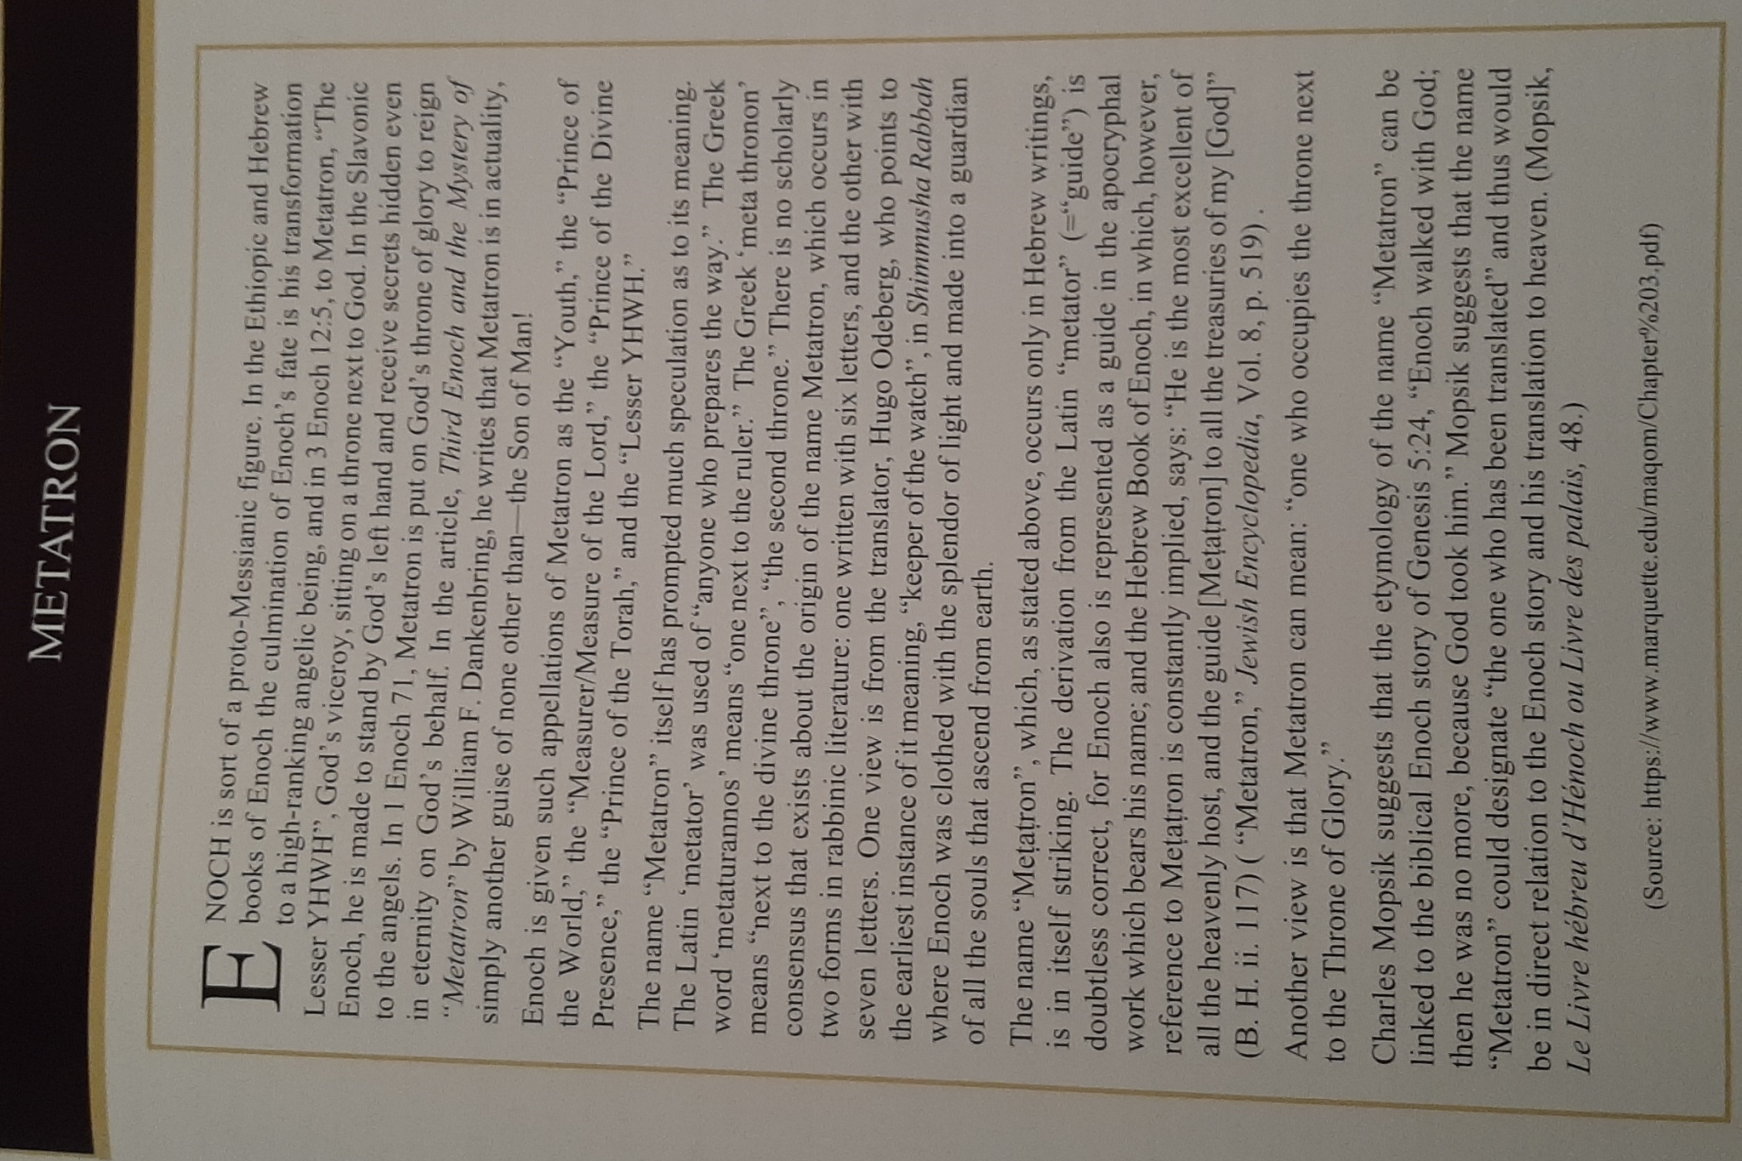

Hocking: Metatron (Enoch) 70 Names, the 70 Tongues
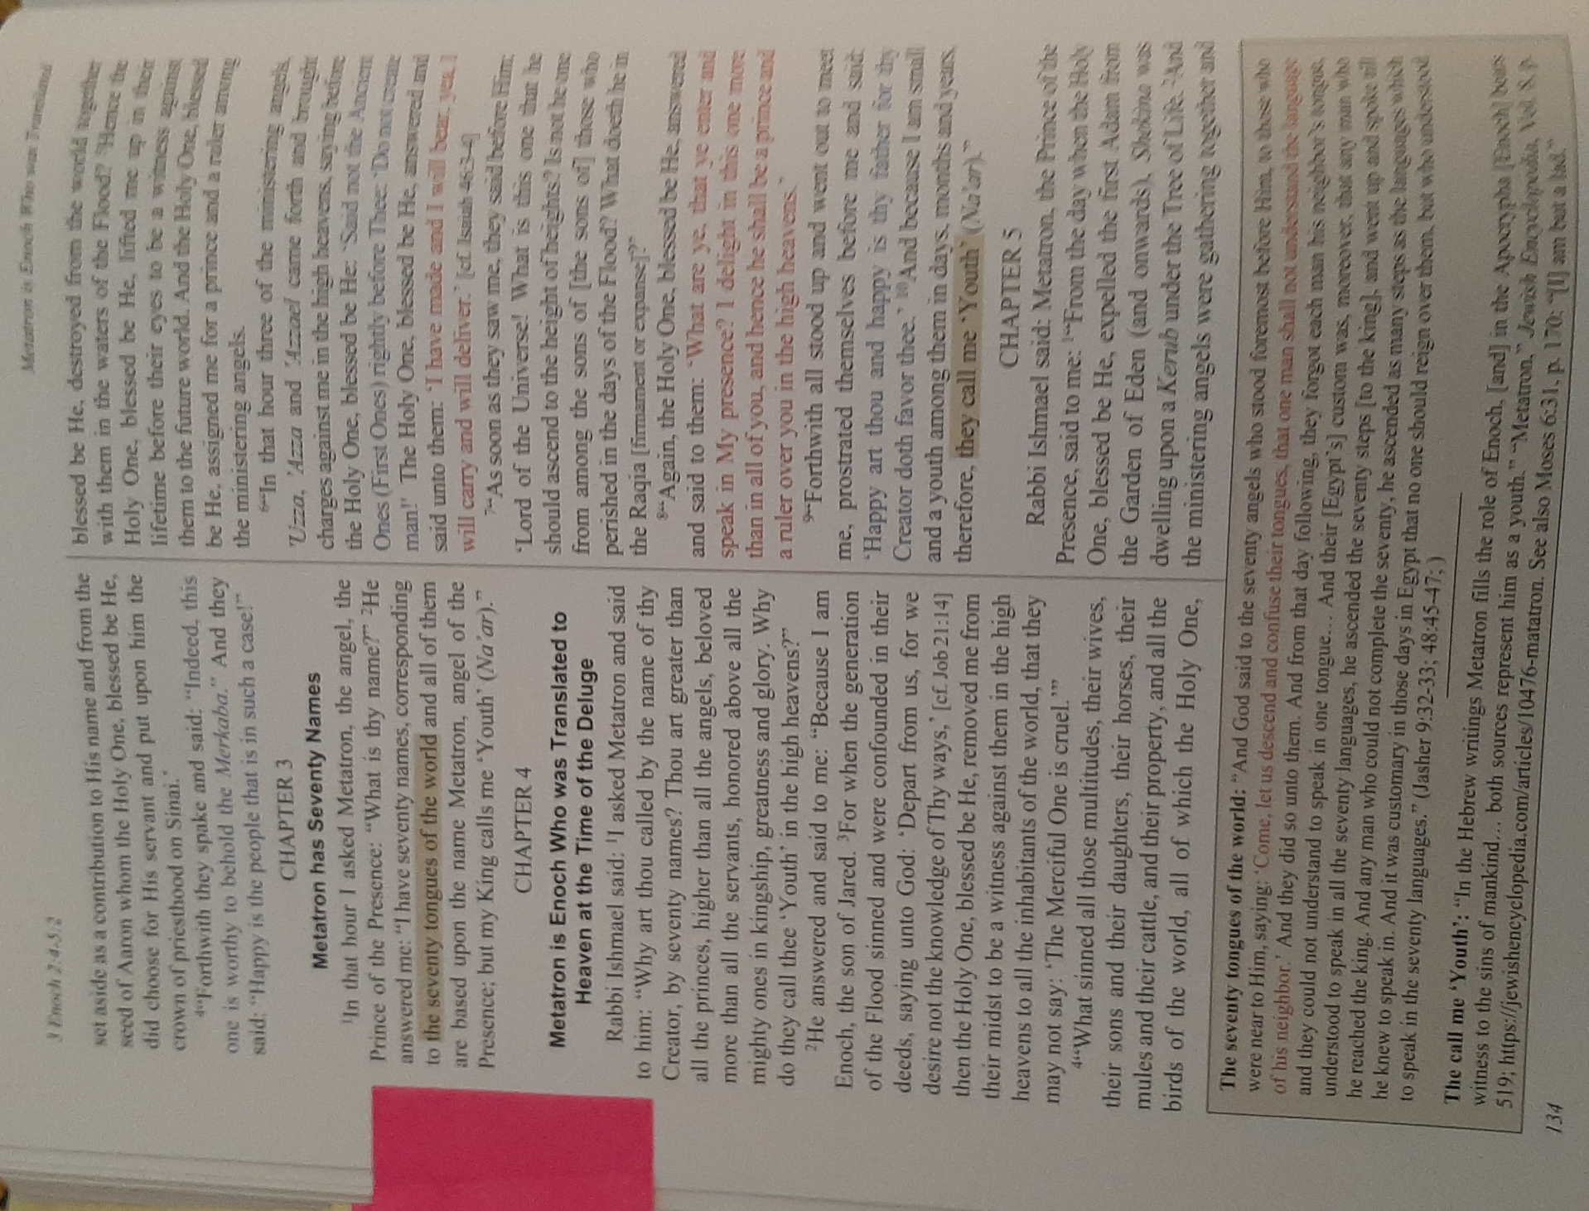
Note the priesthood office of Seventy is only found in the restored church and, in accordance with ancient tradition, represents taking the gospel to all the world.

Hocking: Names of the Rulers of the World & Their Jobs
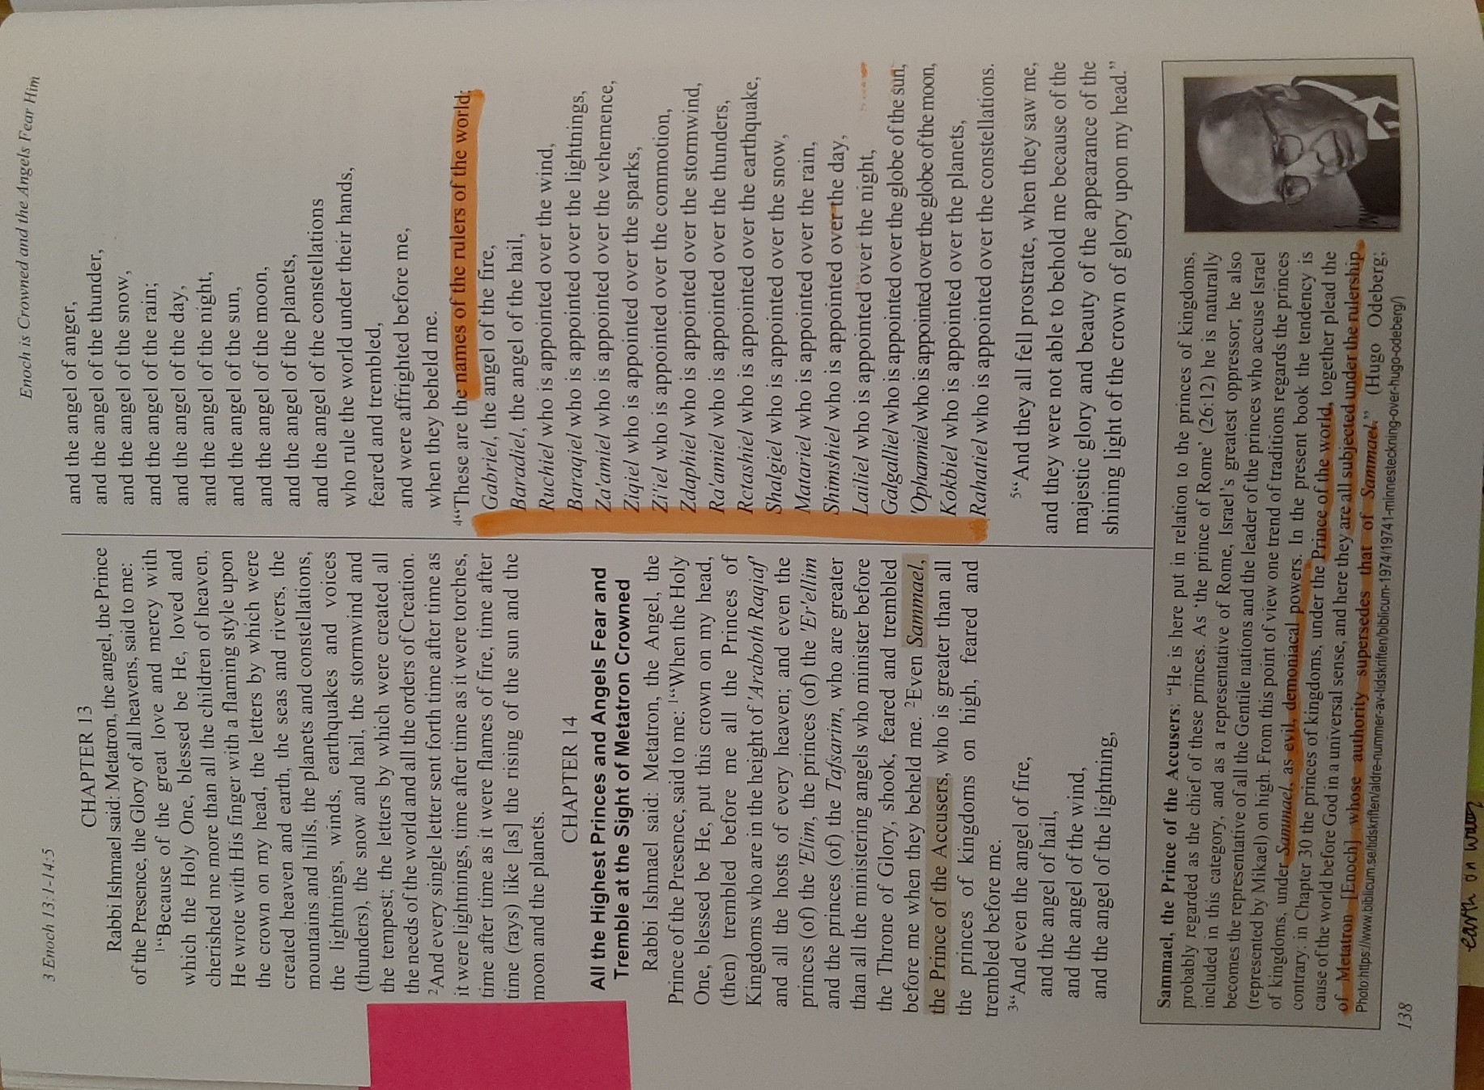

Hocking: The 7 Princes of Each Heaven
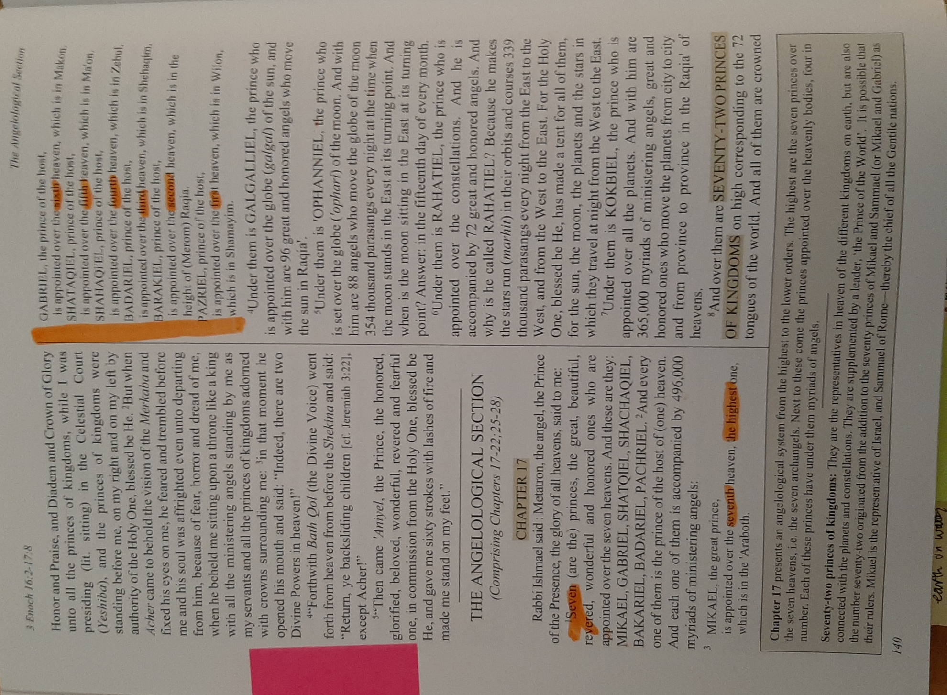

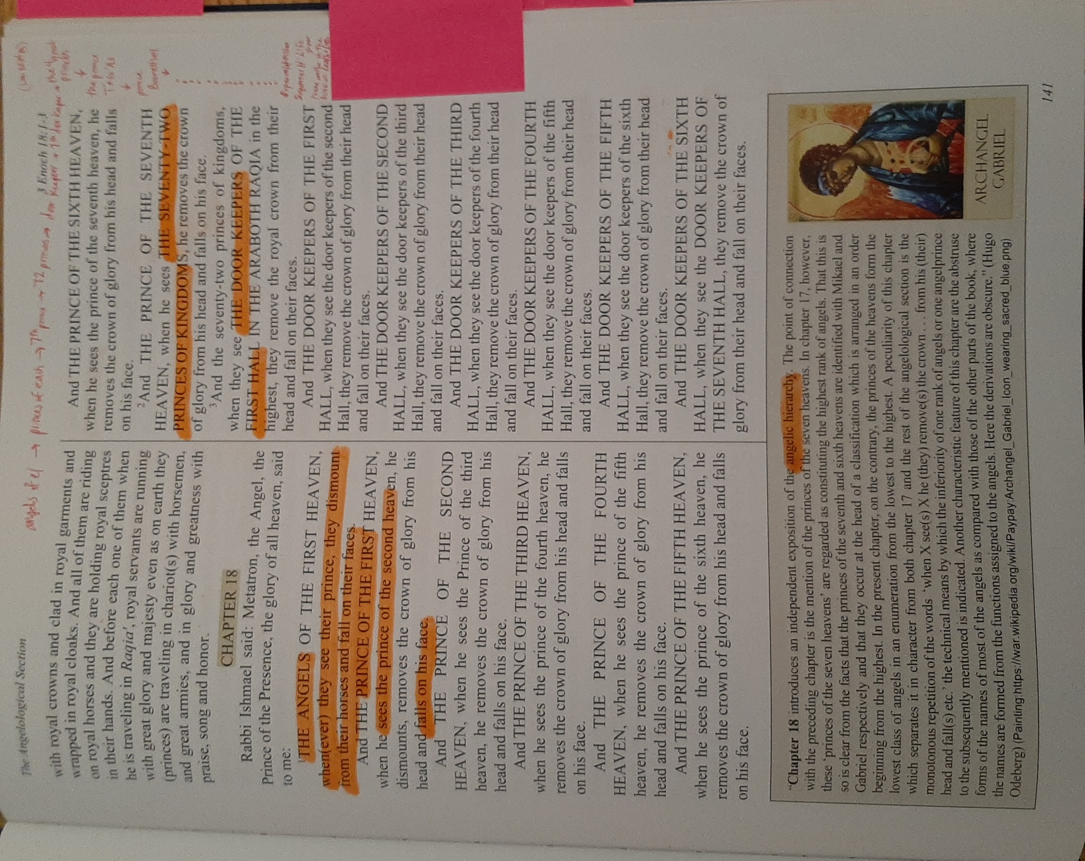

Hocking: Right Hand of MAQOM (The Almighty) Weeping
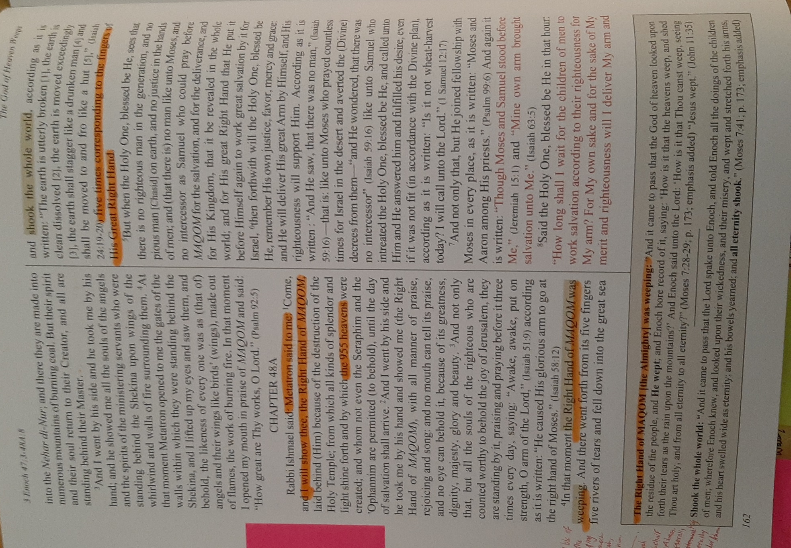
Note: indicates the God in Pearl of Great Price Moses was speaking with was Jehovah the Son.

Hocking: The 72 Names of the Holy One, Numerous Amber Crowns, Large Host, 70 Angels Corresponding to the Nations
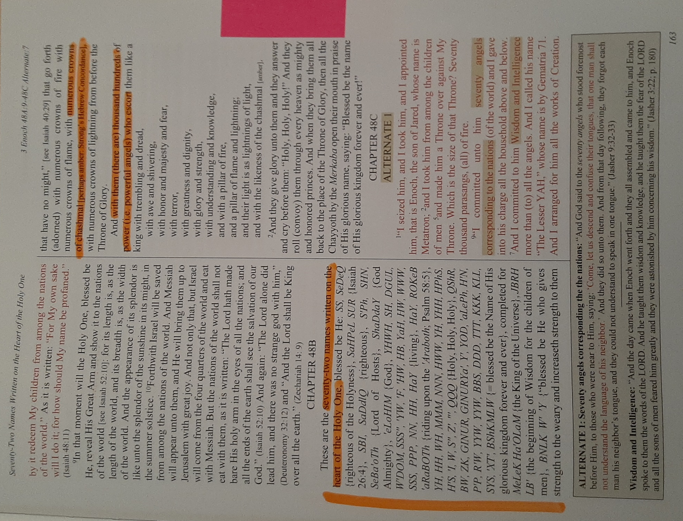

Hocking: The 70 Names of Metatron (Enoch), Moses’ Readings During the 40 Days on the Mount
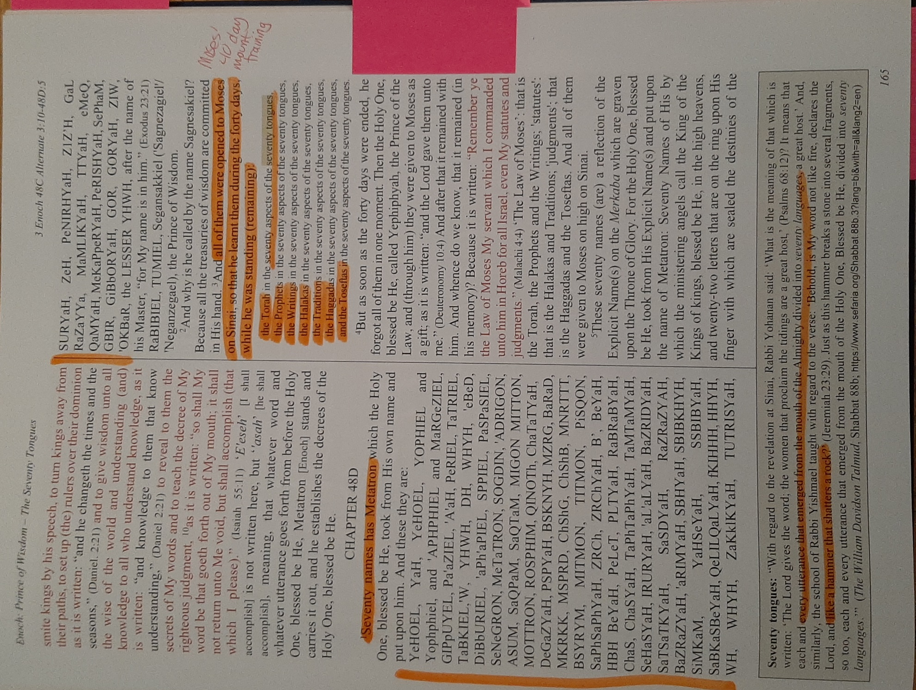

Hocking: Secret Name of God Tetragrammaton YHWH Revealed to Moses, Hillel The Elder who Developed Mishnah Repetition & Talmud, Rabbi Abbahu Oral Torah
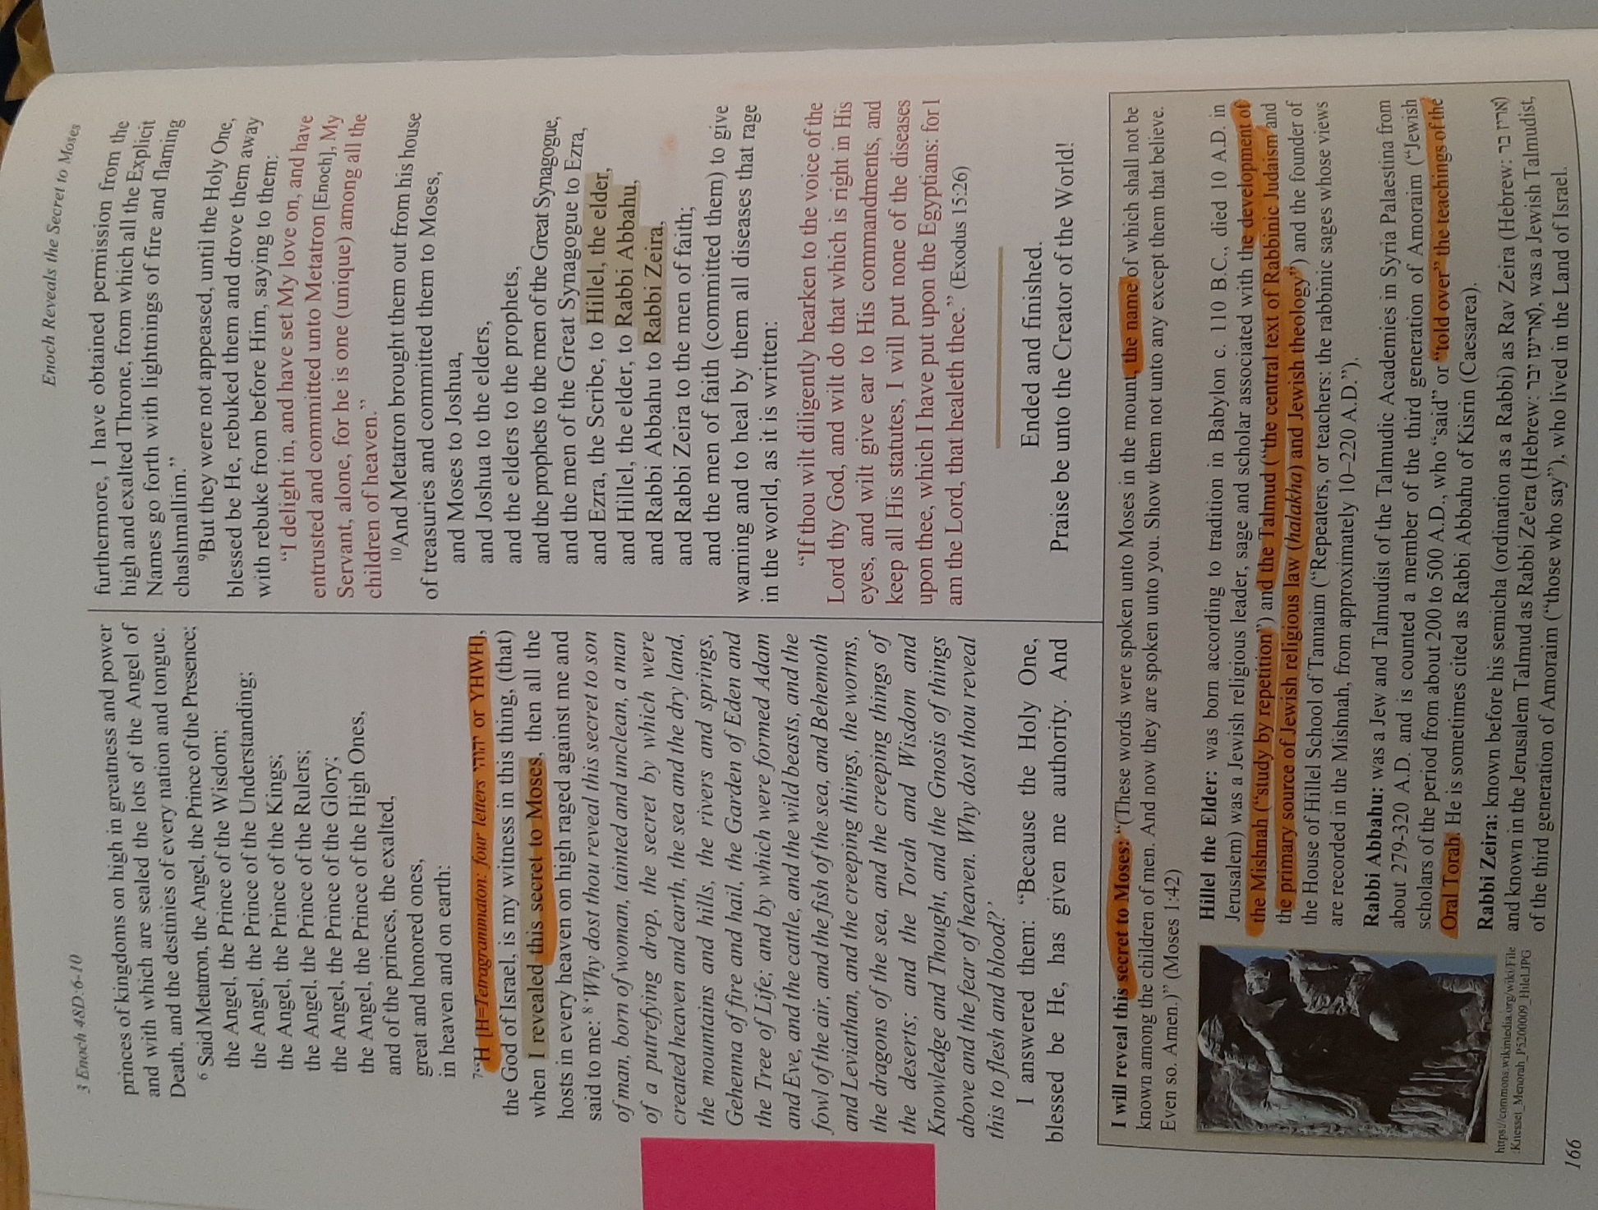

Hocking: Melchizedek is Shem
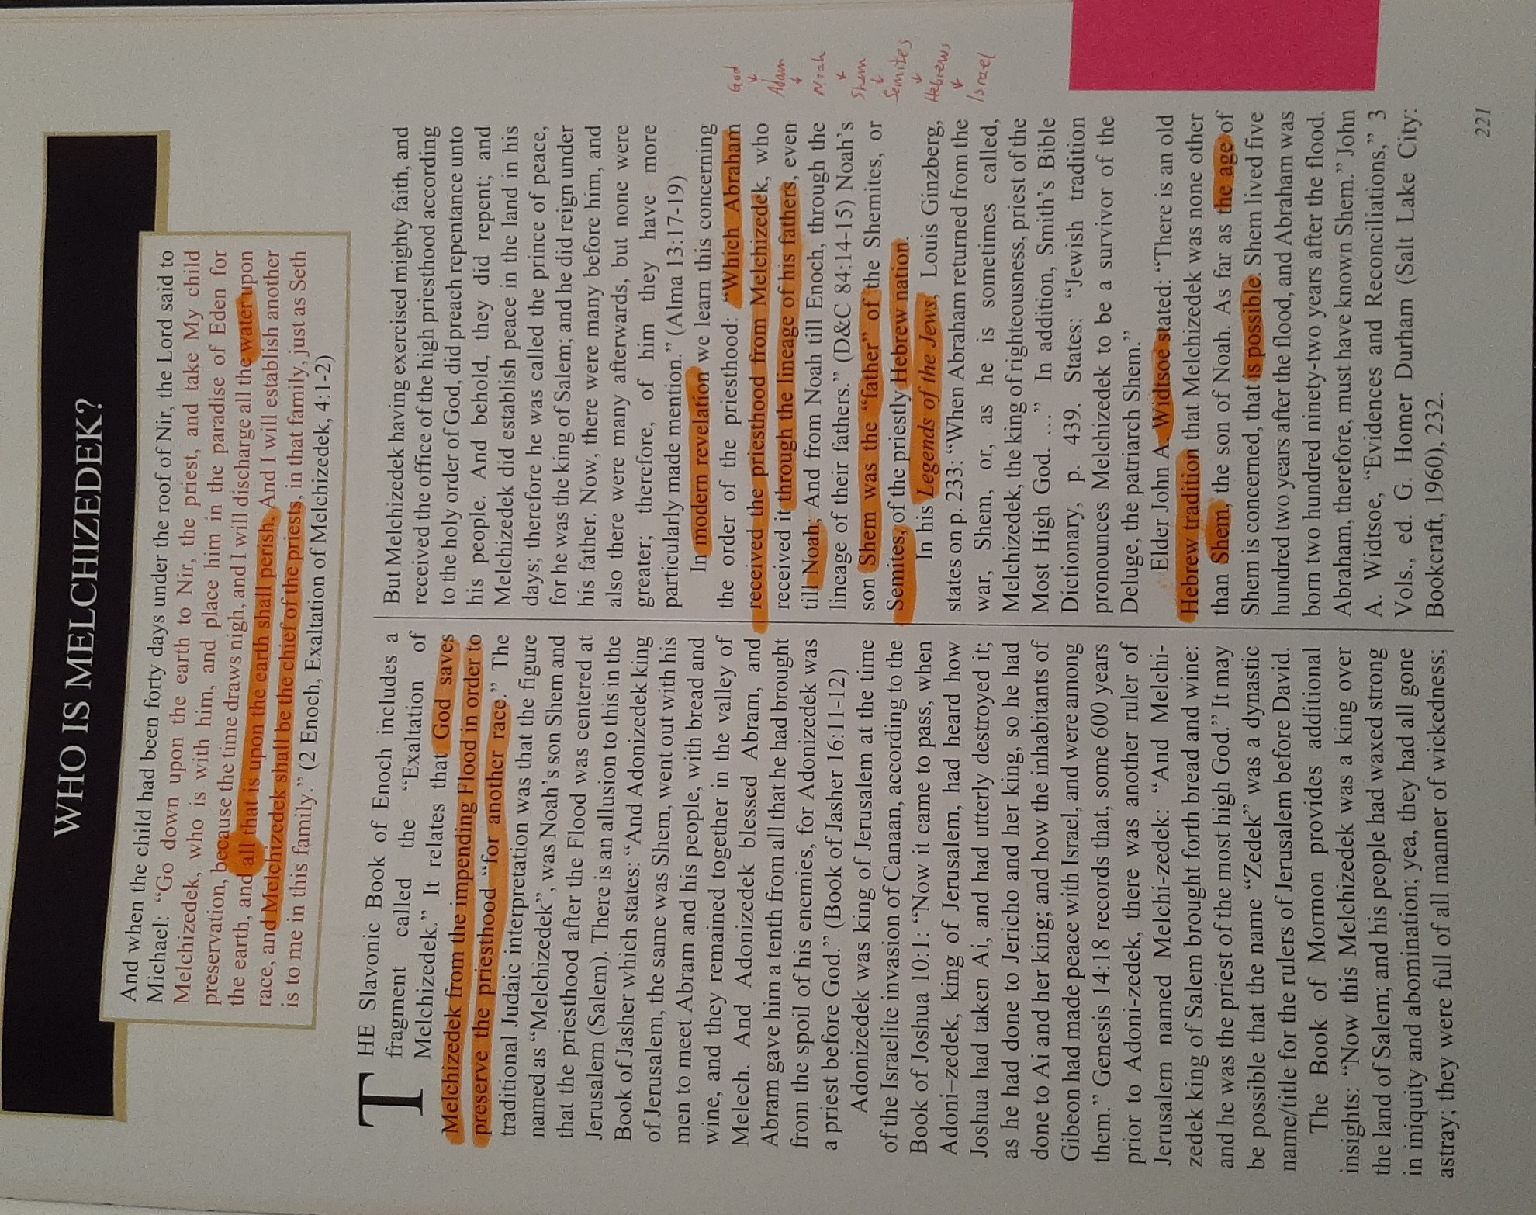

Hocking: The Enoch Calendar: Key Christ Life Events Occurring on Holy Days
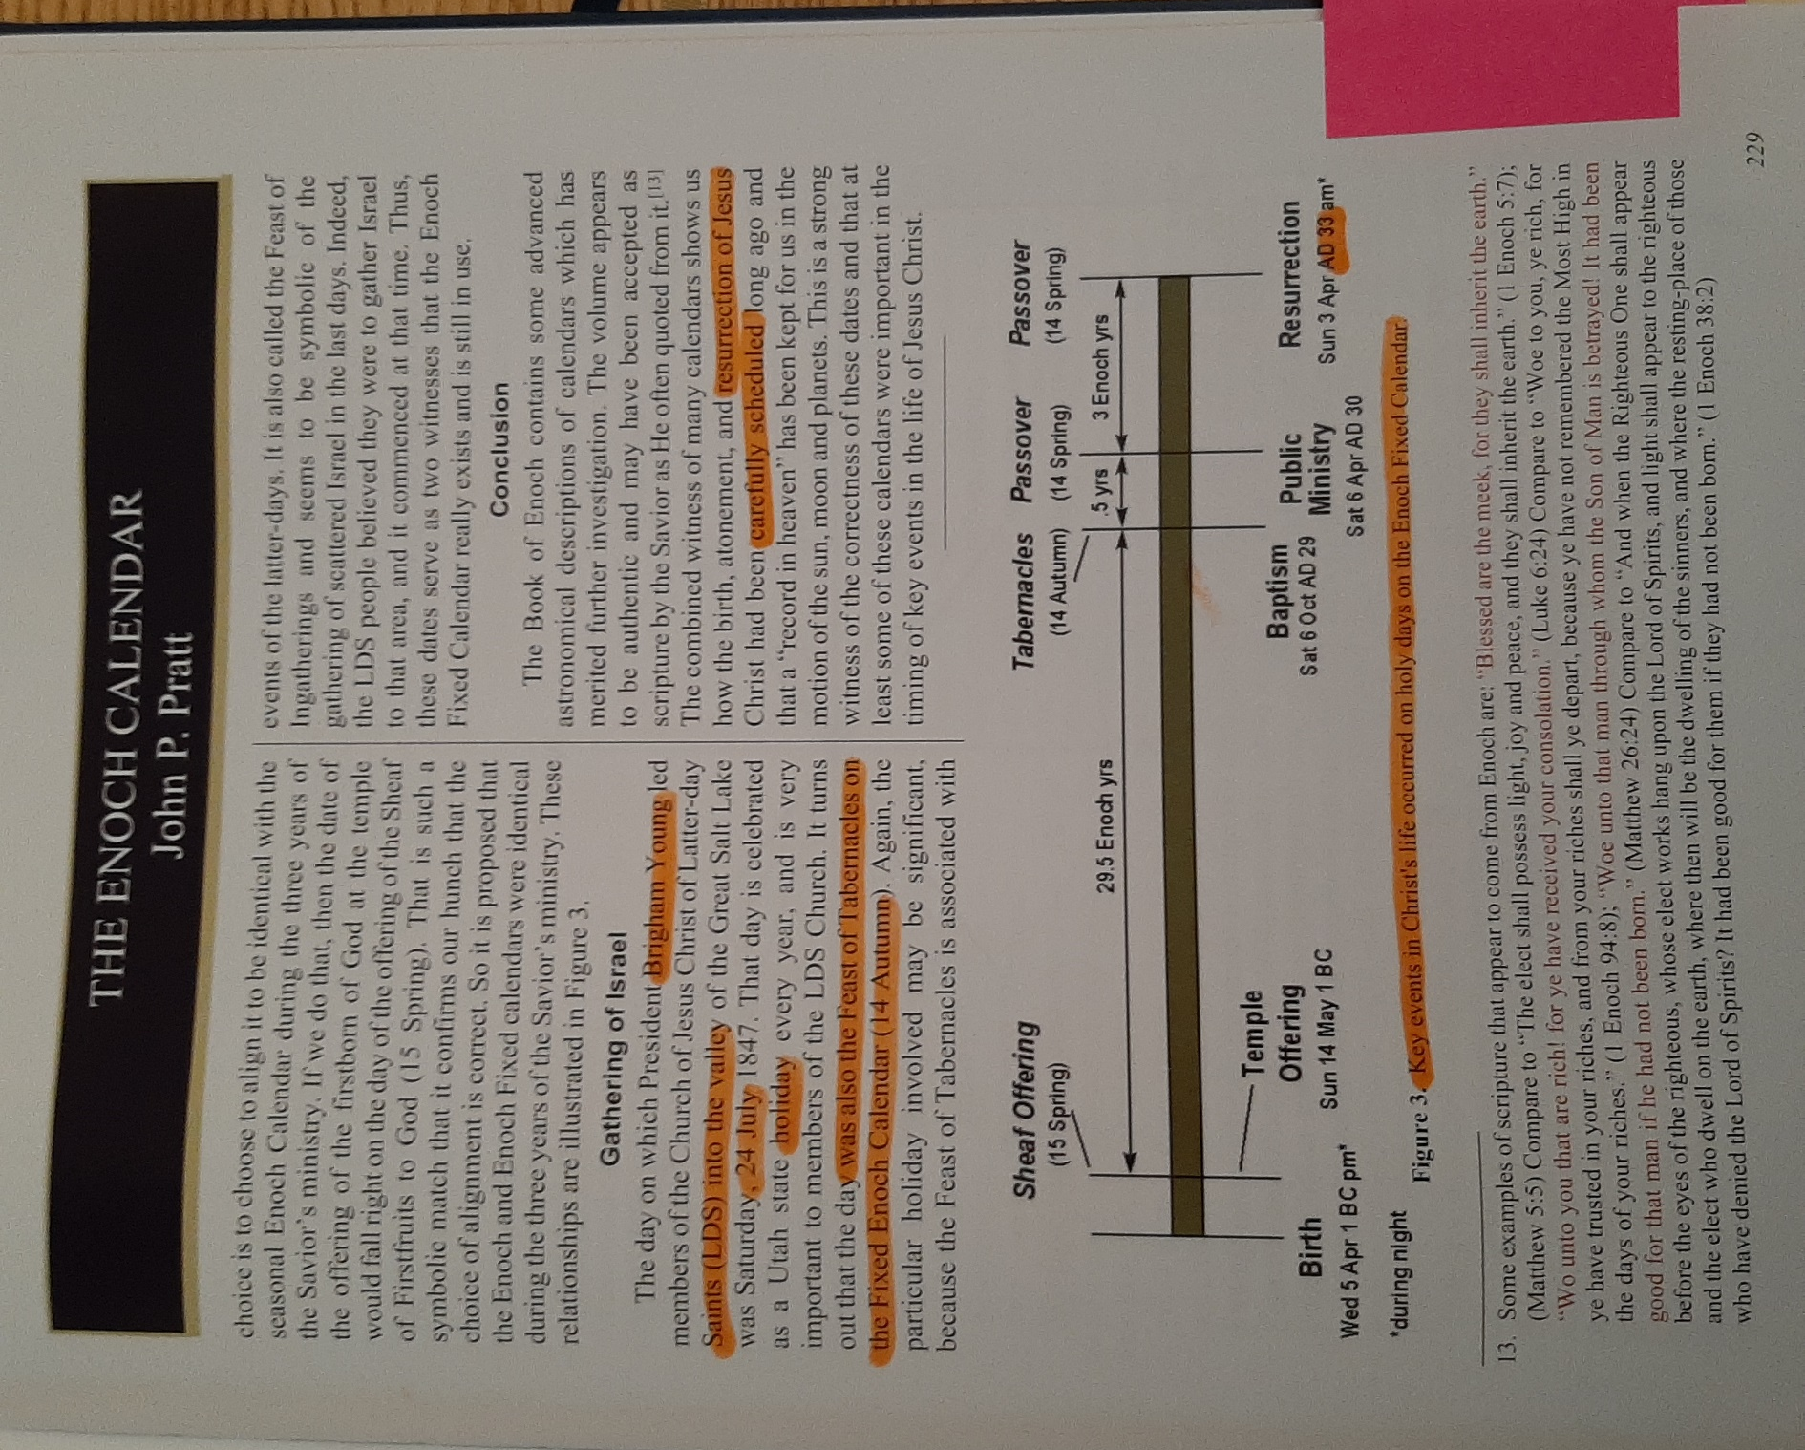

Hocking: Courses & Degrees of the Sun Portals
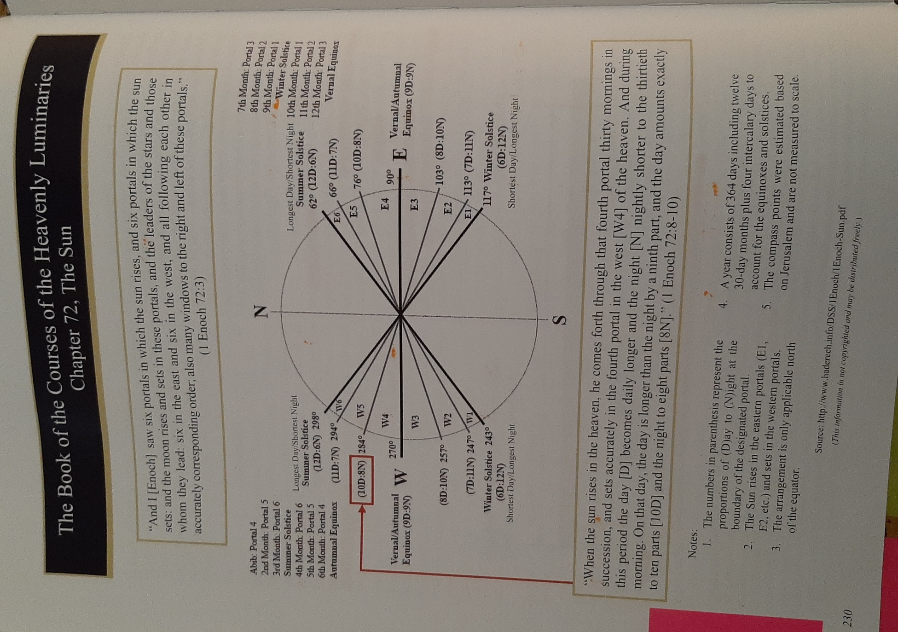

Hocking: Nephilim
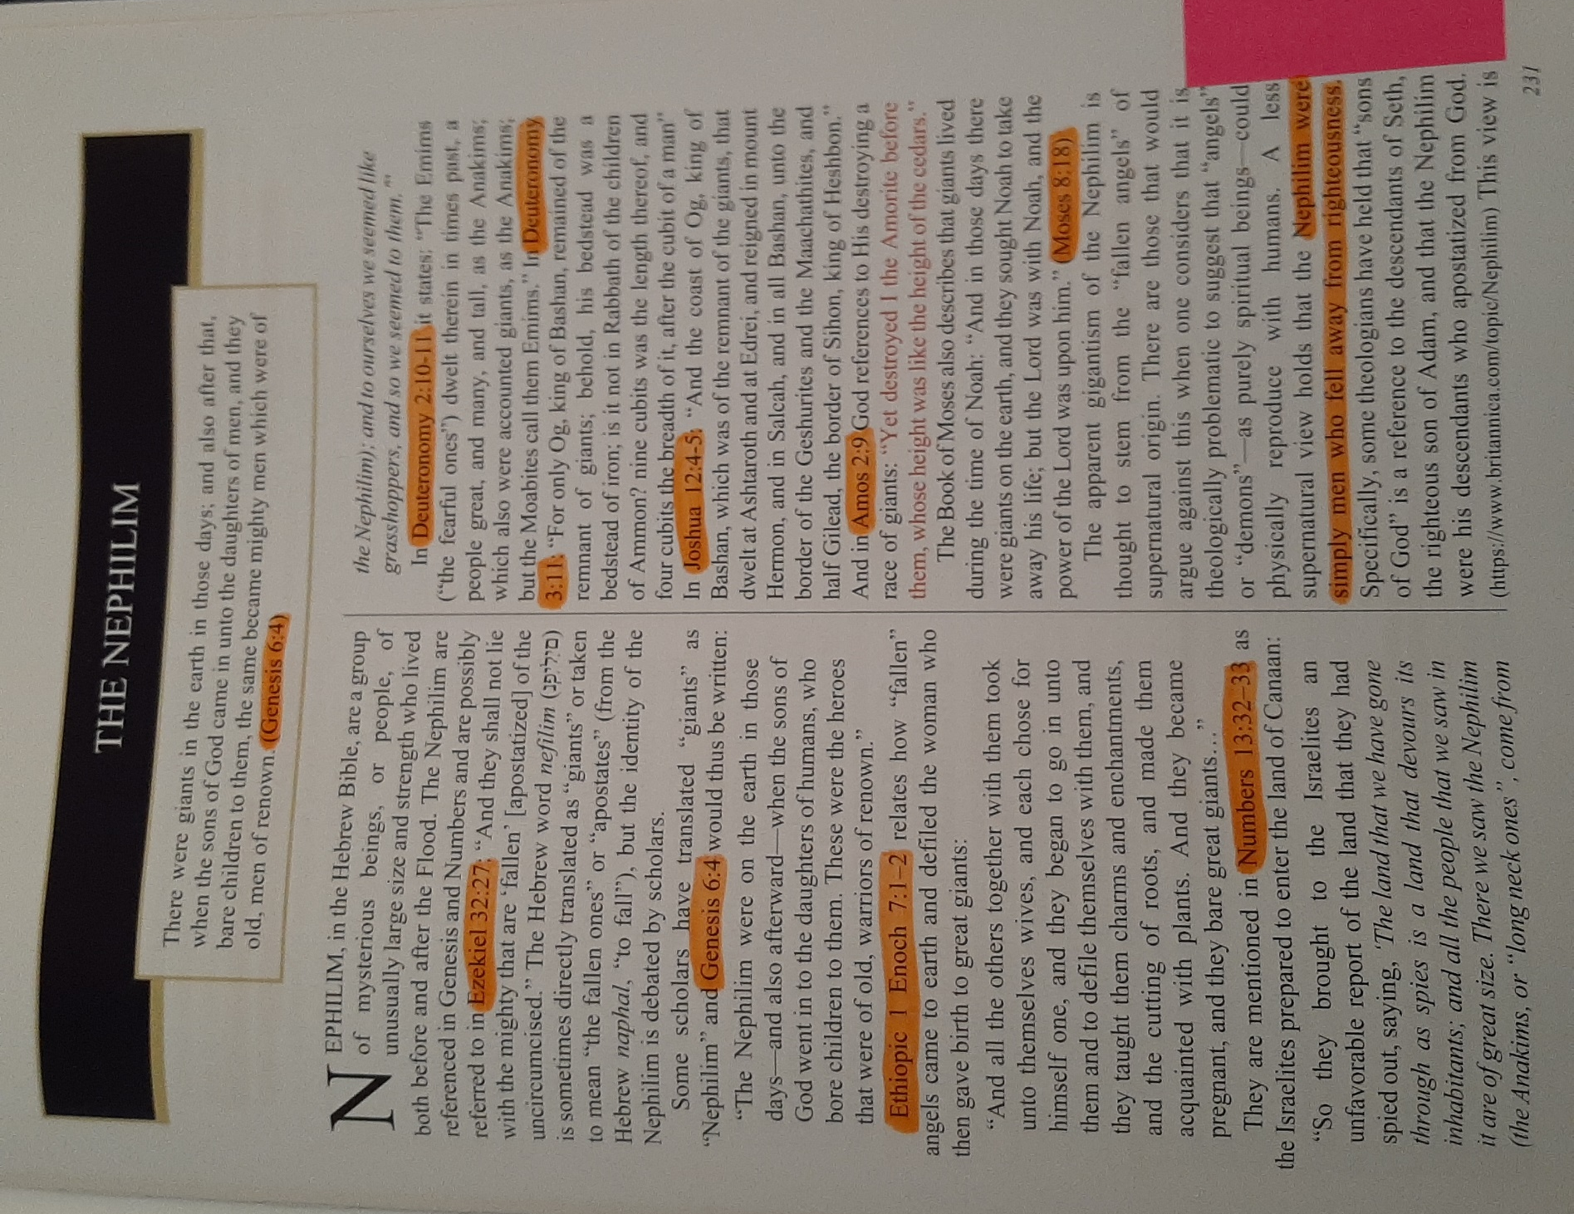

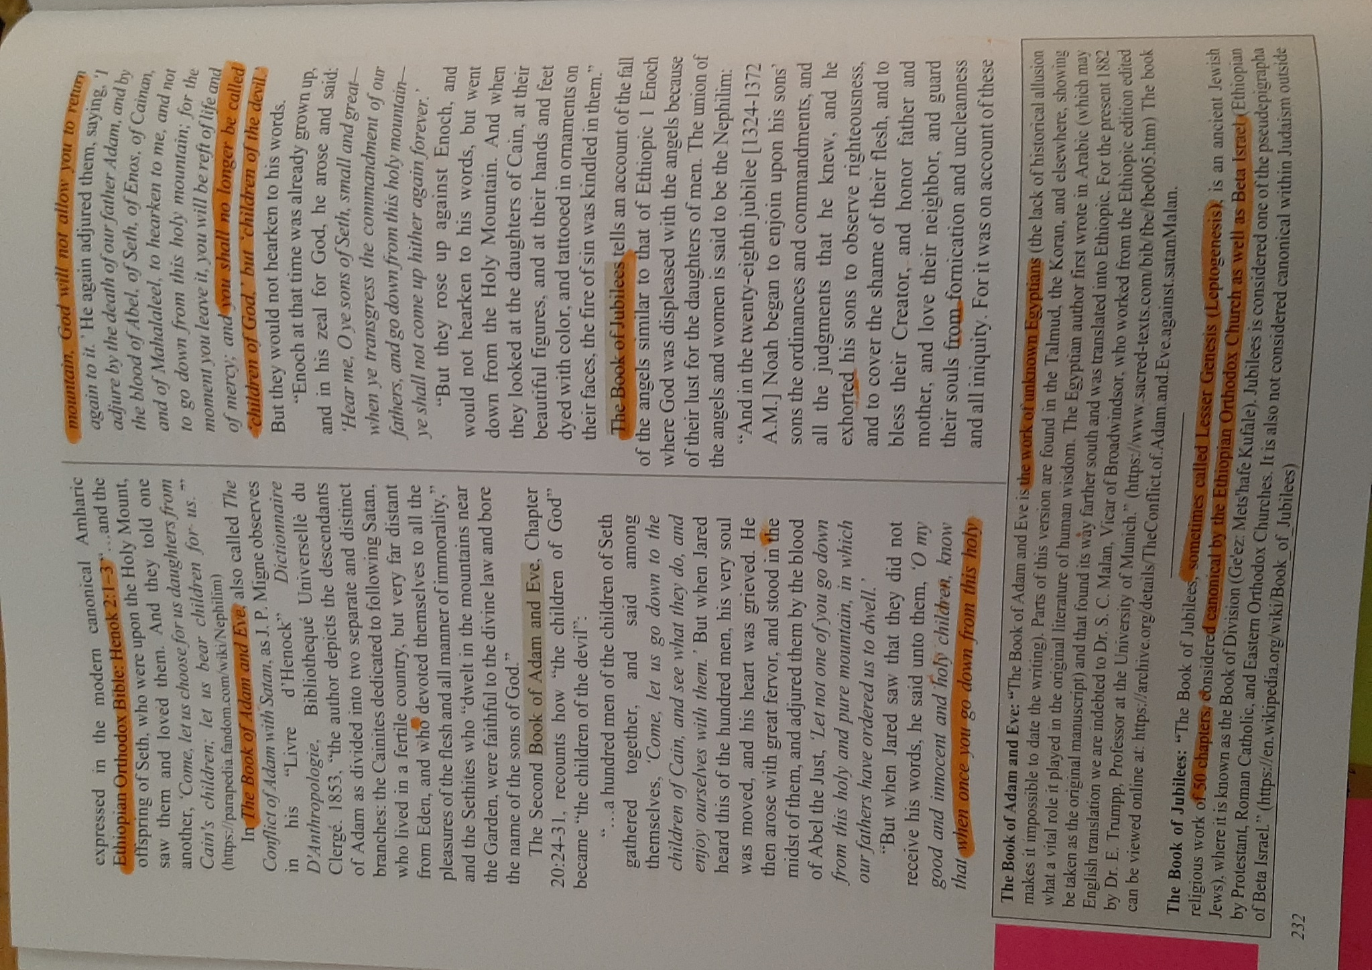

Hocking: Giant Construction, 11’ Skeletons, Sons of God Meaning Covenant Keepers
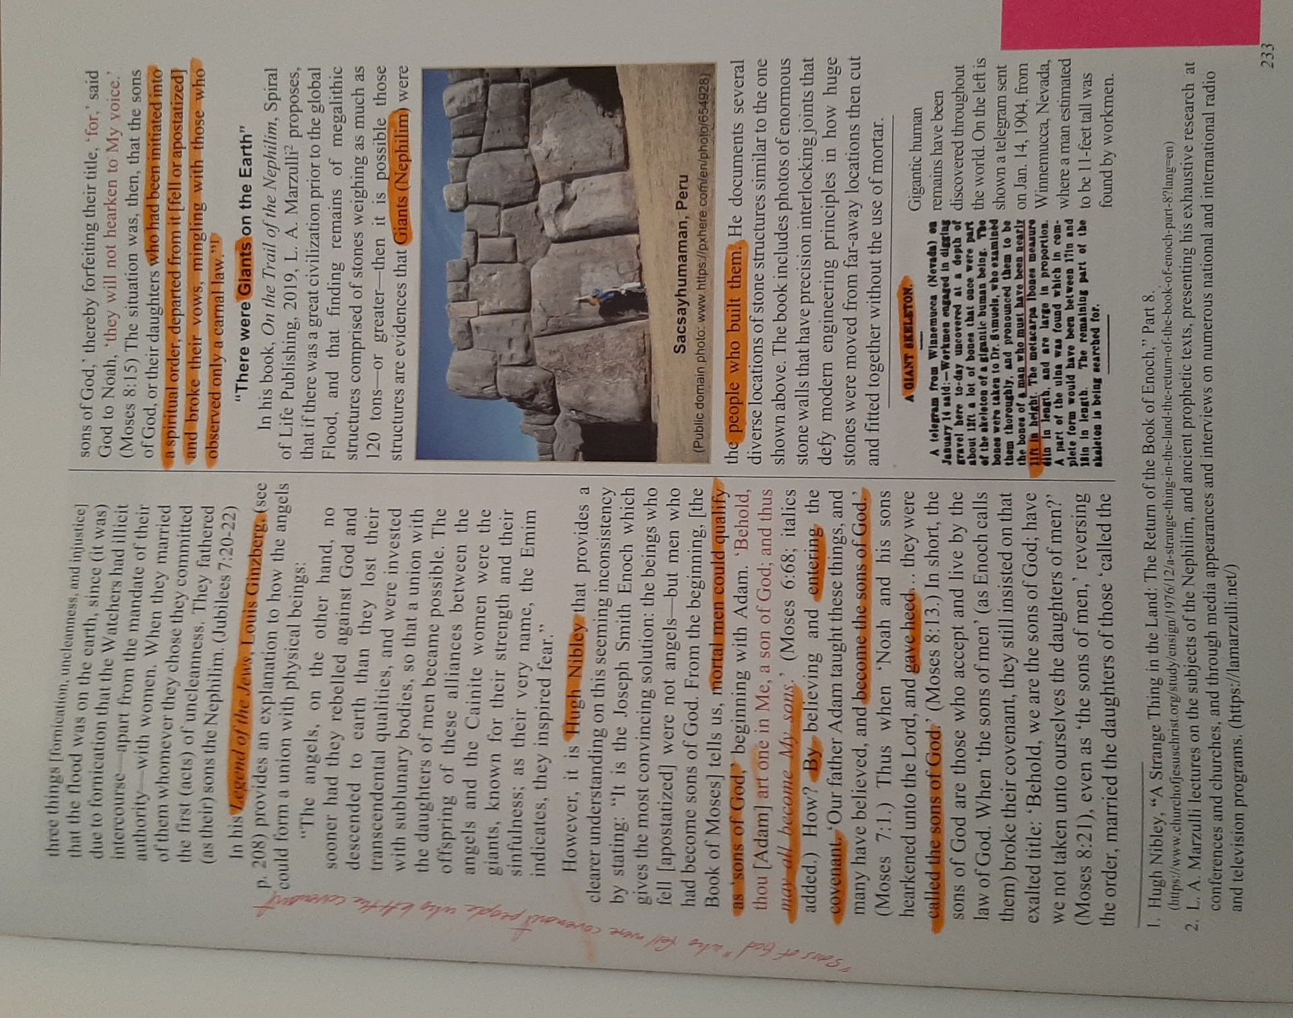

Hocking: Reign of Watchers “Days of Jared” Parallels with Millennial Reign of Christ!
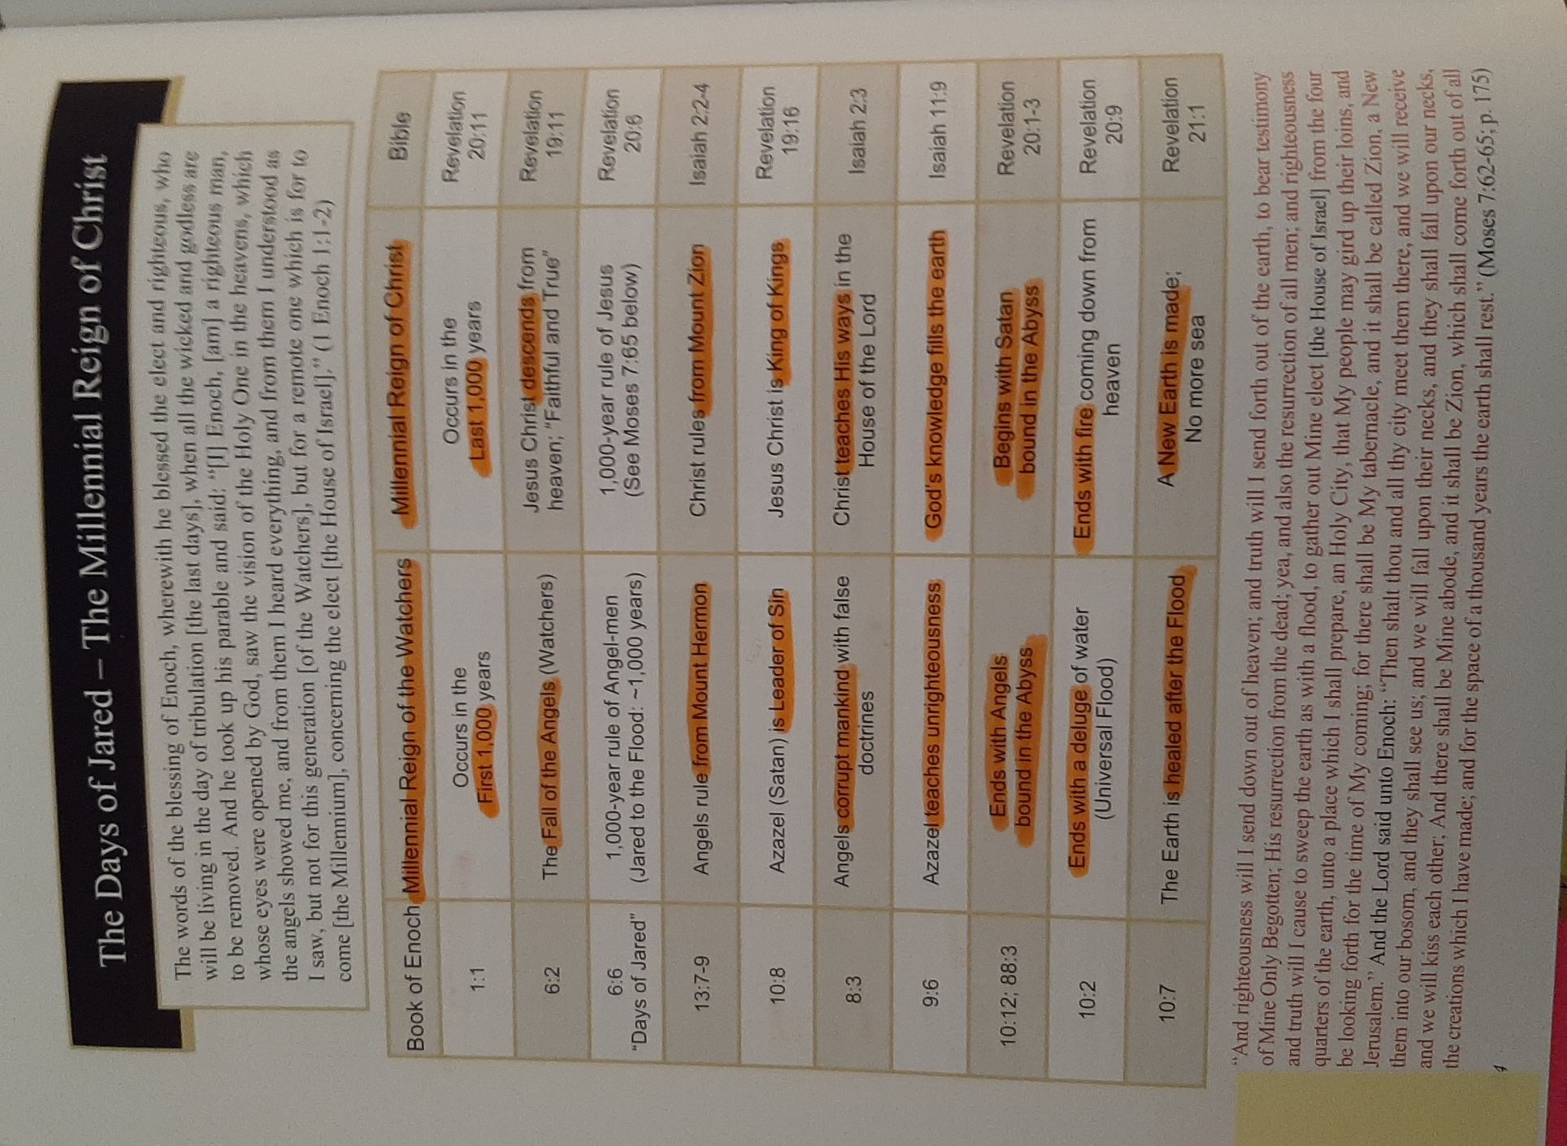

PART 6: NEW TESTAMENT ANNOTATED BY DAVID HOCKING – HIGHLIGHTS PENDING RELEASE

